Module 1 - Basics

**1. Starting Jupyter Notebooks**

**1.1 Intro Python**

Jupyter Notebook: MOD01_1-1.1_Intro_Python.ipynb

Getting started with Python in Jupyter Notebooks

**This unit will cover**

* **Python 3 in Jupyter notebooks**
* **print()**
* **comments**
* data types basics
* variables
* addition with Strings and Integers
* Errors
* character art

Student will be able to:

* **use Python 3 in Jupyter notebooks**
* **write working code using print() and # comments**

**1.2 Using Jupyter Notebooks Video**

**Video:** **UsingJupyterNotebooksV1.mp4**

In this course, we will learn how to program **Python 3 using Jupyter Notebooks in your web browser**. Our Jupyter Notebooks will be **hosted at azure.com**. And we'll **need a Windows account to log in**, so that we can run, edit, and save our notebooks.

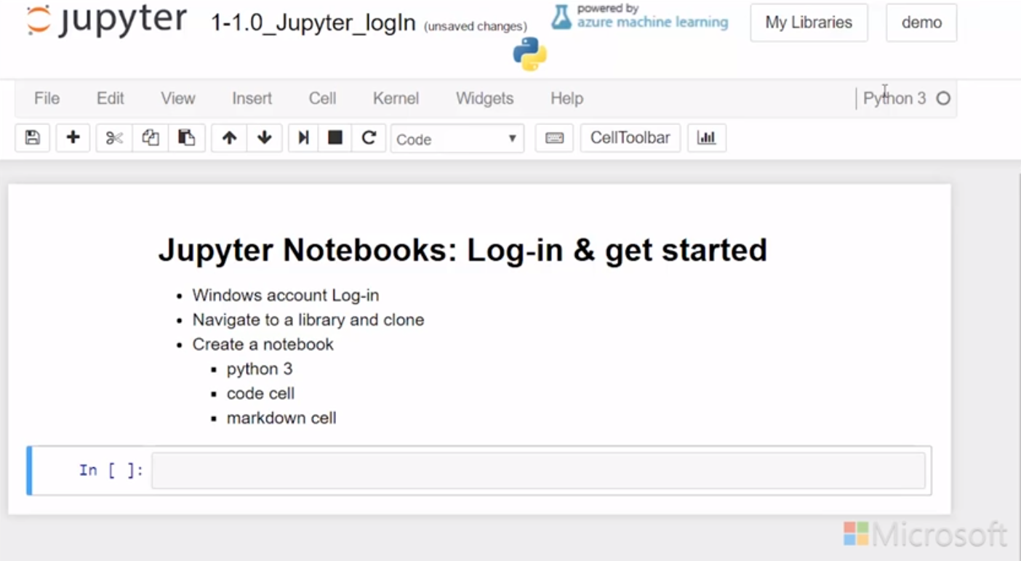

**To log in, you'll need a Microsoft account, such as Hotmail, Live.com, Outlook, or Office 365, which you may have gotten an account from your school.** If you don't have one of these accounts, you can just use any email, and turn that into the login for a Microsoft account. Navigate to account.microsoft.com to create your own Microsoft account with your own email address.

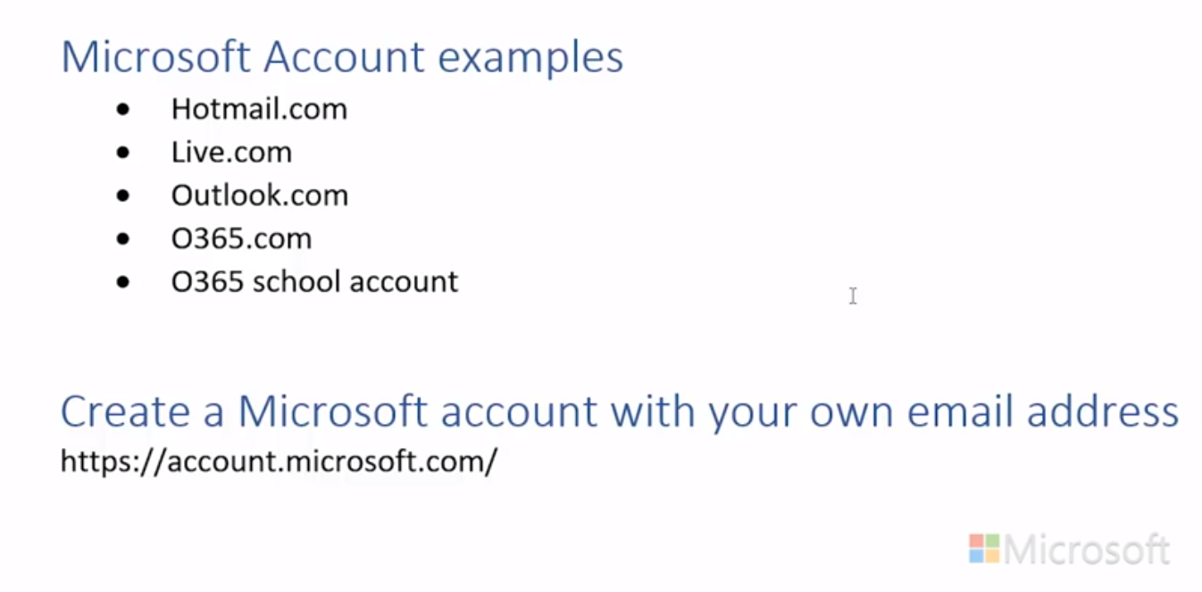

In this course, we'll host our Jupyter Notebooks at notebooks.azure.com. Click the Sign In. Enter the email address associated with your Microsoft account, and then enter your password. Your instructor will provide you with a link to a shared library. Paste the link into the browser address bar.



You'll be able to have read-only access if you're not logged in. But if you're logged in, you'll be able to edit, save, and run notebooks.

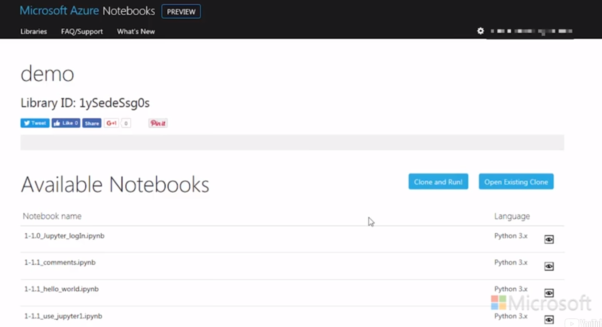

To make a copy of the notebook, click Clone and Run. And then, just choose to open the clone, or if you've opened it previously, Clone Again.

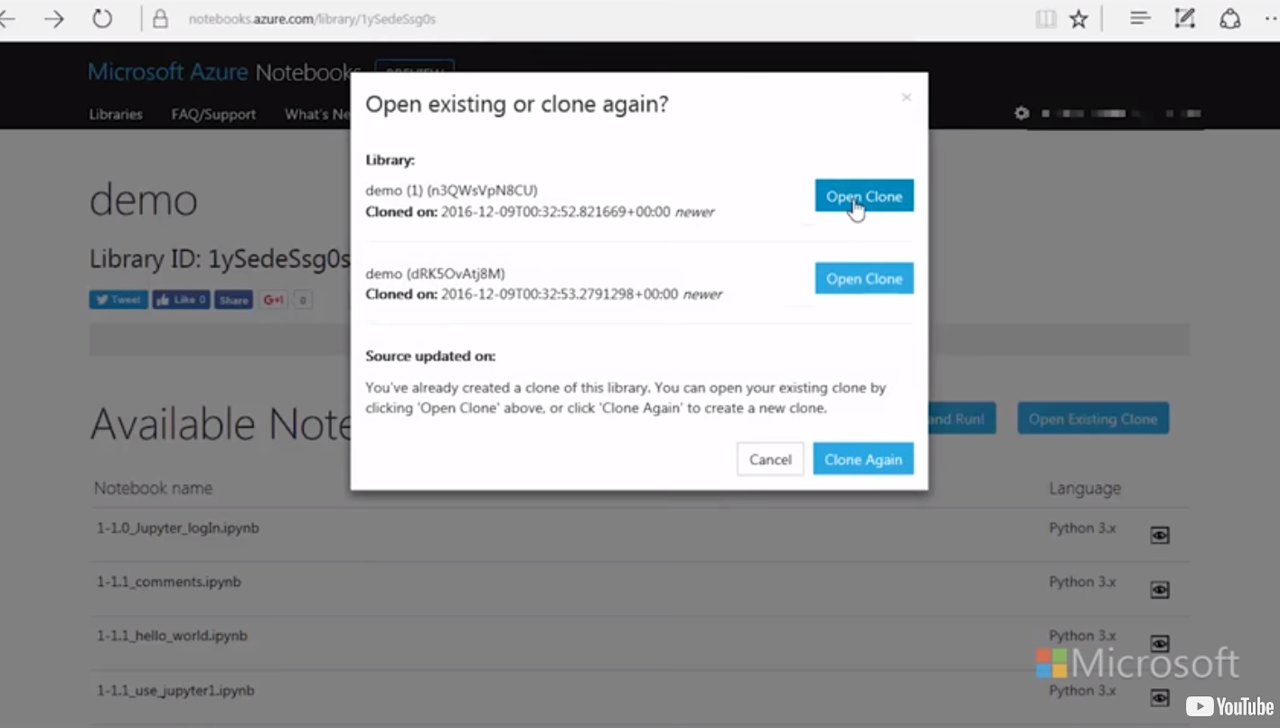

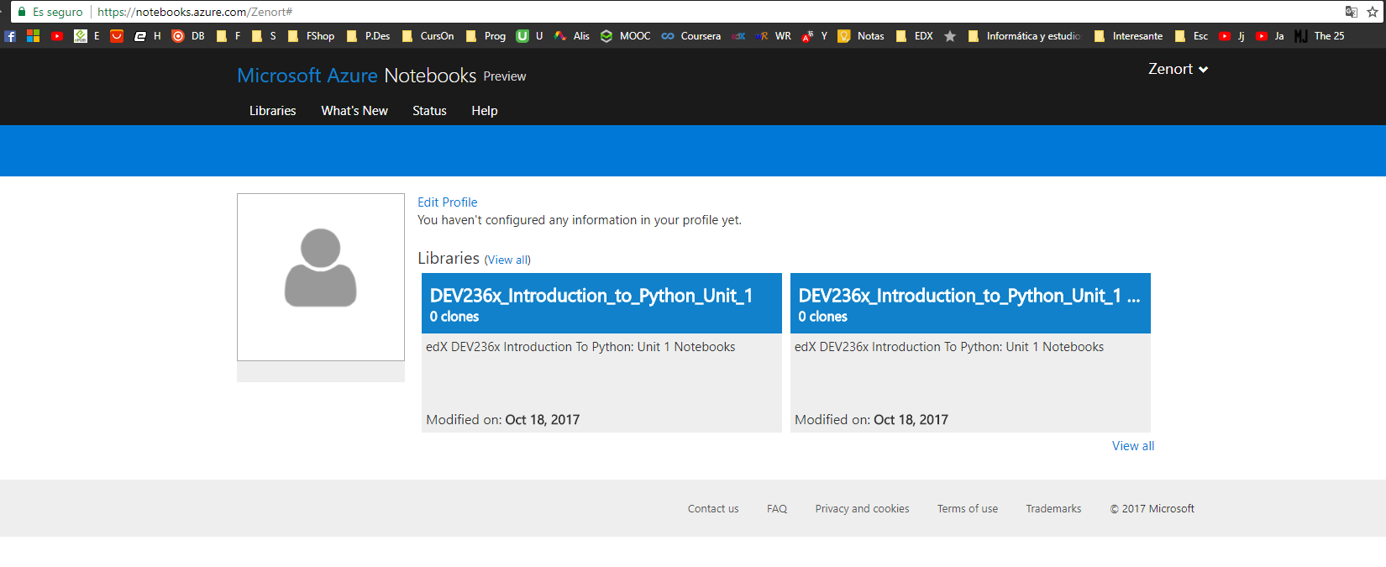

Let's look at the notebook that we had open at the beginning of this video. We saw that we can log-in to a Windows account, and that we know how to navigate to a library and clone. **We can get further acquainted with our Jupyter Notebook by creating a new notebook. So let's go to File > New Notebook, and let's choose Python 3.** Note there are other languages, including Python 2. We'll use Python 3 in this course.

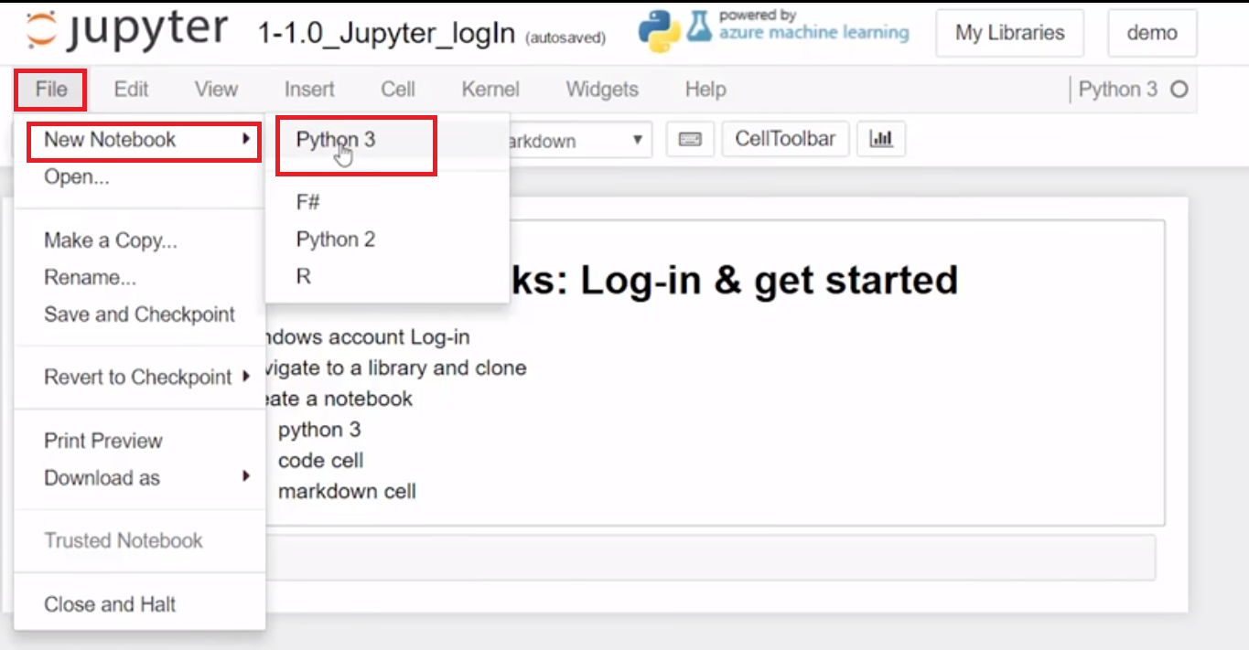

**When I create a new notebook, I can give it a title.**

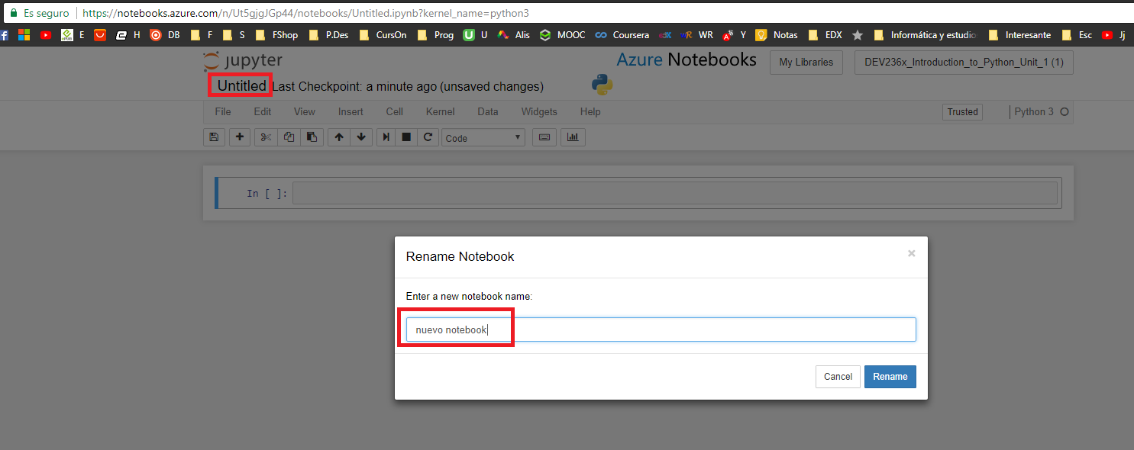

The first cell created in a Jupyter Notebook is a code cell by default.

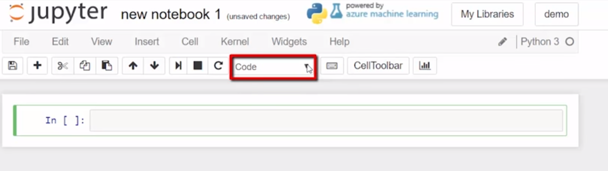

**We can change that to something called a markdown cell as well.**

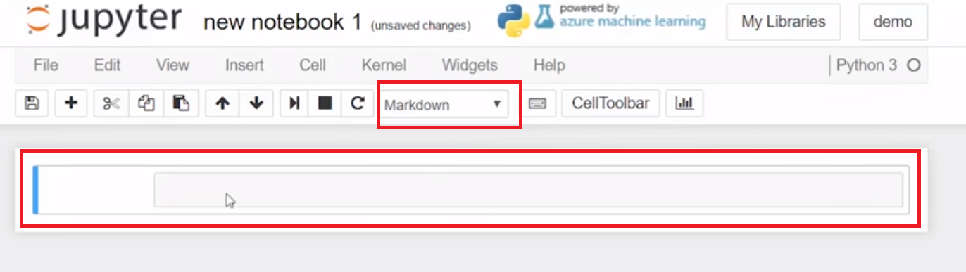

**Markdown cells are where the instructions and explanations are written for these Jupyter Notebooks. *We can enter some text in a markdown cell. And if we run the cell, it will just display, it transforms the text so that we can read it.***

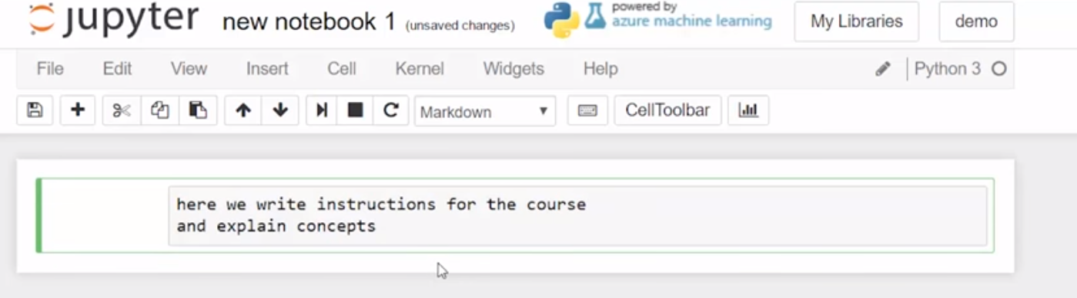

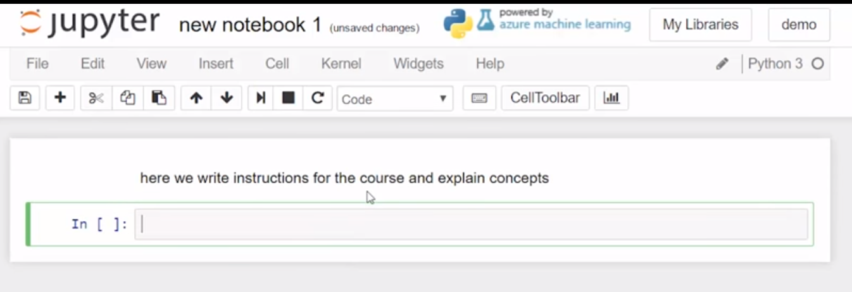

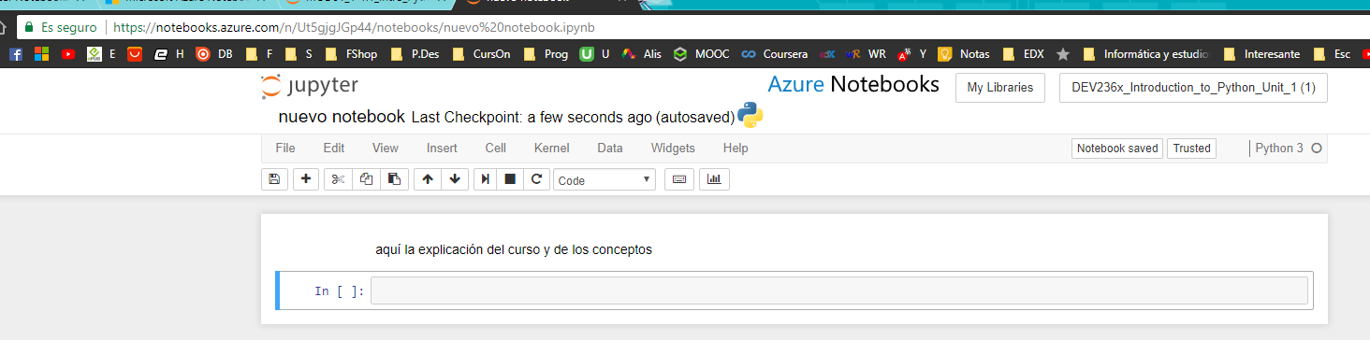

We can also edit the text with markdown code, which is a **formatting that formats it into HTML code, like a web page. And we can use headings, and make lists**, and run that,

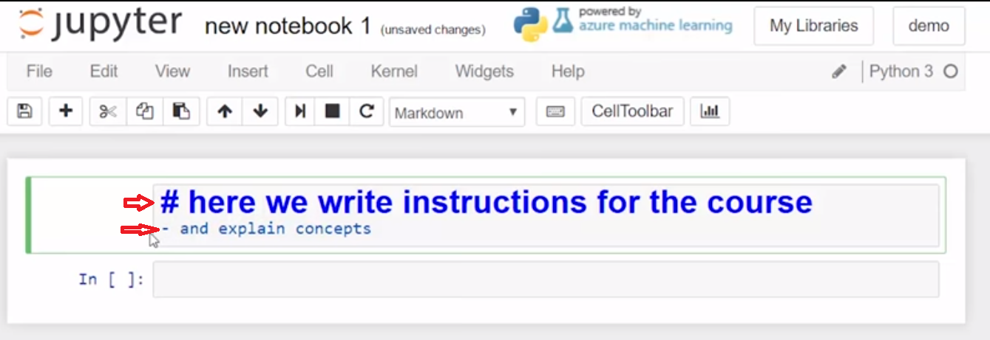

and then that's what we'll see in the course.

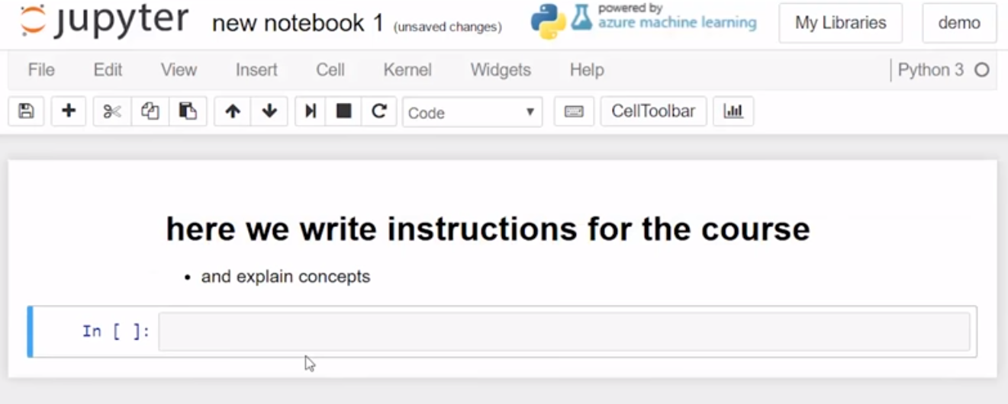

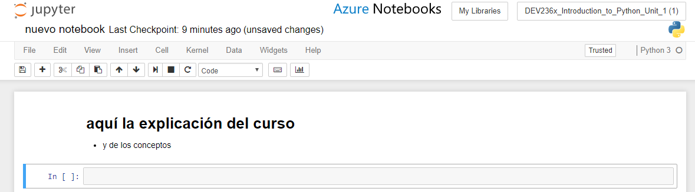

You will not be expected to edit markdown in this course, but you might run into a cell that looks like this state, and you'll know that you just need to run that cell to see it out of the markdown. After the markdown, so we have a new cell here, and that's a code cell. **Whenever there's a new cell, it defaults to a code cell. And in there, you can write some simple code like a variable x = 3, just like in your math class. And you can run those cells, and then that variable now has a value 3 associated with it. So that when we run the cell to ask what x is, we can get an output of 3.** That's just a simple preview of how we'll use code cells in the course.

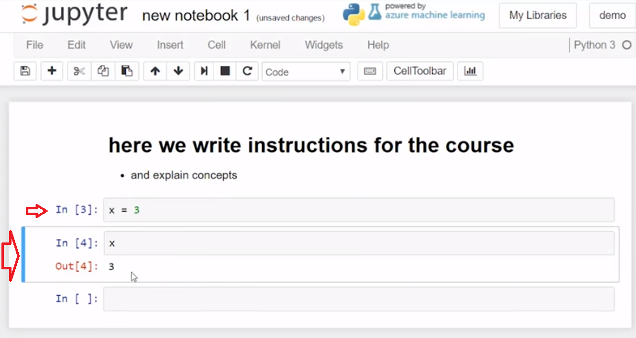

So now we know to log in to notebooks.azure.com with our Windows login account, and that we can navigate to our libraries, or have a link provided to us, and we can clone libraries. Also, we can create notebooks in Python 3. And we saw two types of cells, the code cell and the markdown cell.

Azure: <https://notebooks.azure.com/eric/libraries/DEV236x/html/MOD01_1-1.1_Intro_Python.ipynb>

**1.3 Project Files Download**

Each Section has an associated .ipynb (Jupyter Notebook) where samples can be run, and where practice tasks and code assignments can be completed. The files are available on this page.

Course Materials for Introduction to Python Unit 1 on edX also come in a Jupyter Notebook format (.ipynb files) that enable the student to:

* run sample code
* code and run the practice Tasks
* code and run the unit practices
* code and run the code assignments (4 end of unit and 1 final)

Notebooks can be cloned or uploaded using Azure Notebooks (<https://aka.ms/edx-dev236x-az>) which allows all work to be done and saved via a modern web browser and internet connection.

## Downloads

### Course Jupyter Notebooks: [Download](https://d37djvu3ytnwxt.cloudfront.net/assets/courseware/v1/4bdafe1ccd3430f6899005e368489414/asset-v1:Microsoft+DEV236x+4T2017+type@asset+block/DEV236x_Introduction_to_Python_Unit_1.zip) or [Clone on Azure Notebooks Site](https://notebooks.azure.com/eric/libraries/DEV236x) (recommended)

<https://notebooks.azure.com/eric/libraries/DEV236x>

Multiple clones will result in multiple copies or may wipe out work so it is recommended to clone once and then log into the Azure Notebooks sites thereafter.

Azure Notebooks (<https://aka.ms/edx-dev236x-az>) is recommended to complete coding work as the course is designed using the .ipynb format. The Jupyter notebook files can be run on a local Python 3 jupyter installation for the adventurous student. Also, students are free to use development environment of their choice with which they are familiar.

IDE para programar en Python

**Pycharm link descarga:** [https://www.jetbrains.com/pycharm/download/#section=windows](https://www.jetbrains.com/pycharm/download/%23section=windows)

Recomendación: <https://www.youtube.com/watch?v=-TjPyWKf5IE>

**1.4 Hello World!**

**Video:** **HelloWorldV2.mp4**

Concept: Hello World!

Hello World! - python print() statement

Using code to write "Hello World!" on the screen is the traditional first program when learning a new language in computer science

Python has a very simple implementation:

print("Hello World!")

Hello World is a simple first program that we use when we're learning a new programming language. It helps ensure that our system is working. We'll run Hello World in Python 3 in our Jupiter notebook. And we'll use Python 3 throughout the course. Enter into the cell which we see is a code cell. The word print is typed in lower case. The print function which can display a message that is surrounded by quotations and inside parentheses to the standard output. Let's type hello world. Use print in lower case in parentheses containing a message surrounded by quotation marks. To run the code, choose Cell, Run Cells

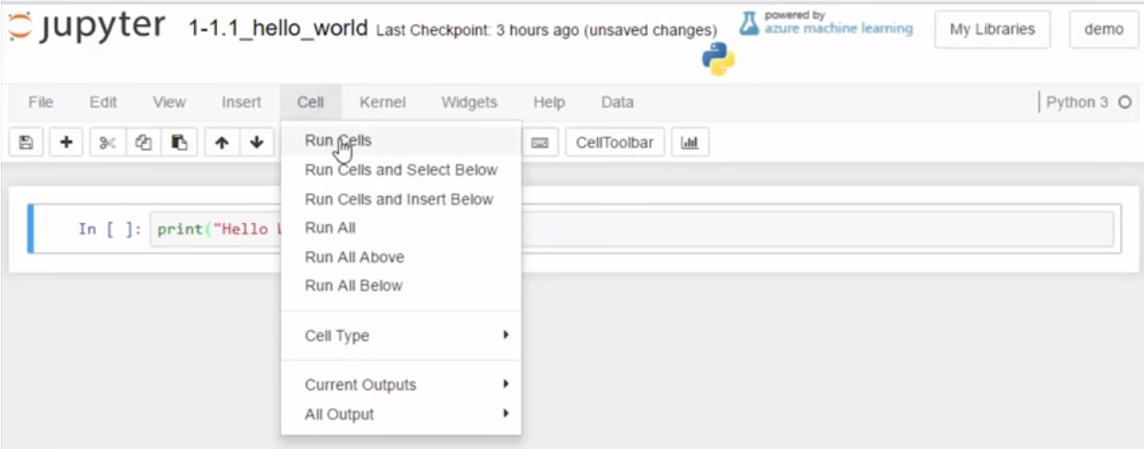

and get the message Hello World.

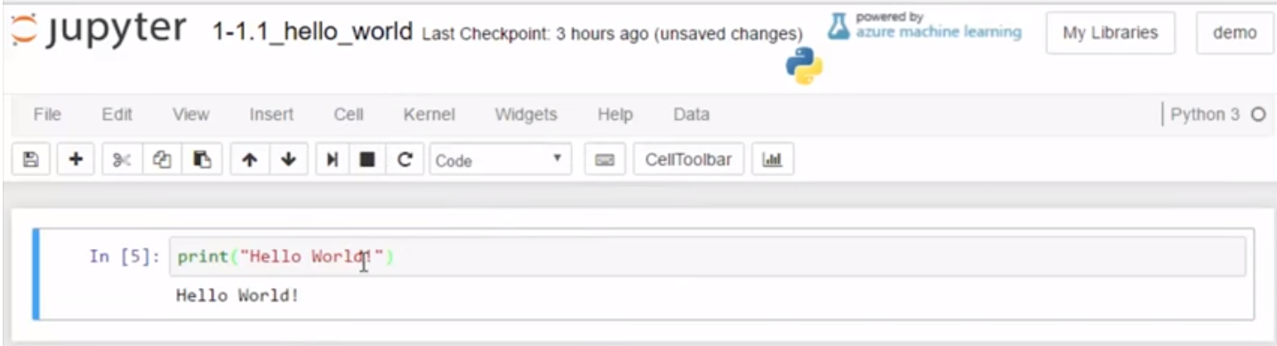

**We can edit to say Hello Students. Run the cell this time using a keyboard shortcut, Ctrl + Enter at the same time**.

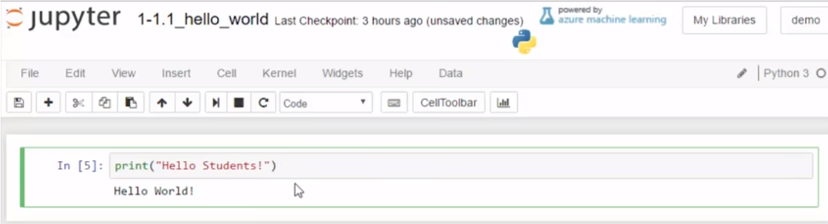

Now you have coded and run the famous Hello World.

------------------------------------------------------------------------------------------------------------------------------

Our "Hello World!" program worked because this notebook hosts a python interpreter that can run python code cells.

**Try showing**

"Hello programmer!"

enter new text inside the quotations in the cell above. Click on the cell to edit the code.

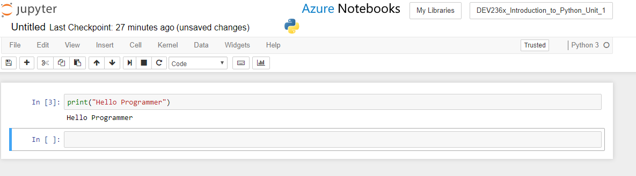

**En Pycharm:**

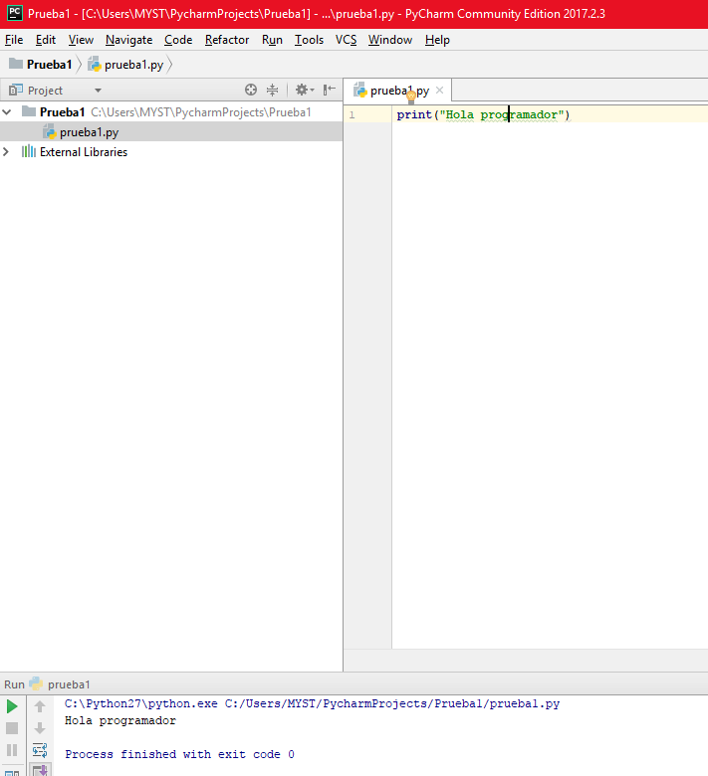

What happens if any part of  print  is capitalized or what happens there are no quotation marks around the greeting?

**Methods for running the code in a cell**

1. **Click in the cell below and press "Ctrl+Enter" to run the code  
       or**
2. **Click in the cell below and press "Shift+Enter" to run the code and move to the next cell**
3. **Menu: Cell**...
4. **> Run Cells** runs the highlighted cell(s)
5. **> Run All Above** runs the highlighted cell and above
6. **> Run All Below** runs the highlighted cell and below

Example

# [ ] Review the code, run the code

print("Hello world")

**1.5 #Comments**

**Video:** **#CommentsV3.mp4**

We'll use the hashtag in Python to create comments. >> Good code is commented code. In this version of the Hello World program, we use the hashtag or the pound sign to enter a comment. Tells the user about the code. Also in this course, we'll use a lot of messages for the student in the cells using a comment. We'll use this symbol to signify that the user has some task. And we'll give instructions on how to run the cells in examples as well.

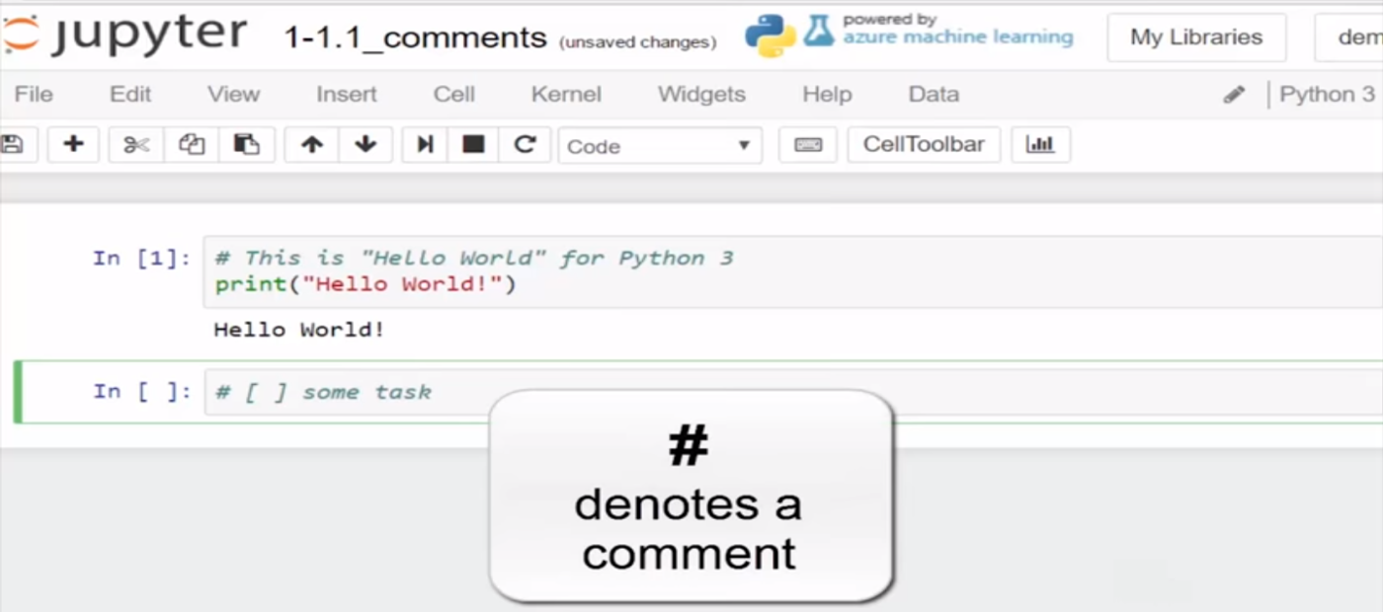

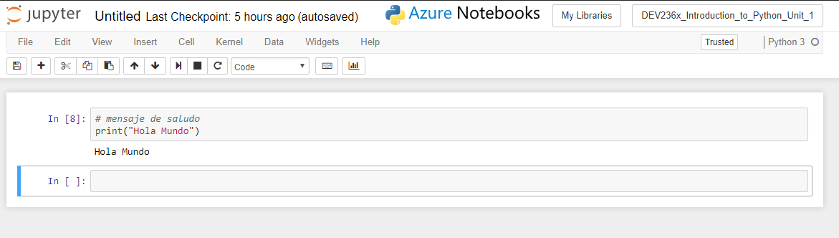

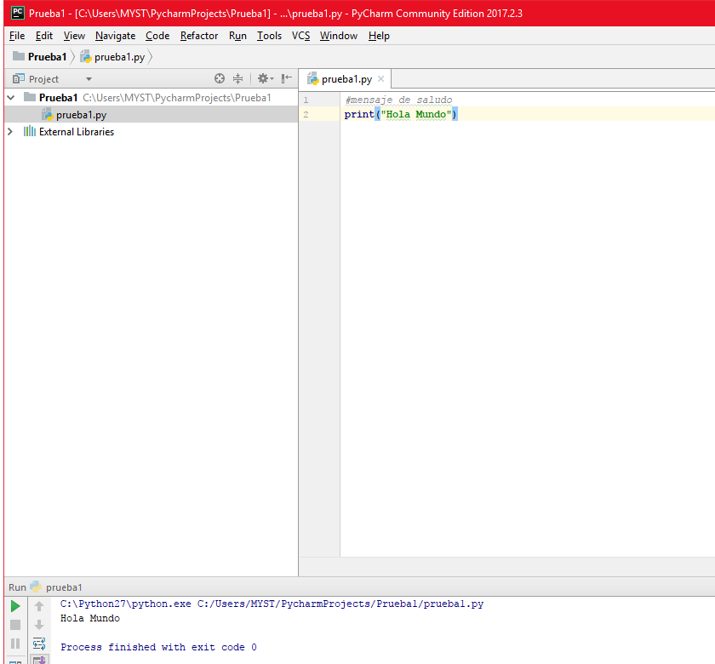

# Concept: Comments

## Comments

When coding, programmers include comments for explanation of how code works for reminders and to help others who encounter the code

### comment start with the # symbol

# Example

# this is how a comment looks in python code

# every comment line starts with the # symbol

# Task 1

## Program: "Hello World!" with comment

* add a comment describing the code purpose
* create an original "Hello World" style message

**1.6 Notebooks and Libraries**

**Video:** **NotebooksAndLibrariesV4.mp4**

**Concepts**

Notebooks and Libraries

Jupyter Notebooks provide a balance of jotting down important summary information along with proving a live code development environment where we can write and run python code. This course uses cloud hosted Jupyter [Notebooks](https://notebooks.azure.com/) on Microsoft Azure and we will walk through the basics and some best practices for notebook use.

add a notebook library

* New: <https://notebooks.azure.com/library> > New Library
* Link: from a shared Azure Notebook library link > open link, sign in> clone and Run
* Add: open library > Add Notebooks > from computer > navigate to file(s)

working in notebook cells

* **Markdown cells** display text in a web page format. Markdown is code that formats the way the cell displays (*this cell is Markdown*)
* **Code cells** contain python code and can be interpreted and run from a cell. Code cells display code and output.
* **in edit** or **previously run:** cells can display in editing mode or cells can display results of *code* having been run

**Video:**

A common work flow for using Jupyter Notebooks for coding is to use Edit, Run and Save. Some really common operations we're gonna use in our Jupyter notebooks are edit, run, and save. So to edit a cell, and I'm talking about a code cell here, you can see this is a markdown cell. Remember up here, and a code cell, if I highlight, is there. To edit, all I have to do is highlight in there, and you see my blinking cursor. **So I already had x = 2, let's go ahead and add to that. I'm gonna say that y is equal to x + 5, and then I will look at how to run this. And so if I run this cell**, there's a couple ways I can do that. First let's go to the menu and see Cell > Run Cells. And that has just run the cell. And what it does is put the value 2 in memory for x, and the value of 2 + 5, because that's x + 5 in the for y in memory. And we don't see anything,

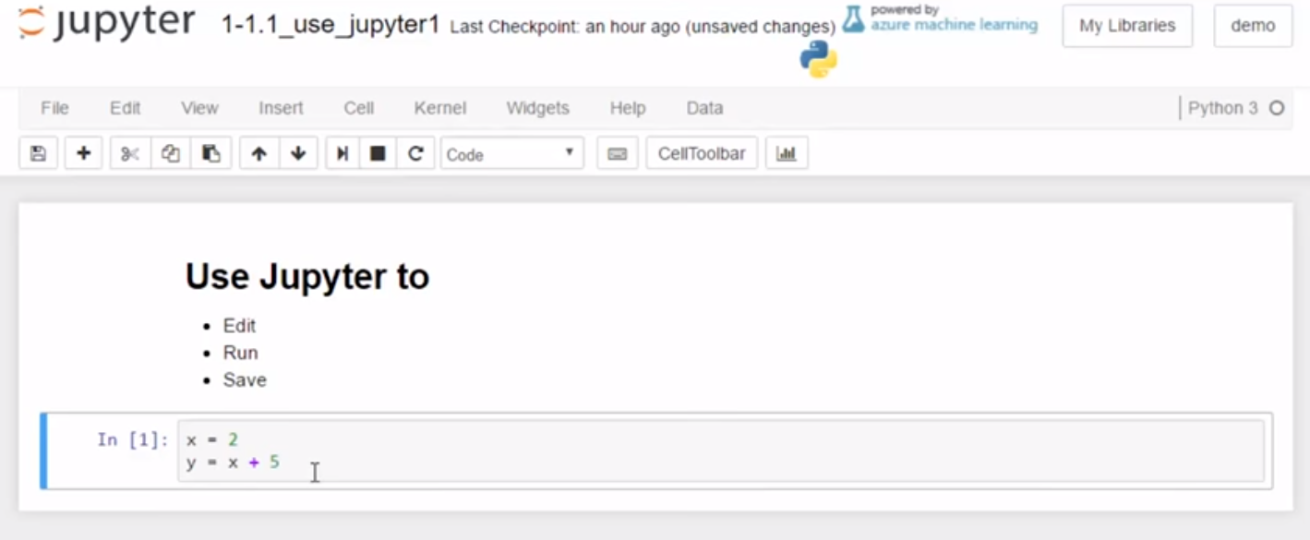

so let's run it again so we can see something. So I'm just gonna put y there, and all that's gonna do is say echo the value of y to the screen below here. So let's go ahead and run that again, but I'm not gonna hit Cell > Run Cells this time. What I'm gonna do is just click into the cell, the code cell, and hit the Ctrl button, Ctrl+Enter. And then we see that I have the value of 7 there.

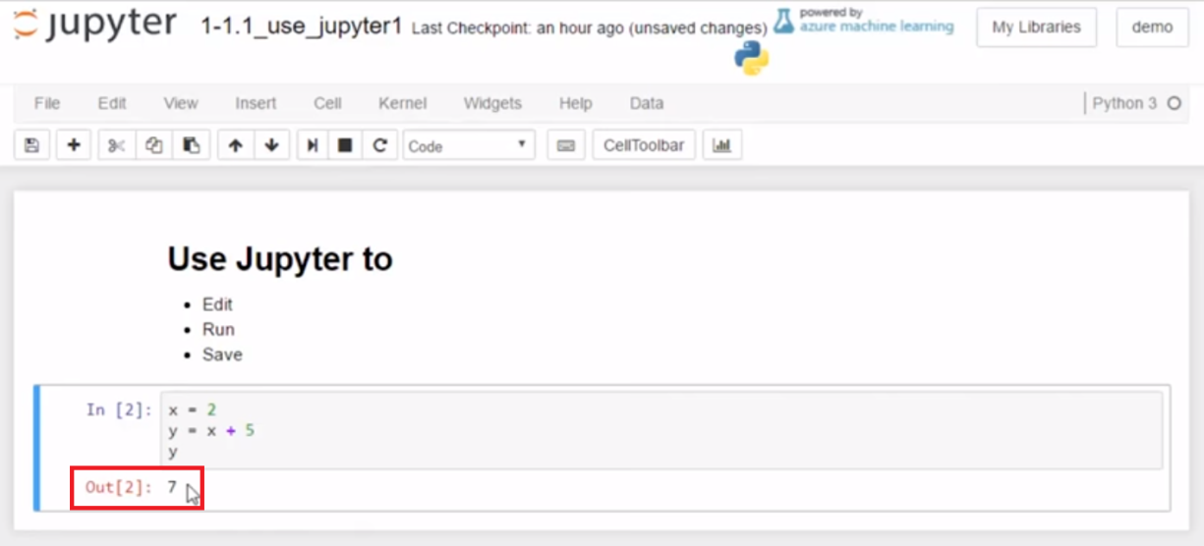

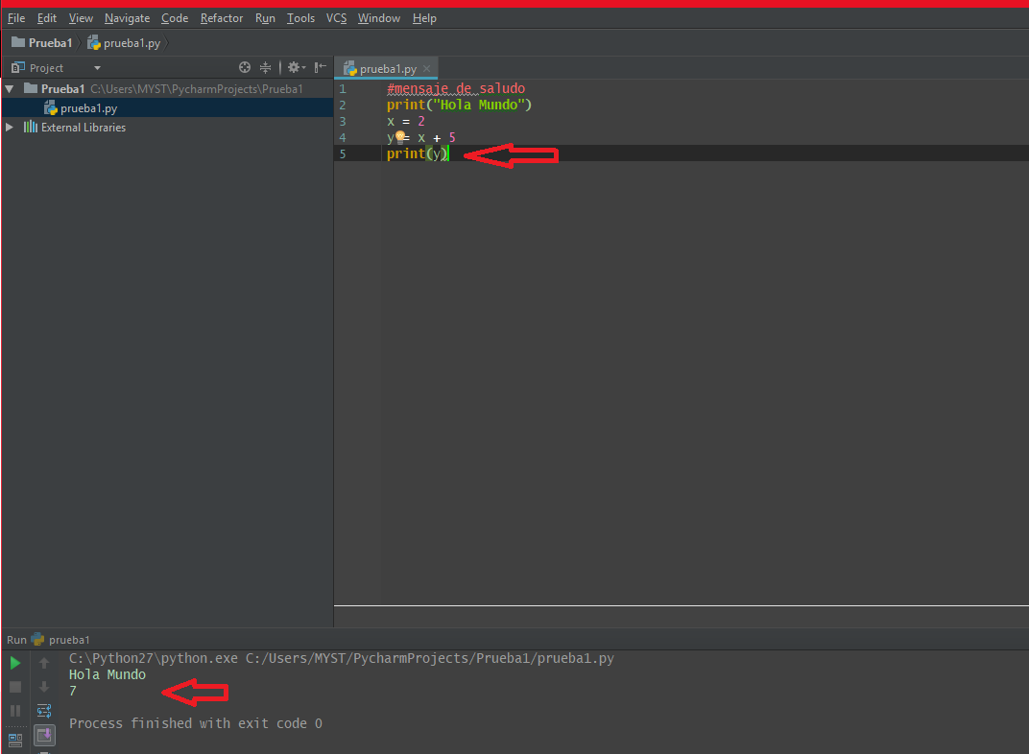

**I can edit again by highlighting it in there, and I can add more to the equation. So I'm gonna add 3 more to the value of y. So I'm gonna expect 10 to come out.** And I can hit Ctrl+Enter again to run it, or I can hit Shift+Enter. What Shift+Enter will do is move to the next cell, and if there's no cell below it will create a new cell. **So we see that the cell was run because the value changed from 7 to 10, and then I have a new cell.** And all new cells always default to a code cell, and our notebooks are still Python 3.

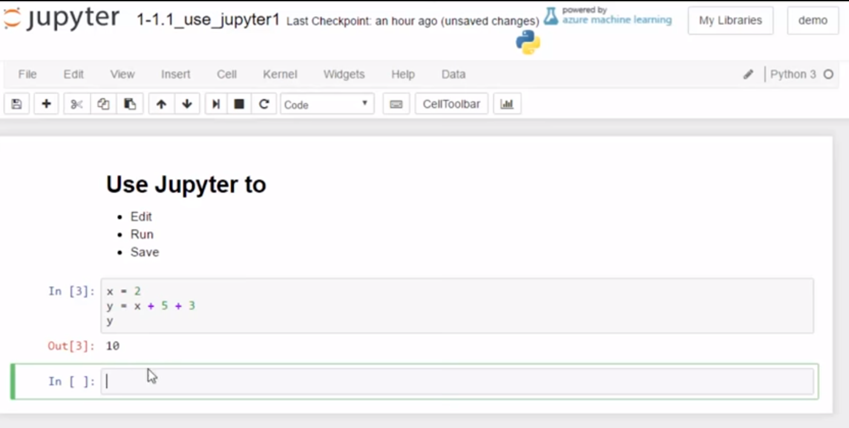

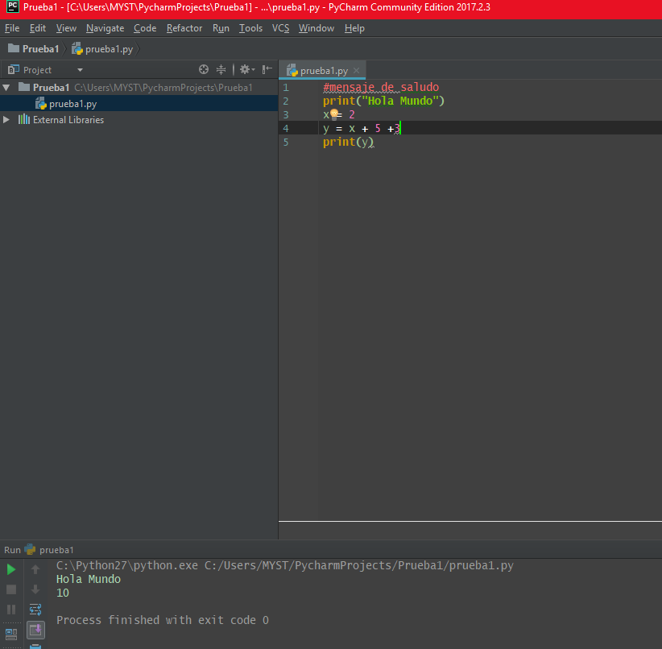

Now to save my work, there is a Save button right there that will save that. It says Save and have a checkpoint so that next time, when I open this notebook, it will still have the edited text that I put in right there and the new cell. So we learned how to edit just by typing within the box. All you need is the focus there to run using the menu, or we can use Ctrl+Enter, or we can use Shift+Enter, which we'll probably use the most because it will move us to the next cell. And then we can start working on the next cell and keep running them in order. And then to save we can push the Save button.

### edit mode

* **text** cells in editing mode show markdown code
* Markdown cells keep editing mode appearance until the cell is run
* **code** (python 3) cells in editing look the same after editing, but may show different run output
* clicking another cell moves the green highlight that indicates which cell has active editing focus

### cells need to be saved

* the notebook will frequently auto save
* **best practice** is to manually save after editing a cell using **"Ctrl + S"** or alternatively, **Menu: File > Save and Checkpoint**

**1.7 Altering Notebook Structure**

**Video:** **AlteringNotebookStructureV5.mp4**

Common tasks in using the Jupyter Notebook are to set the programming language, reset the kernel, and insert new cells. The first item of setting the programming language, we always want our notebook in a Python 3 state. Sometimes they can be in a different version of Python, such as Python 2 and we see right there that I have it in Python 2.

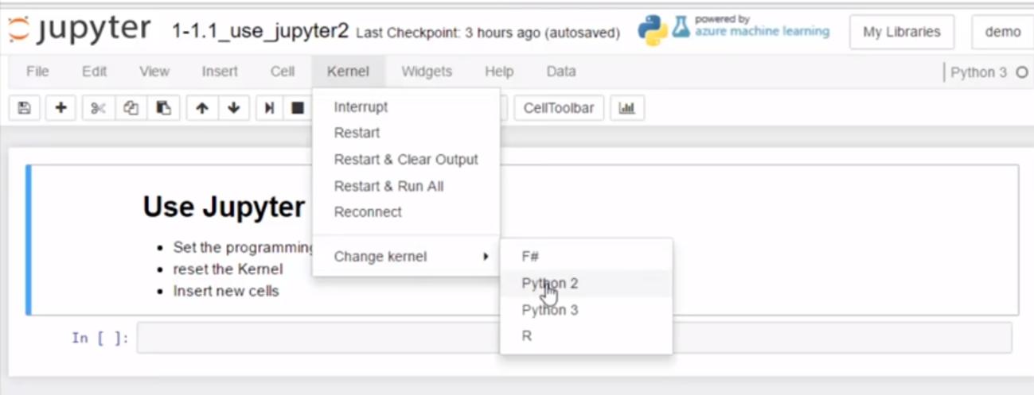

And what I did to change that is the same thing we're gonna do to get in into Python 3, which is go to the kernel tab, which is the operating system that runs this Jupyter notebook. Hit Change kernel, and then choose Python 3.

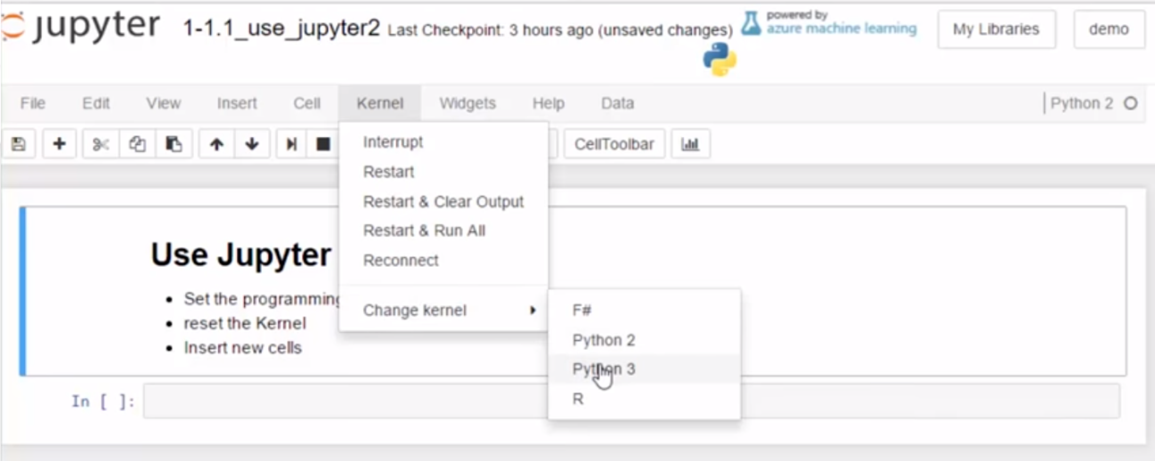

**Another common issue with a Jupyter notebook is you might write some code and it puts the notebook in an unstable state. Either the browser will become frozen or the code just is running too long and will not finish.** **So we reset the kernel, so again we're gonna go to the Kernel menu up there, and we're gonna either hit Restart or often you're gonna hit Restart and Clear Output. And what Clear Output will do is put all of the previously run code to a starting point so that there is no variables in memory.** So I'm just gonna go ahead and push Restart there to show that and then it asks for confirmation. Sometimes it will also ask you if you are ready to restart again after it has to force something to shutdown.

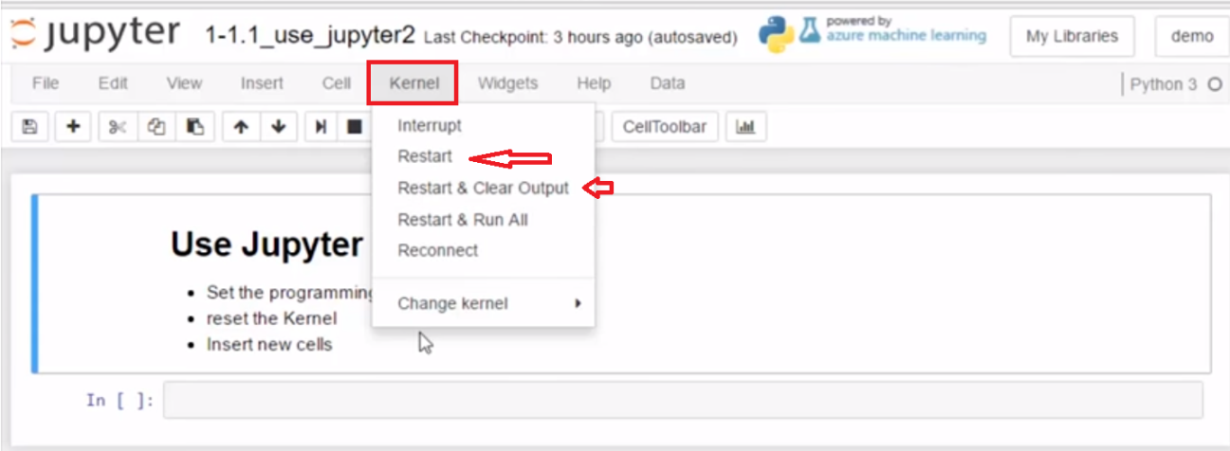

The last item we saw previously is inserting new cells. So, to insert a new cell we know that we can push both Shift + Enter at the same time. If it is the last cell, it will add a cell at the bottom,

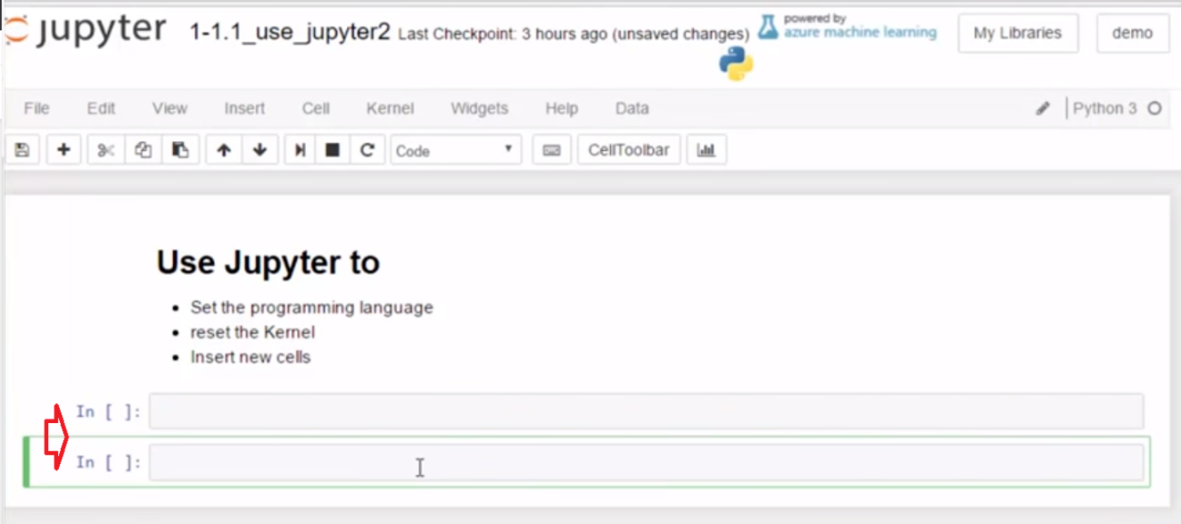

but if you're in a middle cell, if you hit Shift+Enter, it just runs the cell and then moves to the next cell. And we may want to have a cell where I have x set up here and I have z with a variable over there and I go,

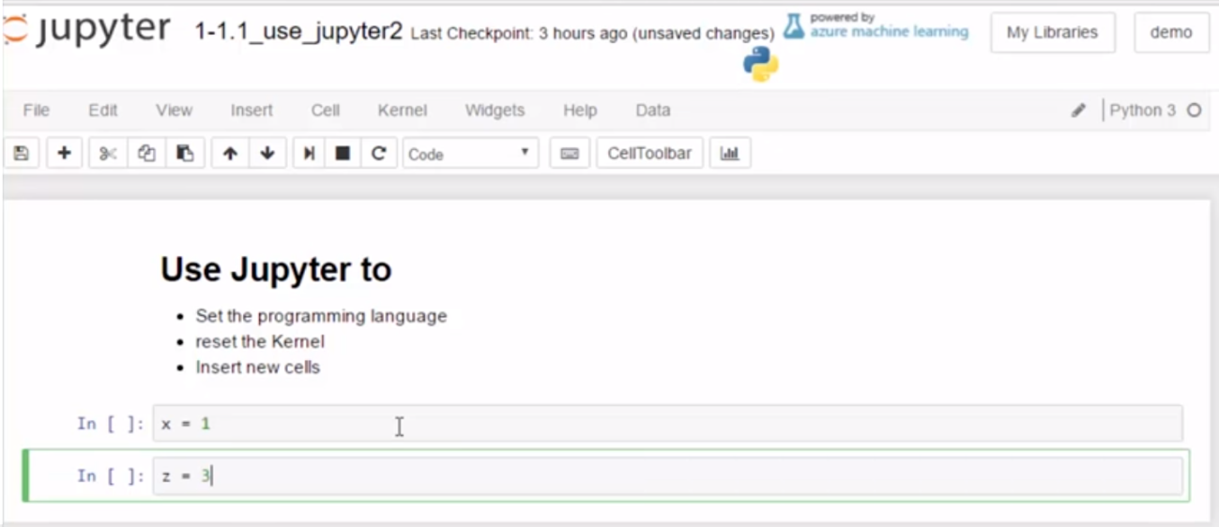

I forgot y and so, I wanna insert a cell. Well there is the Insert menu and I can insert a cell above or below. In this case, I'll do below

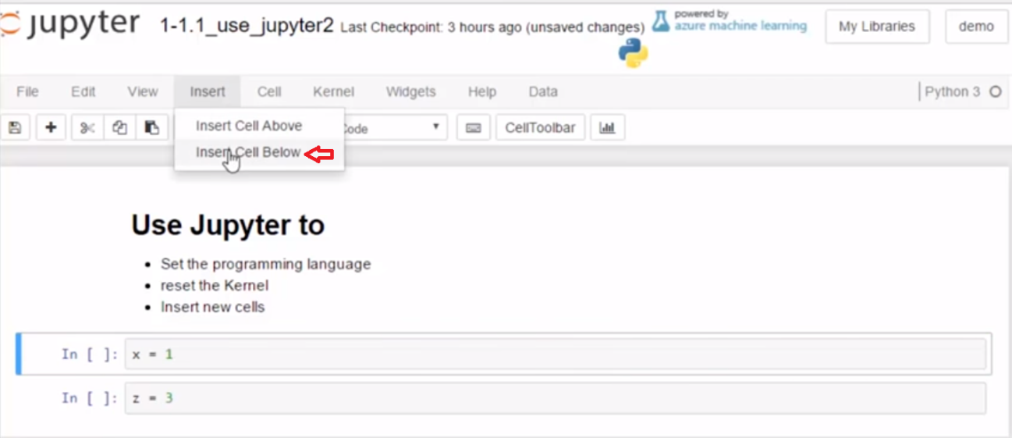

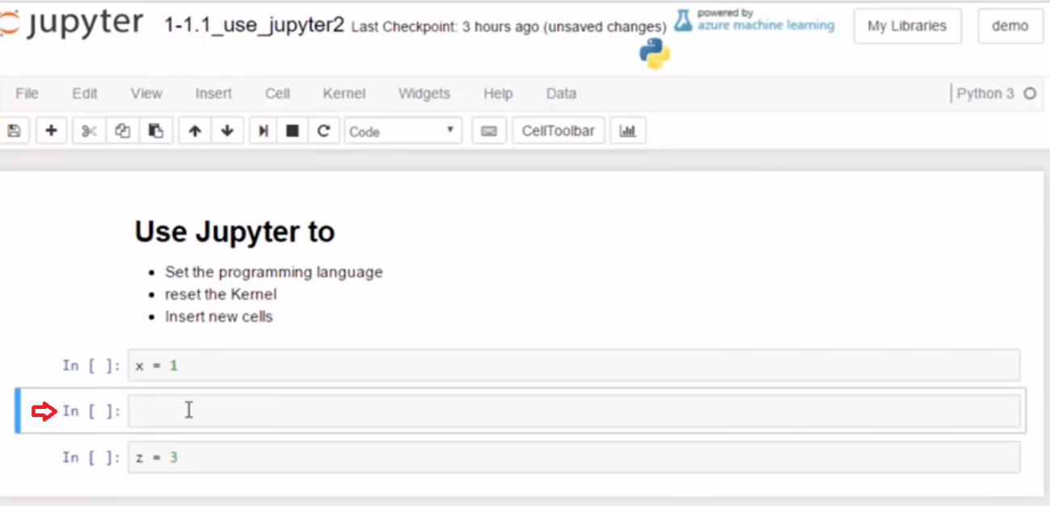

and then I can put my y value in there and I can insert a cell.

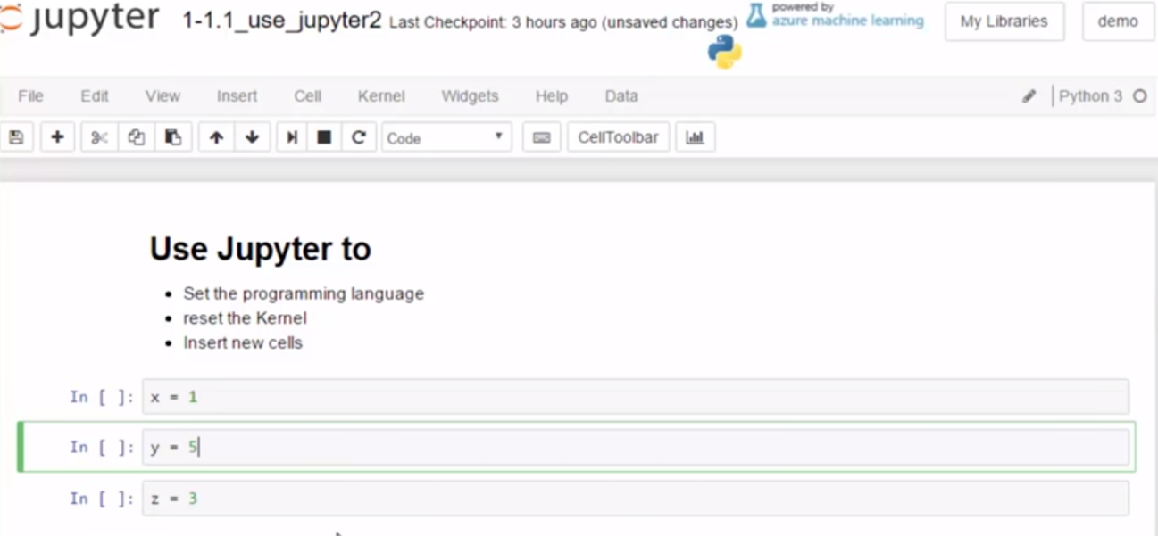

So we saw we can change the programming language from the Kernel tab. With Change kernel, we can also restart and restart and clear all the output using the Kernel tab and we can insert new cells using the Insert menu and insert either above or below.

# Concepts

## Altering Notebook Structure

### add a cell

* Highlight any cell and then... add a new cell using **Menu: Insert > Insert Cell Below** or **Insert Cell Above**
* Add with Keyboard Shortcut: **"ESC + A"** to insert above or **"ESC + B"** to insert below

### choose cell type

* Format cells as Markdown or Code via the toolbar dropdown or **Menu: Cell > Cell Type > Code** or **Markdown**
* Cells default to Code when created but can be reformatted from code to Markdown and vice versa

### change notebook page language

* The course uses Python 3 but Jupyter Notebooks can be in Python 2 or 3 (and a language called R)
* To change a notebook to Python 3 go to **"Menu: Kernel > Change Kernel> Python 3"**

# Task 2

## Insert a new cell

* Insert a new Code cell below with a comment describing the task
* edit cell: add print() with the message "after edit, save!"
* run the cell

### Insert another new cell

* Insert a new Code cell below
* edit cell: add print() with the message showing the keyboard Shortcut to save **Ctrl + s**
* run the cell

**1.8 Self-Check: Module 1 Section 1**

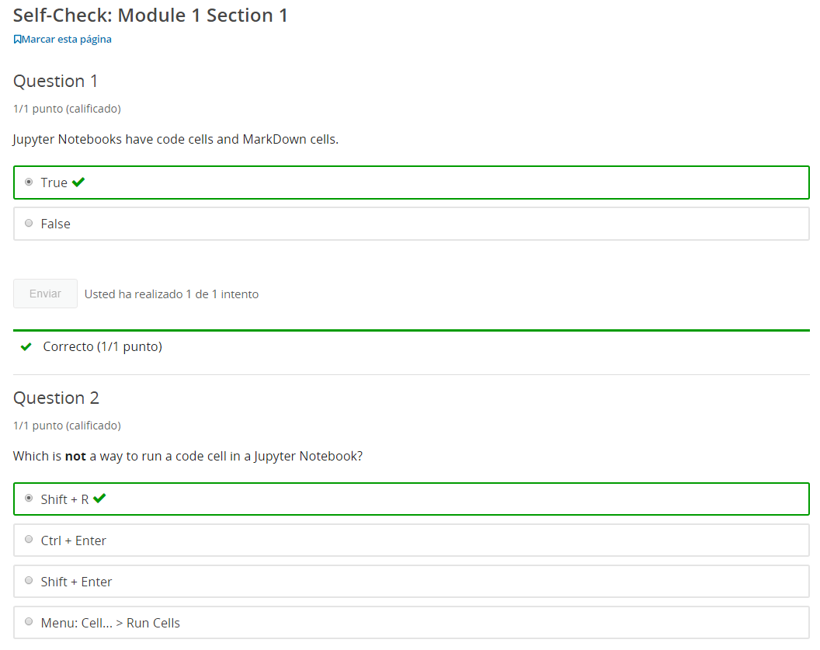

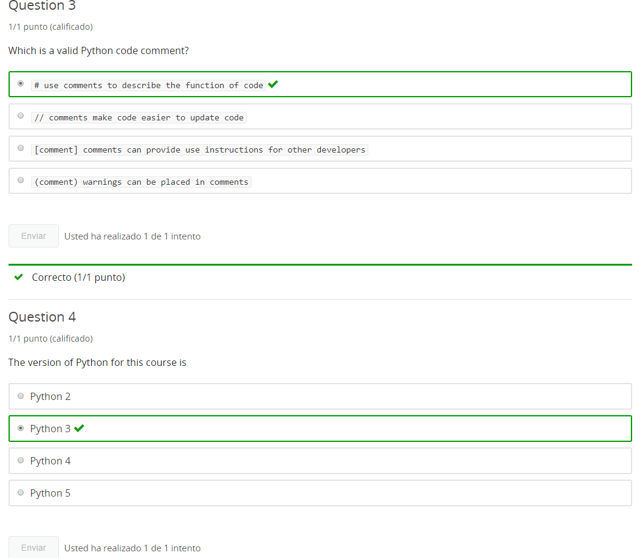

**2. Types & Variables**

**2.1 Intro Python**

Jupyter Notebook: MOD01_1-1.2_Intro_Python.ipynb

Getting started with Python in Jupyter Notebooks

* Python 3 in Jupyter notebooks
* print()
* Comments
* **data types basics**
* **variables**
* addition with Strings and Integers
* Errors
* character art

Student will be able to

* use Python 3 in Jupyter notebooks
* **write working code using print() and # comments**

**2.2 What is a string**

**Video:** **WhatIsStringV6.mp4**

We've worked with some strings printing, and now let's talk a little bit more what a string is. So a string, is just a sequence of characters, and so that just means one or more characters. And the characters are just the keyboard characters, for the most part. So case a through z, lowercase a through z, as well as the digits 0 through 9, and a variety of punctuation and characters and just any of the symbols that we see. **We can add some more in there, but basically, all of these pieces that we see in our keyboard, those are all valid characters.** And we can also have characters that we'll see later how to do that are not printable, such as a new line character as well. And so we can echo that to the screen by running, because the characters are in our quotes. Just like we did with the print statement earlier, we could show our string.

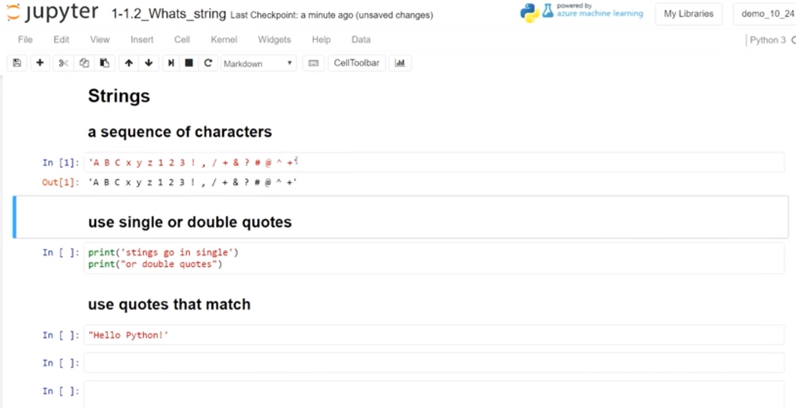

So, again, the rules are single quotes matching, so this starts and ends with single quotes and, or double quotes matching, start or end with a double quote. Just run that, and so that runs nicely.

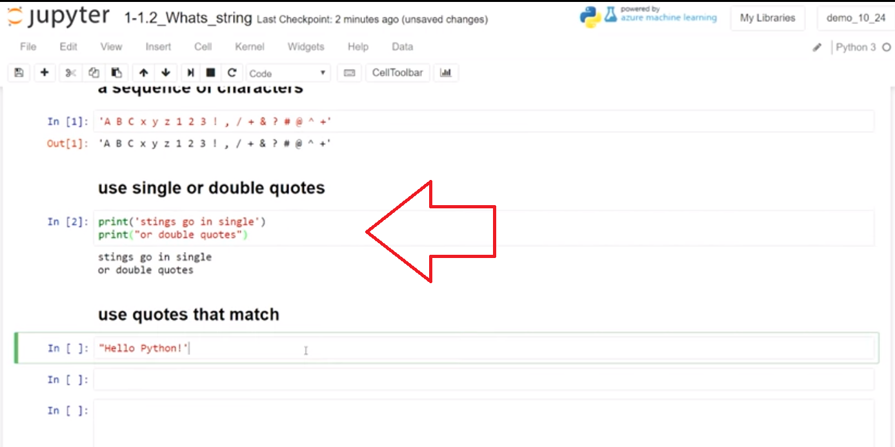

**If we don't match our quotes, we can see how that looks, so it tells us we have a SyntaxError. And that's just telling us that we have not used proper Python formatting on the way that we use a string.**

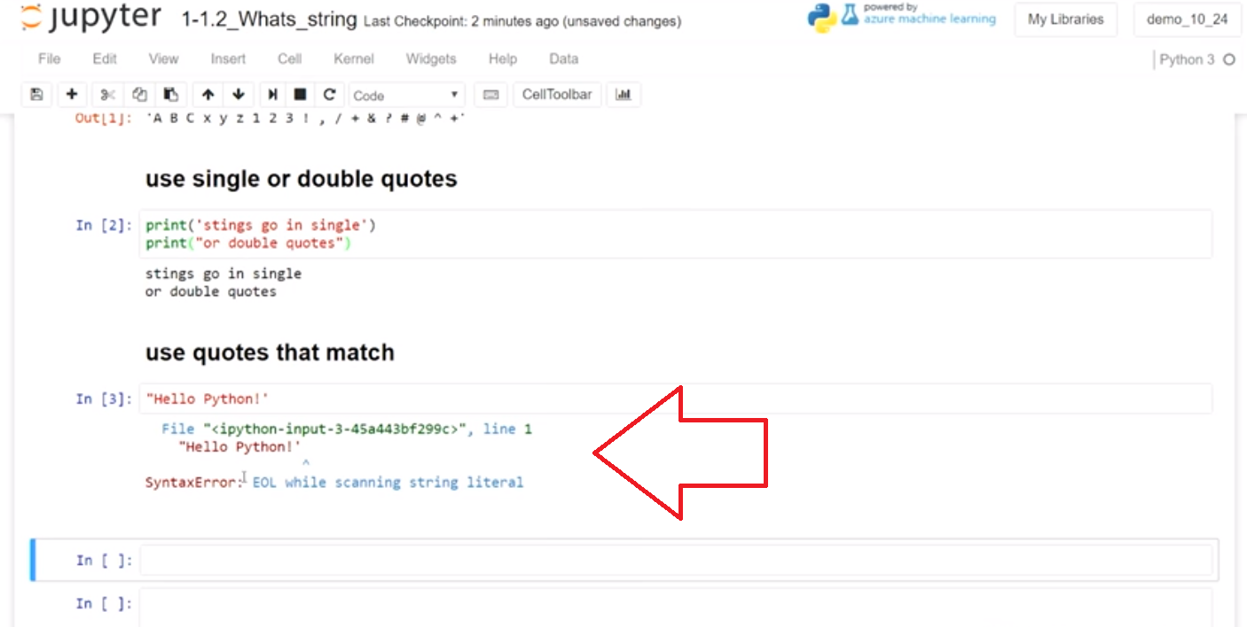

And so, because it starts with a double quote and ends with a single quote, we have to match those. I could either make them both single or both double. And then I will make them both double, maybe not with so many returns. And then that will work right there.

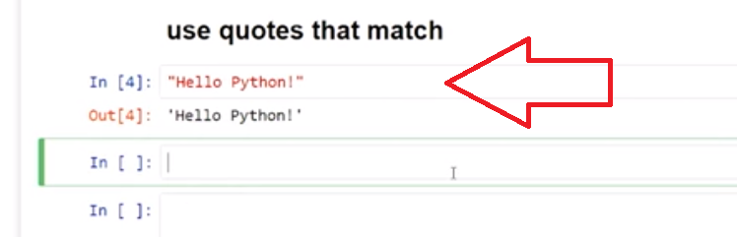

So we see, in working with strings, that they are a sequence of characters, so one or more character. And that the characters have to be in matching quotes, double quotes or single quotes.

Concept: Strings

What is a **String?**

Strings were used in "Hello World!" print function examples. Strings are sets of characters. In Python strings are in double or single quotes like "Hello World!" or 'after edit, save!'

A String is a common **type** of data, used in programming, consisting of a sequence of 1 or more characters.

* **A String is a sequence of characters** (aka: a *string* of characters)
  + Character examples: A, B, C, a, b, c, 1, 2, 3, !, &
* A String in python is contained in quotes, single(') or double(")
  + String examples: "ABC", 'Joana Dias', 'I have 2 pet cats.', "item #3 cost $3.29 USD"

**Note:** the quotes containing a string must come in matched pairs

* + "Hello" or 'Hello' are correctly formatted strings
  + "Hello' is incorrectly formatted starting with double " and ending with single ' python needs a matching quote to know where the string ends

Example

# examples of printing strings with single and double quotes

print('strings go in single')

print("or double quotes")

Task 1

print messages with "double quotes" and 'single' quotes

# [ ] enter a string in the print() function using single quotes

# [ ] enter a string in the print() function using double quotes

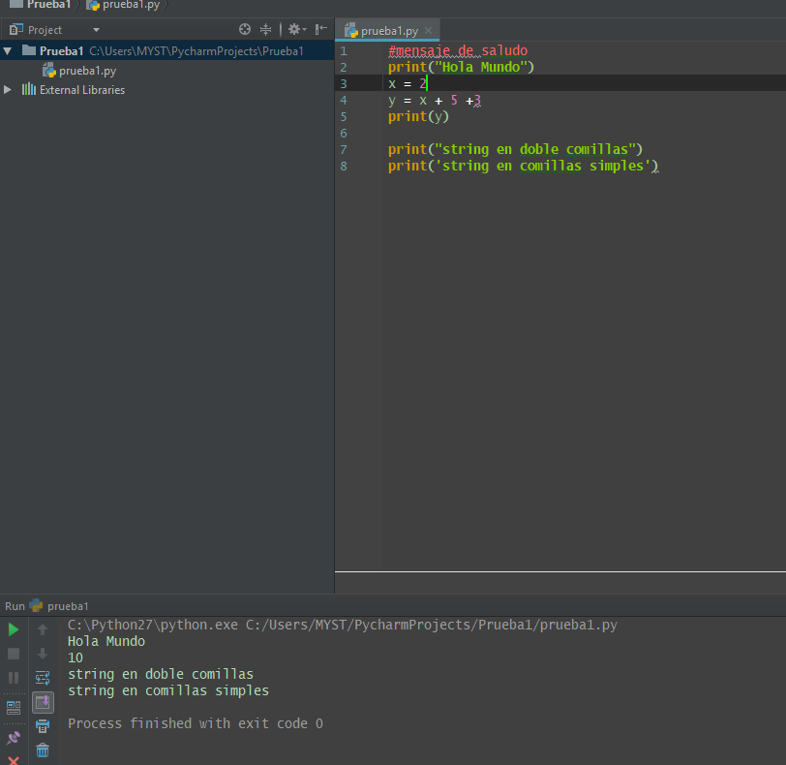

**2.3 Integers**

**Video:** **IntegersV7.mp4**

Let's talk about integers. Integers are a data type. They are a type of information that is numbers and we use these just like we do in normal mathematics. So the counting numbers, positive or negative, zero included, and let's contrast those to the strings we just learned about. Strings are characters which include the A through Z characters and digits zero through nine. But the difference is a string is just a representation of a picture of that number. It's the representation of the shape of the number three, versus the actual integer number three as something that we can do mathematical operations with.

And so the difference between the two is quotes and not quotes. So we see that the string number representation here, this would be the same as -123, but it's a negative character and then the 1 and 2 and 3 digit characters. And so we can echo that to the screen and we see the -123. And a integer has no quotes, and we can echo that as well. And notice that the quotes do not echo in the integer right there.

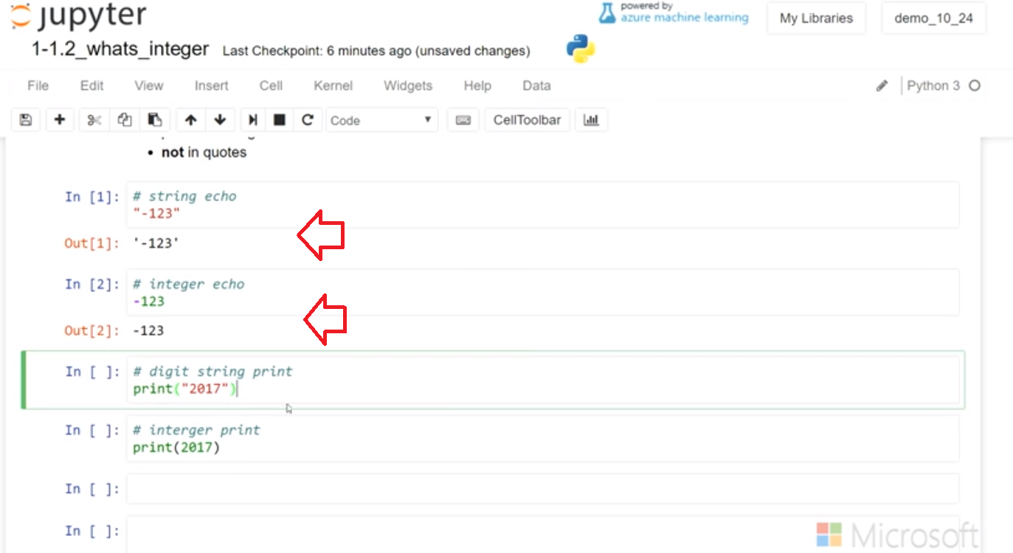

In the print statement, we have a little bit different behavior for strings and for number integers. So let's go ahead and print that and we see it prints without the quotes because that's the behavior of the print statement. The print statement is also able to decipher numbers, and in this case an integer number, 2017. And it can echo it as well.

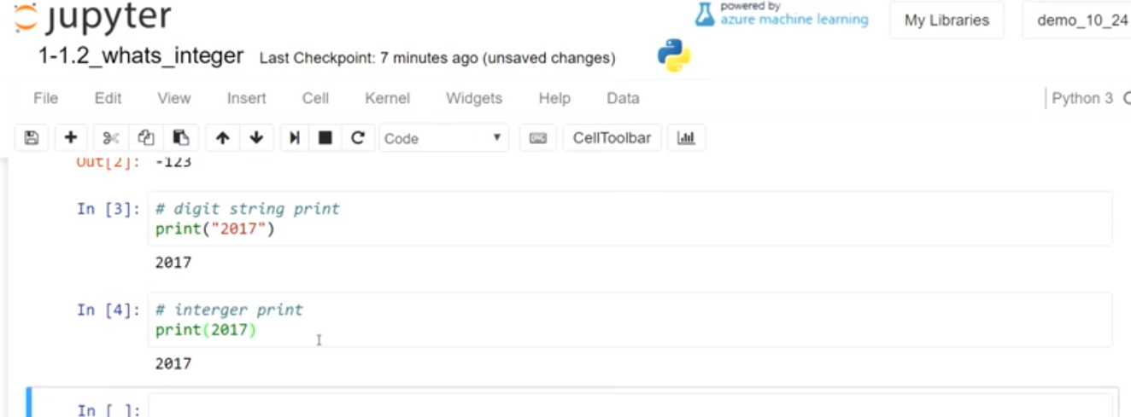

It can also echo a negative number.

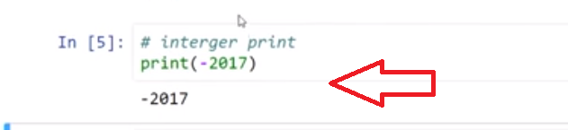

The difference here is the quotes. This makes it a string. So I can add a letter in with that because it's a string. If I put a letter into here, it no longer makes sense to Python and it causes an error.

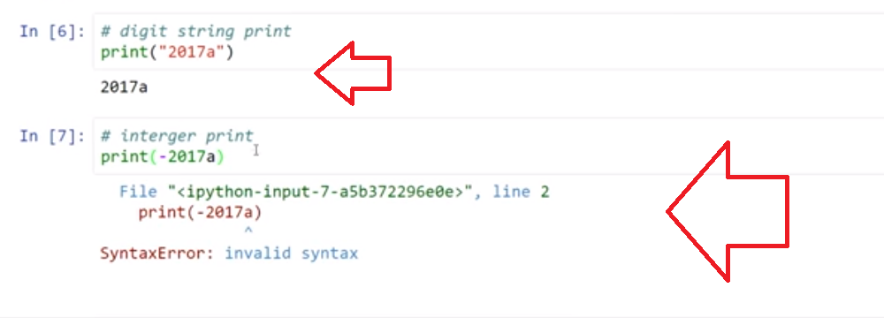

Integers are the counting numbers, both positive and negative, and include zero. If you put them in quotes, that'd be a string**. So we don't use strings with our integers. Just put on the number, no quotes.**

Concept: Integers

Integers are another type

* whole numbers such as -2, -1, 0, 1, 2, 3 are Integers
* Integers are **not placed in quotes**

A String can contain any character, this includes letters, spaces, punctuation, number digits and formatting. In a string with digits ("123") the digits are text images rather than representations of numeric values.

**remember** a line of python code starting with the pound or hash symbol (**#**) indicates a **comment** comments are for humans to read and are not run by computers.

Example

# printing an Integer with python

print(299)

# printing a string made of Integer (number) characters with python

print("2017")

Task 2

* **print Integers**
* **print strings made of Integer characters**

# [ ] print an Integer

# [ ] print a strings made of Integer characters

**Student Tip:** look for **[ ]** , which indicates a task in the notebook needs to be completed.  
Edit and Run to complete the task.

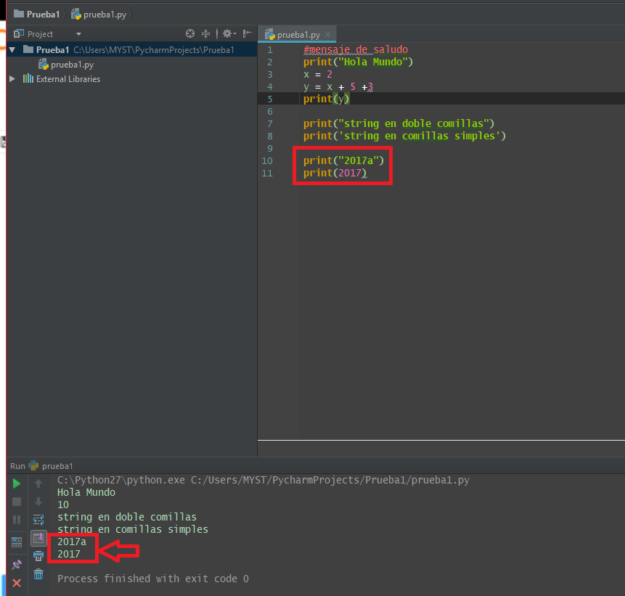

**2.4 Variables (Variables & Storing Strings in Variables)**

**Video:** **VariablesV8.mp4**

A variable is just a container. It's a name storage location that holds an object. You might have used variables in math and you think of x equals five or other equations that have variables. It's similar in Python. With Python, we use variables so that we can re-use code and we can assign different values to the variable.

**So in Python, we use very simple** **names. As we show here, for a student_name that would be a good example of a variable. It's descriptive, we use lower case and we connect it with an underscore.** Variables can also be assigned strings not just numbers like in math. And *if we run that cell, we don't get an echo but what we've done is we've assigned this storage location*, which has a student name with a string of the student's name, that's in quotes. Then we can call back on that variable and we see that it will echo below.

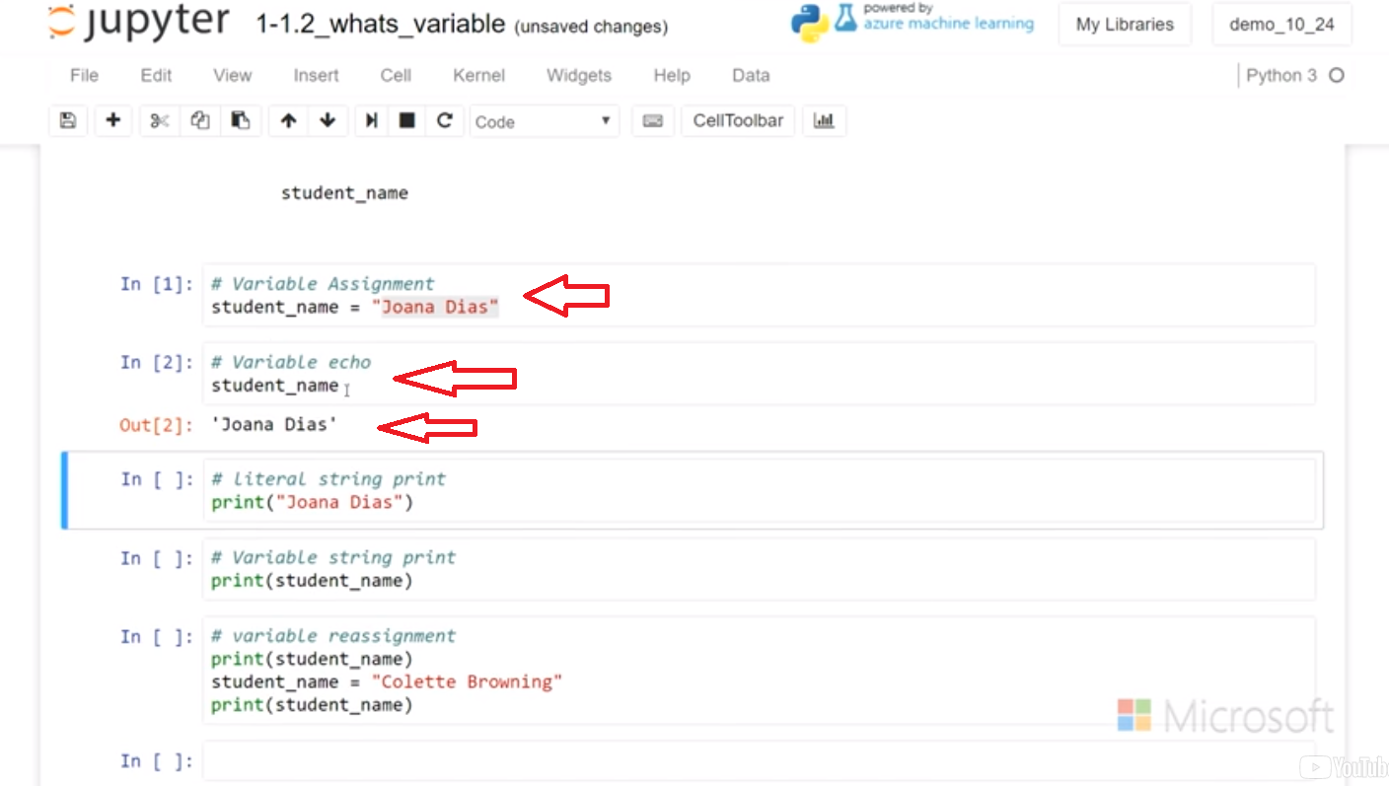

We can also print the literal string as we did in earlier assignments. But through using a variable I can automate that. And I can have a different student name going through this print statement each time, where other code can change the value of student name. So, what would that look like? Well we call that variable reassignment. And we see the example below, the first time that print ran, it had the student name of Joana. Then, we reassigned the variable with Colette, and when we print it again, Colette prints. >>

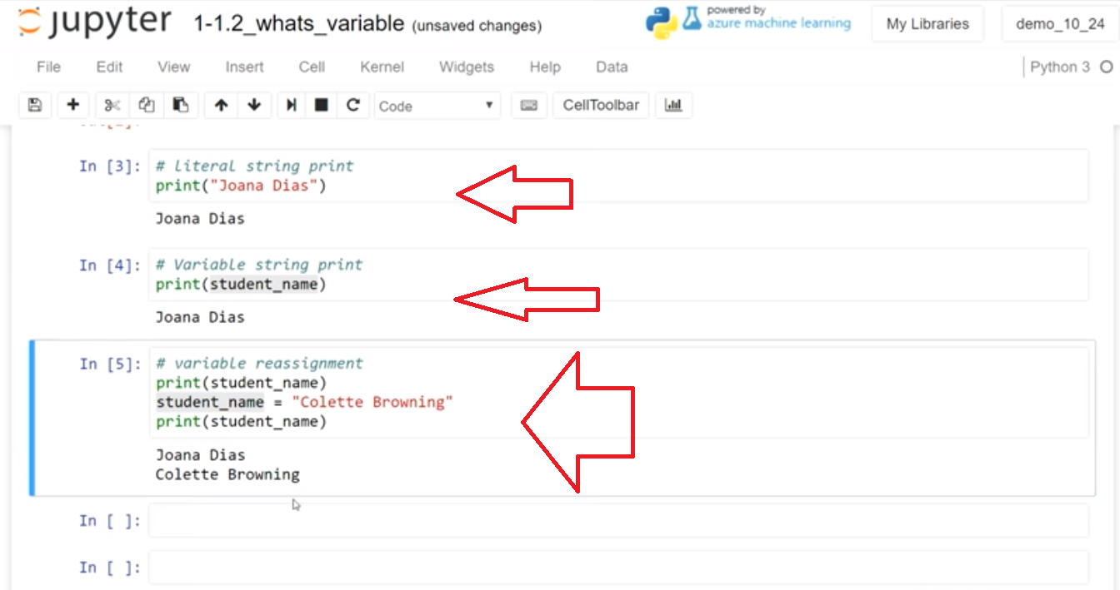

**If we go back up to the top, we can rerun the cell and reinitialize the variable. And then we can check the further value now in student_name. Now it is Joana**

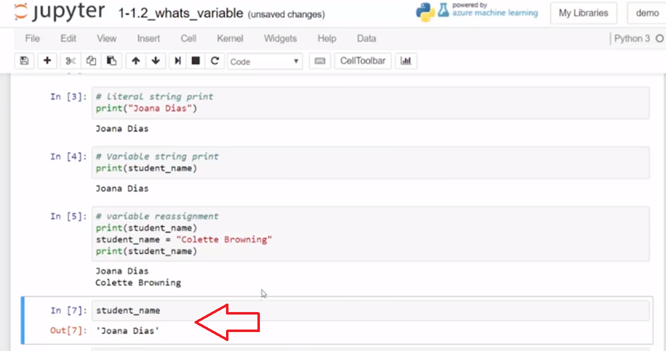

**and we can see that if I re-run this previous cell and then rerun the student_name again, it will change back to Colette. >>**

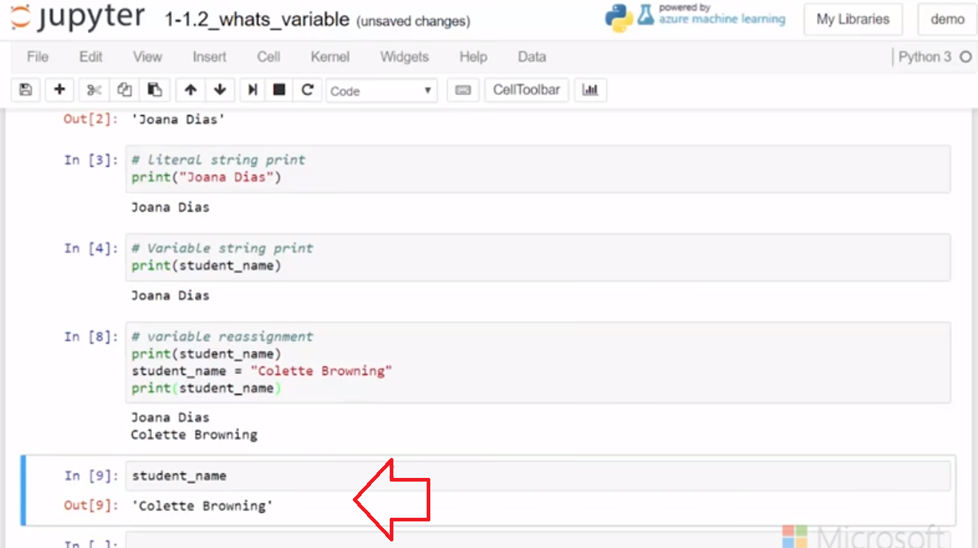

So, a variable is a name storage address that we can use in our code, just the same we do as a literal string or number or other objects we'll see later. A variable means change as well, so remember we can reuse that variable within our code and make it more efficient.

# Concepts: Variables

## Variables & Storing Strings in ****Variables****

### Variables are named containers

Computer programs often create storage for things that are used in repeated processing like item_price, student_name, stock_symbol. In python a variable is a type of **object** that can be addressed by name to access the assigned contents.

#### Name a variable staring with a letter or underscore "_"

There are different styles for creating variables this course uses lowercase descriptive names connected by underscores:

* item_price
* student_name
* stock_symbol

descriptive names reduce the need for comments in the code and make it easier to share code or read code written long ago

### Variables can hold strings

once a variable is **assigned**:

**current_msg = "I am a string"**

a python program can refer to the variable,   **current_msg**,   in code  
so that  **current_msg**, can be used like the string value  (**"I am a string"**)   which it stores

### Variable reassignment

We can reassign a variable, changing the contents. **current_msg = "new current message"**

### Variables can be used in place of literals

If we initialize **current_msg = "new current message"** then  
the literal string **"new current message"** and the variable **current_msg** are the same when used in code

# Example

* **Initializing variables**
* **literals & variables** in printing
* **Variable reassignment**

# [ ] Review code and Run

# initialize the variable

current_msg = "I am a string"

# print literal string

print("I am a string")

# print variable string

print(current_msg)

# [ ] Review code and Run

# assign a new string to the current_msg

current_msg = "Run this cell using Ctrl+Enter"

print(current_msg)

# Task 3

## Program: assigning values to a string

* in the cell below
  + print the variable current_msg
  + assign a new string to current_msg
  + print the variable current_msg again
* run the code cell above and then run the cell below

# { ] run cell above then run this cell after completing the code as directed

**Q?:** In the cell above, why did the variable have a value to print before it was assigned?

Jupyter notebooks run cells individually. Any cell in the notebook can access a variable assigned from a cell that has been run in the current notebook session.

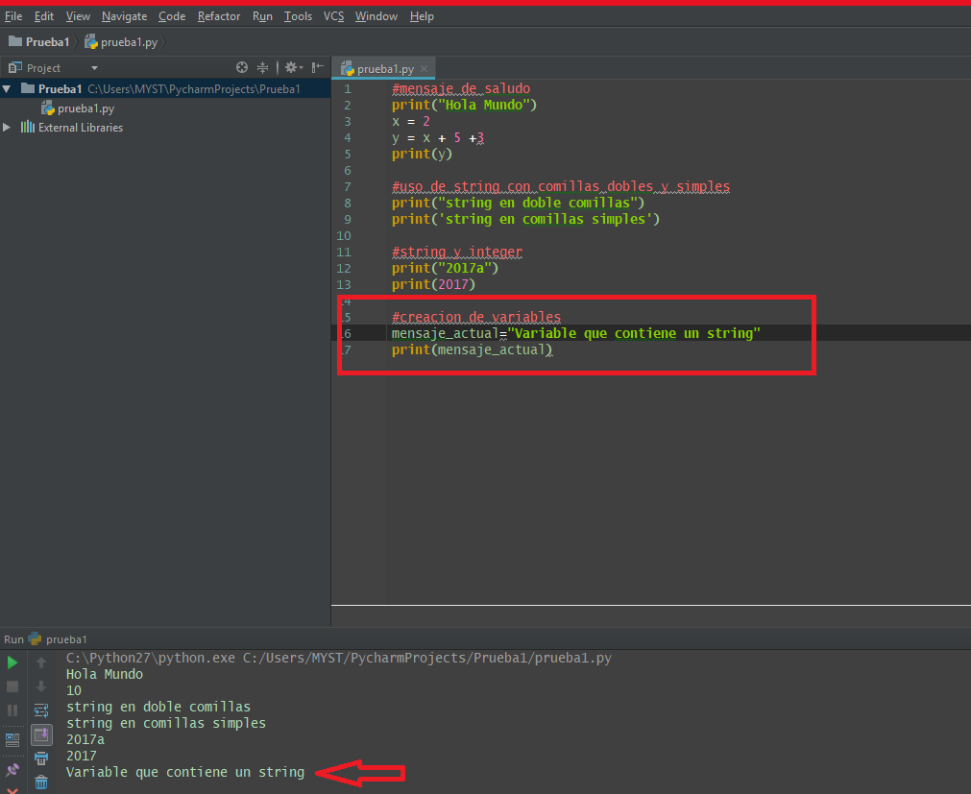

**2.5 Data Types in variables**

**Video:** **DataTypesV9.mp4**

We've learned about variables and data types for string and integer. **Let's see a little bit about the behavior**, the way they work together. **Let's start with a string data type again. So we're gonna assign student variable to the string name.** We can echo that on the screen to see what is in student and that will show below. And that's a string, it's got quotes on it.

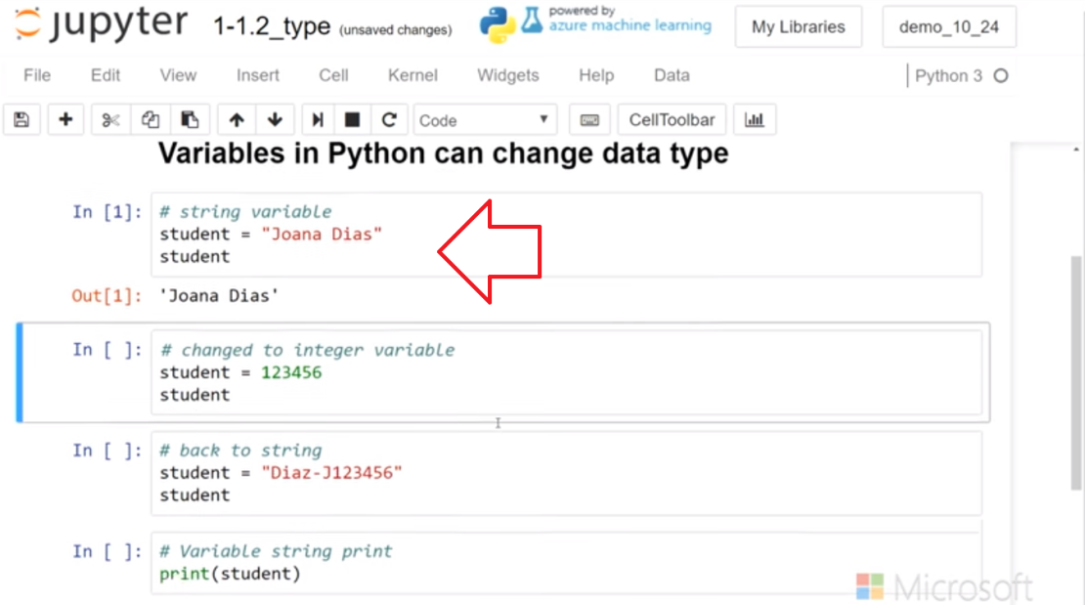

**It's got letters that are strings, so we are gonna go over here again and change student. So, maybe student might be some type of id number. And so I'm gonna change this to 123456, and then let's see how that echoes to the screen. And so now I've changed student, not just reassigned the data, but reassigned the data type. We started with a string and now we have an integer.** **So, this is not something you can do in every language, but Python allows your variables to change data type.** And that's important to know, it can be very useful and it can be something that you'll need to pay attention to because it can cause problems. If you intended this to be a string and you somehow left it as the number, it might still continue to run as an integer.

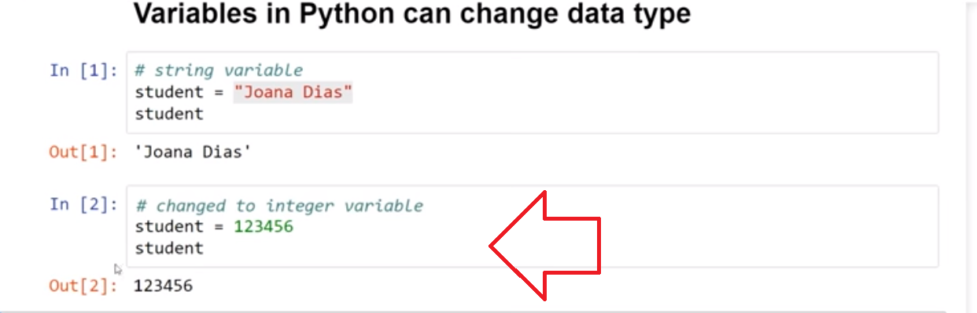

So let's change it back to a string and this is a string, again, a different type of ID that has the last name and some numbers in there as well. But it's all string because it's in the quotes. So we run that and so that's legal to run that way too and of course I can print that. Because it's a variable I can call it,

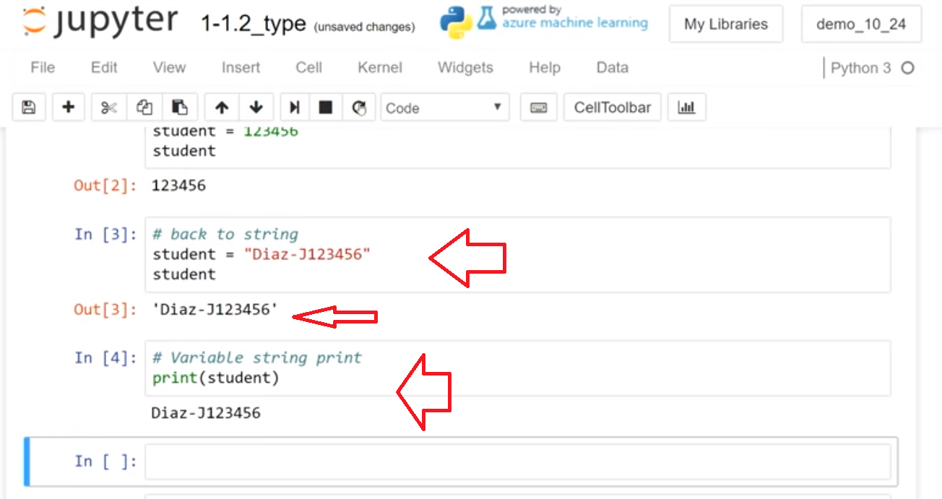

I could go back up and reassign it again. And so if I run this cell, now student should be 123456 and it's back to a number again.

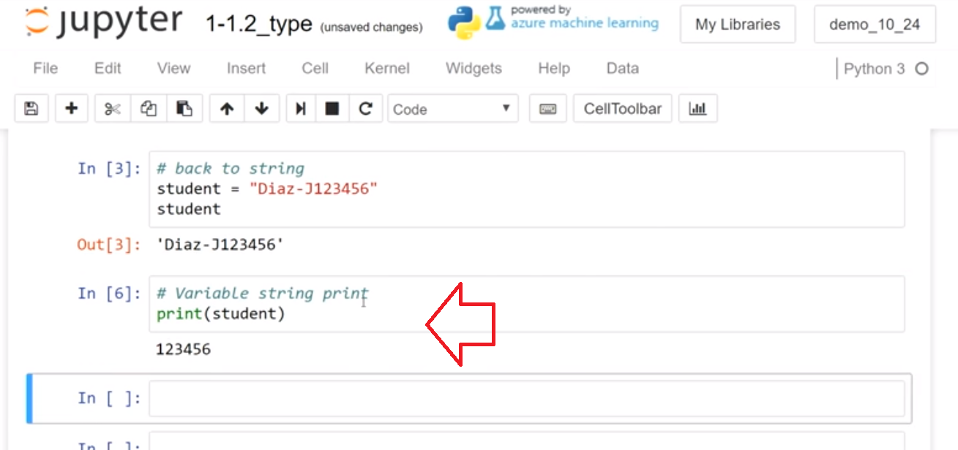

So we have learned about the two data types, string and integer. And that in Python, you can assign a variable to string an integer and change between the data types.

# Concepts: Data Types

## Data types in variables

variables can be initialized with different data types. Below we see item_price is a **decimal** (aka - float) and student_name is **string**

item_price = 10.25 #item_price initialized as a numeric value (no quotes)

student_name ="Dias, Joana" #student_name initialized as a string

license_plate = "123A" #license_plate initialized as a string

### Variables can start initialized as an Integer number data type

x = 22

here the Integer 22  value was assigned to the variable  **x**

### The type of data a variable holds can be changed, Python variables can change the ****type**** of data a variable holds

x = 22

x = "I am a string"

**x**  changed type from Integer  **x = 22**   to string  **x = "I am a string"**

| **Best Practice: Friendly Names** |
| --- |
| **Friendly name** examples, (item_price, student_name,license_plate), were used above. |

#### Variables help us to write code that can be used repeatedly

A personalized letter can be sent to every student with individual names by using a name in a variable. Let's start with printing a name based on string variable.

Create a variable, name, at the top of the next cell. Assign a string value to   name.

Remember to use the quotes for string values

# Examples

name = "Joana Dias"

print(name)

test_value = 22

print(test_value)

test_value = "Joana"

print(test_value)

# Task 4: multi-part

## Assign a variable and print the value

* assign a string value to a variable **student_name**
* print the value of variable **student_name**

# [ ] assign a string value to a variable student_name

# [ ] print the value of variable student_name

# Tasks 4 cont...

## modified the value of a variable

* assign the **student_name** variable a different string value (a different name)
* print the value of variable **student_name**
* assign and print a 3rd value to **student_name**

# [ ] assign the student_name variable a different string value (a different name)

# [ ] print the value of variable student_name

# [ ] assign a 3rd different string value, to the variable name

# [ ] print the value of variable name

# Tasks 4 cont...

## change variable type with reassignment

* assigning a value to a variable called **bucket**
* print the value of **bucket**
* assign an Integer value (no quotes) to the variable **bucket**
* print the value of **bucket**

# [ ] assigning a value to a variable called bucket

# [ ] print the value of bucket

# [ ] assign an Integer value (no quotes) to the variable bucket

# [ ] print the value of bucket

## Q?: What is the difference between 123 and '123'?

**A:** A String type **is not** a number, even if it is all numeric digits

* in Python code a number can be assigned to a variable: x = 31
* a string of digits can be assigned to the variable **id**  --> id = "001023"  the quotations, mean the number symbols should be stored in the variable as **type** string, meaning the digits "001023"  are treated as text

The **print()** function can print Integer or string values:

print(123) #integer, with numeric value

print("123") #string, represents text characters

# Tasks 4 cont...

* run the above code the next cell:

# [ ] print integer 123 number

# [ ] print string "123" number

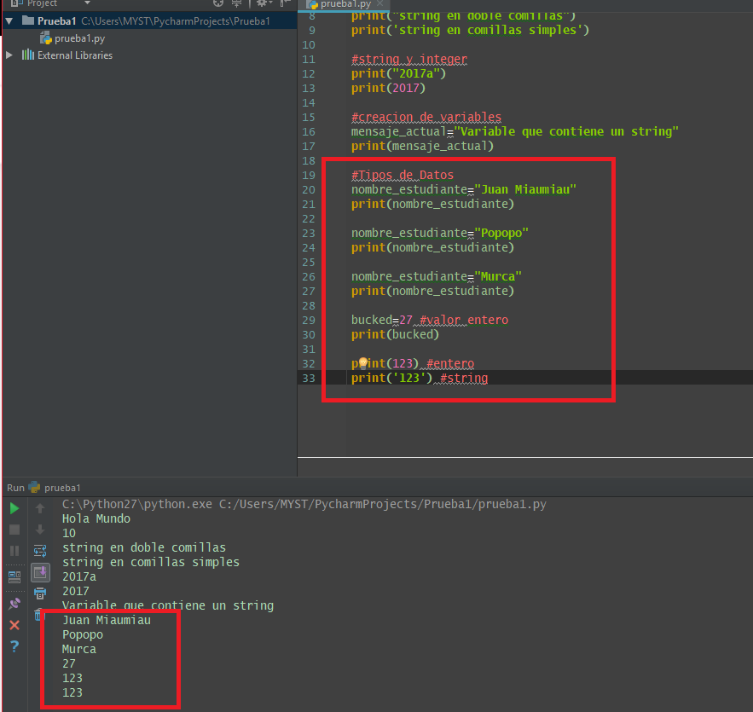

**2.6 Self-Check: Module 1 Section 2 (Evaluated)**

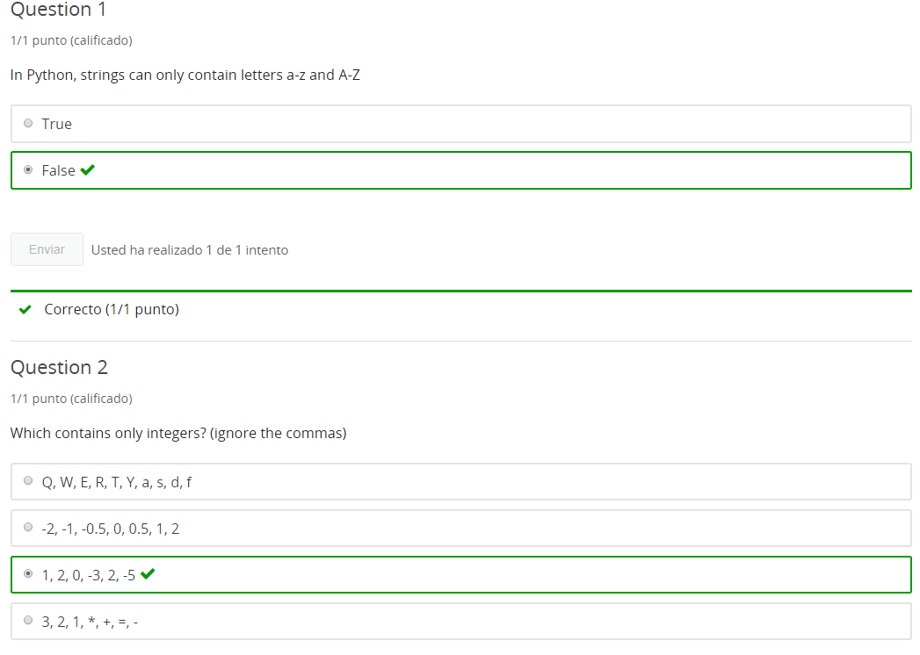

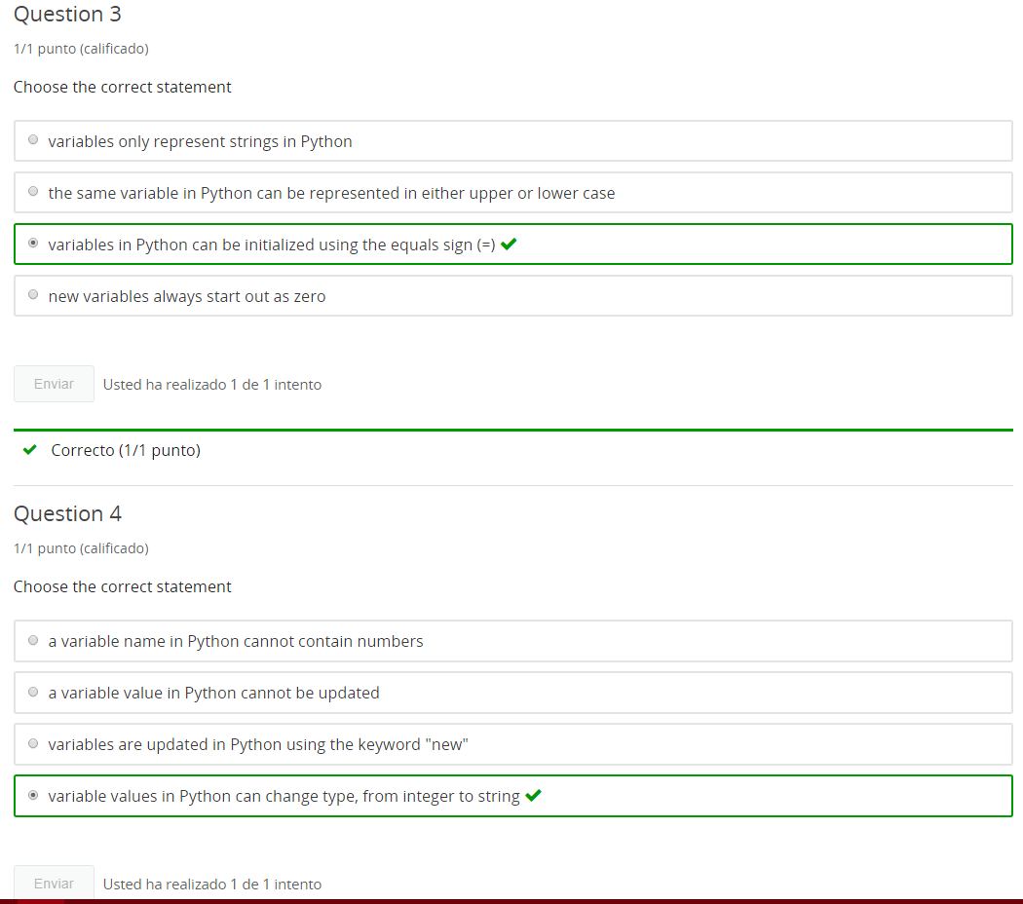

**3. Type Function**

**3.1 Intro Python**

Jupyter Notebook: MOD01_1-1.3_Intro_Python.ipynb

Getting started with Python in Jupyter Notebooks

* Python 3 in Jupyter notebooks
* print()
* comments
* **data types basics**
* **variables**
* addition with Strings and Integers
* Errors
* character art

Student will be able to

* **write working code using type() and variables**

**3.2 Concept Using type (Using the Python type() function)**

**Video:** **ConceptUsingType()V10.mp4**

We've talked about the data types for string and integer, now let's add in float and the type function so that we can programmably understand what type we're working with. So, the decimal in this literal number here, 3.14, makes this a float data type.

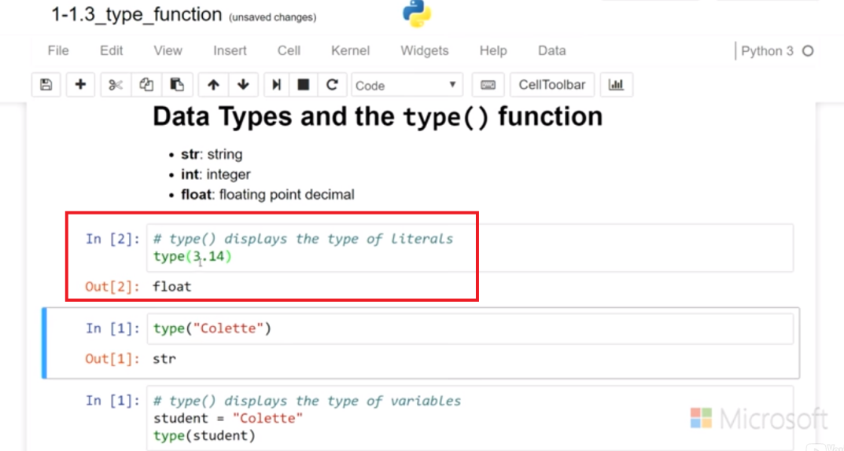

It's a floating decimal point and so any number with a decimal, it could have just all decimal is a float versus the counting numbers are gonna be the integer types. Now, what I did here is I put those into the type function and it returns the type of the variable.

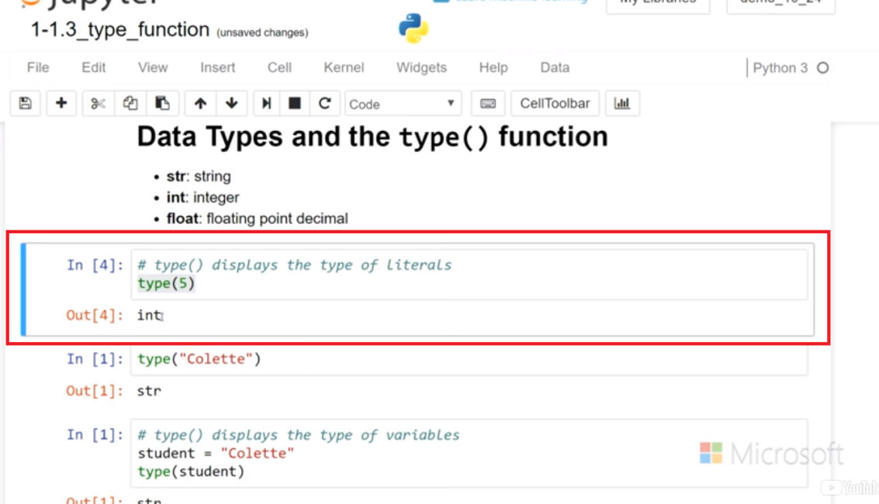

Right here, it is just echoing it to the screen and we could also just print that as well. When we print it, we get a little bit more information and it says it's a class int right there

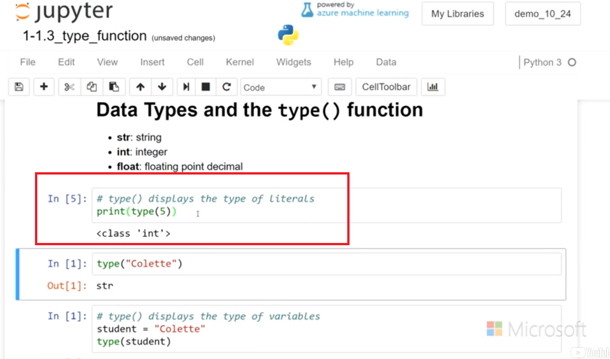

and if I add a decimal, then I get class float.

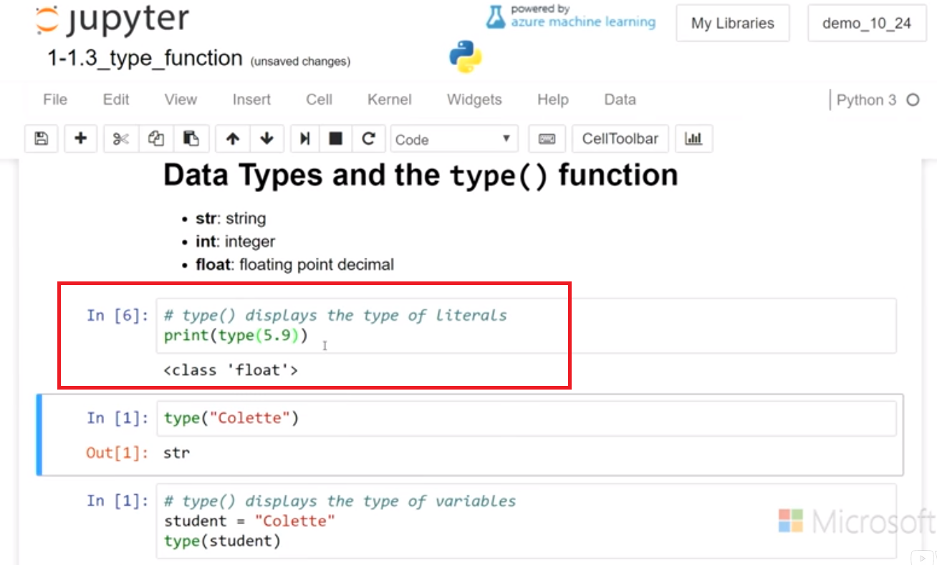

The type also will work for strings as we show below here.

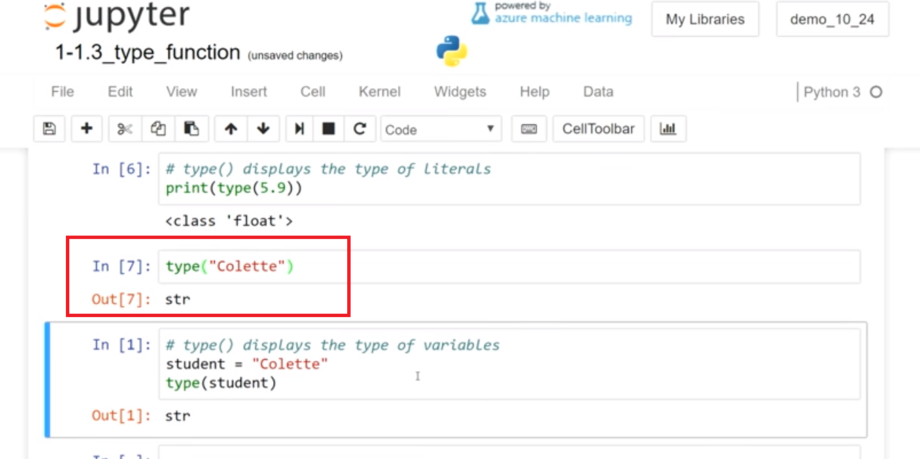

And it can also display in a variable, so if we assign student- "Colette" in here.

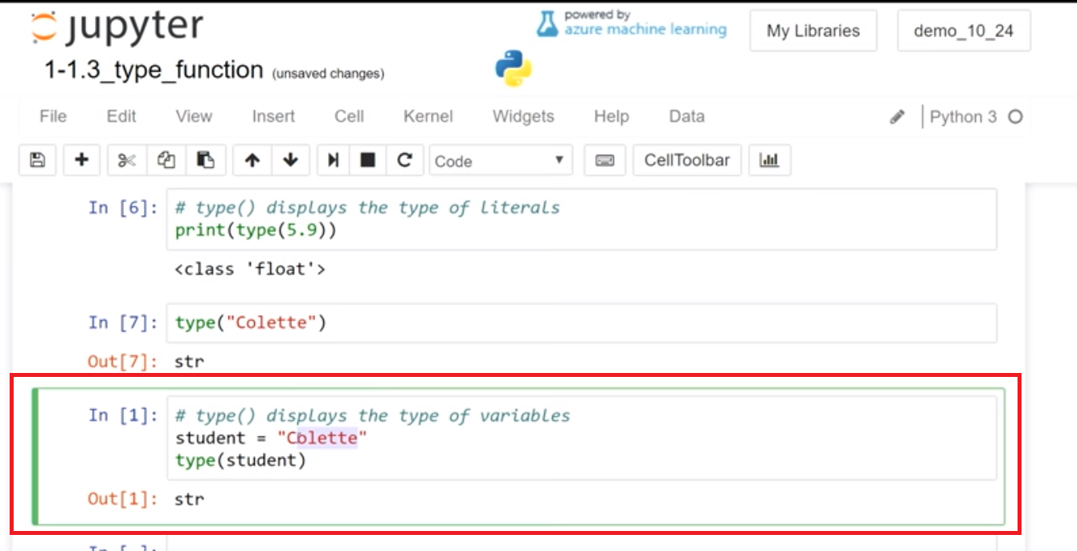

We should throw it's a string, but we can change that to the number again, student number, in quotes, it's gonna be a string.

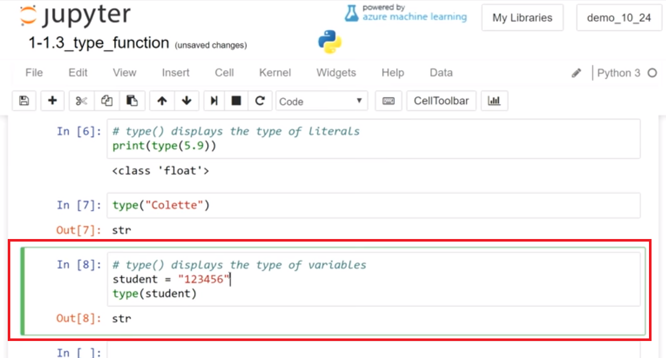

Without quotes, It's a integer.

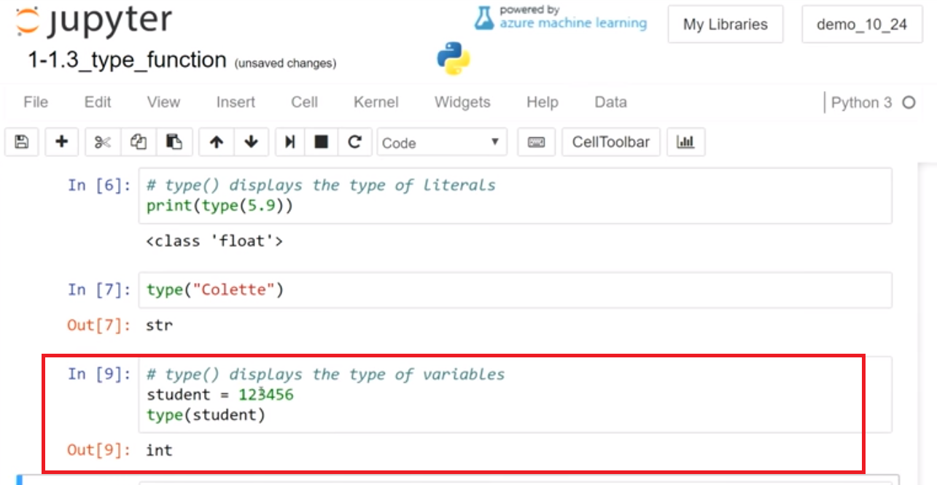

Even if it's the name it's gonna be a string again. So we learned about a new type, the float, which is floating decimal point. And that's any number with a decimal within it, a fractional number. **We also learned that the type function can help us return the type of a different variable or a literal type.**

# Concept: Using type()

## Using the Python type() function

**type()** returns the data type of Python objects

### str, int, float

#### What does using type() reveal?

* **str**: when **type()** returns **str** that means it has evaluated a **string** characters (numbers, letters, punctuation...) in quotes
* **int**: when **type()** returns **int** that means it has evaluated an **Integer** (+/- whole numbers)
* **float**: when **type()** returns **float** that means it has evaluated decimal numbers (e.g. 3.33, 0.01, 9.9999 and 3.0), ...more later in the course

# Example

* Read and run the code for each sample

# [ ] read and run the code

type("Hello World!")

type(501)

type(8.33333)

student_name = "Colette Browning"

type(student_name)

# Task 1: multi-part

## Using type()

* Complete the "identify data types" tasks by assigning values to the variable  **bucket** and using **type()**

# [ ] show the type after assigning bucket = a whole number value such as 16

# [ ] show the type after assigning bucket = a word in "double quotes"

# [ ] display the type of 'single quoting' (use single quotes)

# [ ] display the type of "double quoting" (use double quotes)

# [ ] display the type of "12" (use quotes)

# [ ] display the type of 12 (no quotes)

# [ ] display the type of -12 (no quotes)

# [ ] display the type of 12.0 (no quotes)

# [ ] display the type of 1.55

# [ ] find the type of the type(3) statement (no quotes) - just for fun

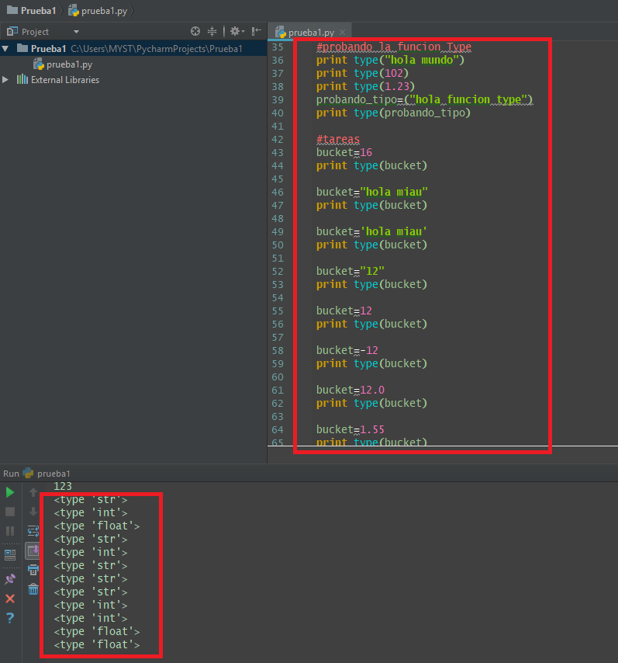

**3.3 Self-Check: Module 1 Section 3 (Evaluated)**

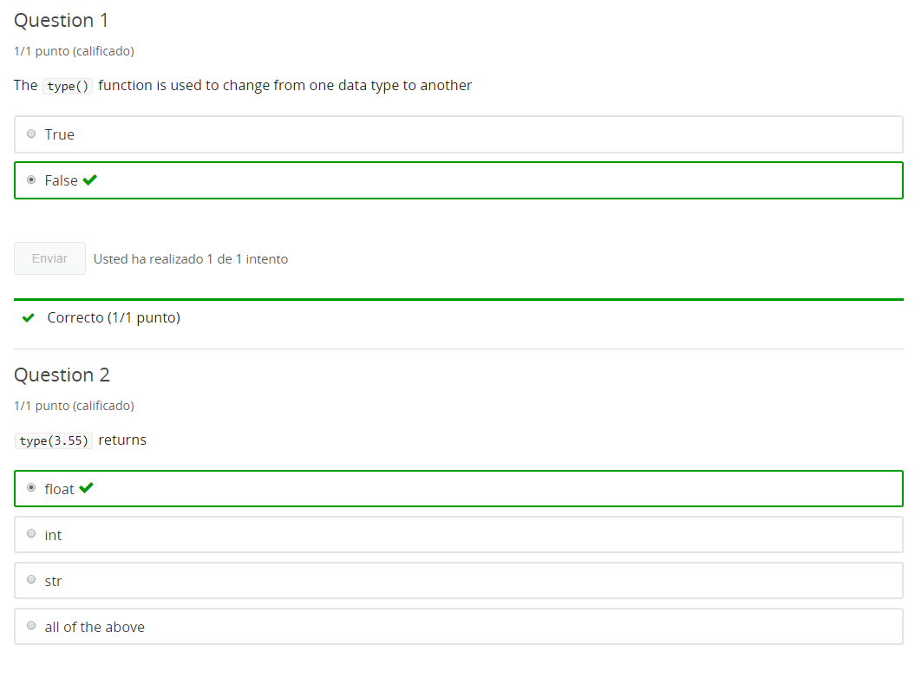

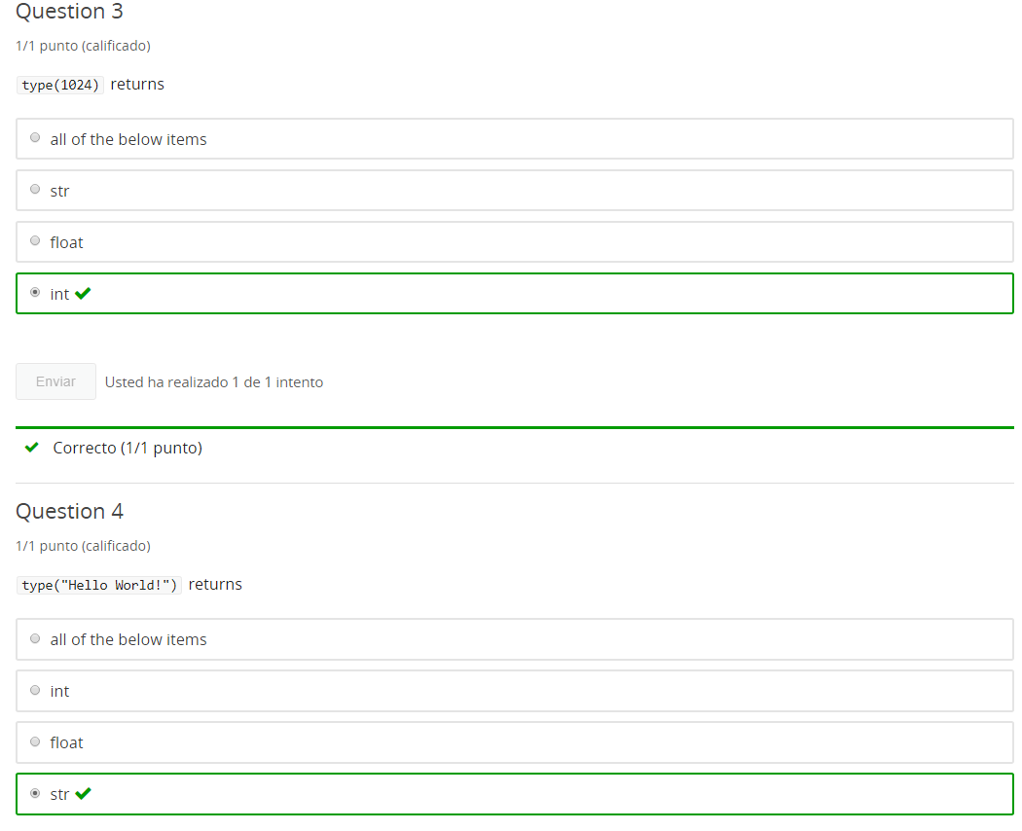

**4. Addition & Errors**

**4.1 Intro Python**

Jupyter Notebook: MOD01_1-1.4_Intro_Python.ipynb

Getting started with Python in Jupyter Notebooks

* Python 3 in Jupyter notebooks
* print()
* comments
* data types basics
* variables
* **Addition with Strings and Integers**
* **Errors**
* character art

Student will be able to

* **add numbers in code (+)**
* **troubleshoot errors**

**4.2 Addition: Numbers and Strings**

**Video:** **AdditionNumbersAndStringsV11.mp4**

The addition operator can do math and numbers, such as energies and floats, or it can concatenate strings. Let's take a look**. Here, I just have a simple math equation, 19 + 3. And if we echo to the screen by running it, we see we can get an answer there.** You can change the numbers and use this as your own calculator.

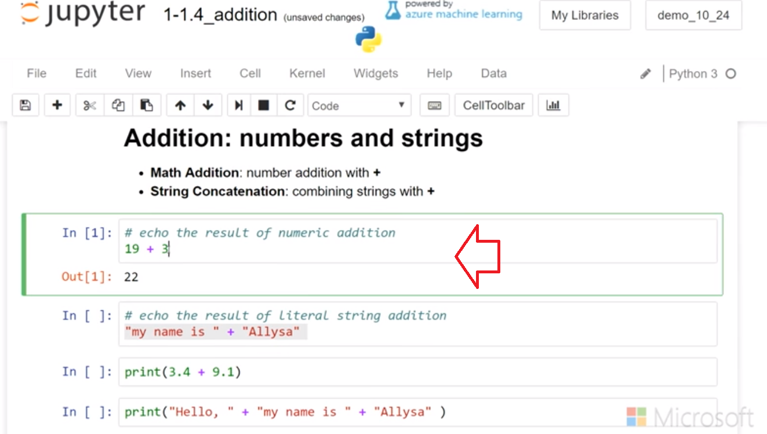

**I can also use this to add float numbers.** And that also shows the result below. So this is a typical mathematical operation, and use this just like you would in your math.

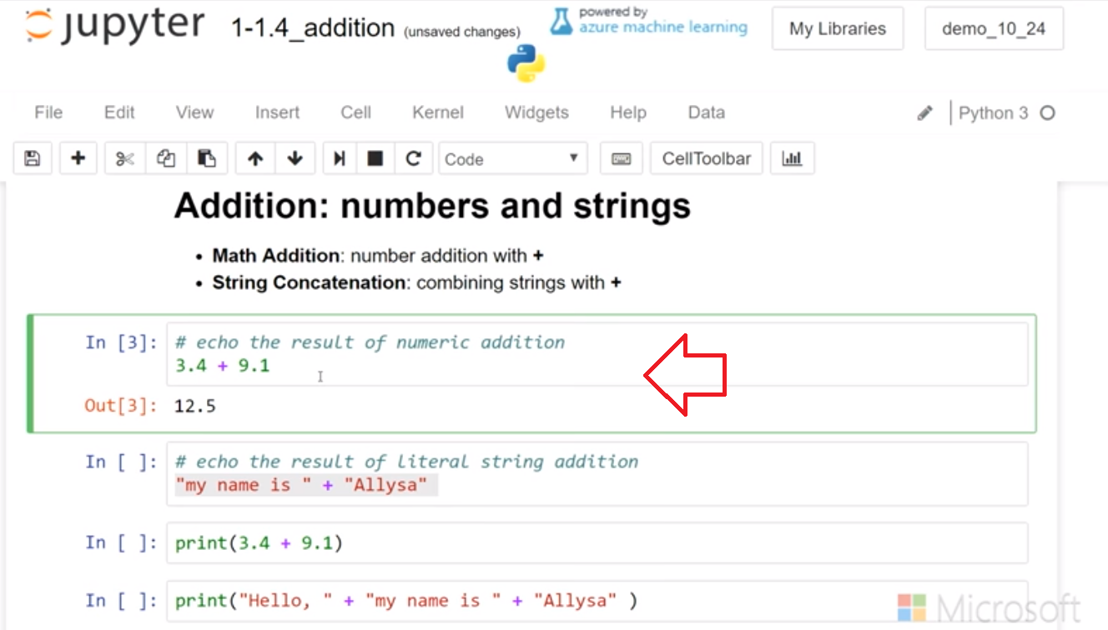

**We can also add strings. Here, I have two strings, my name + Allysa. If I echo that below, it displays as a single string.**

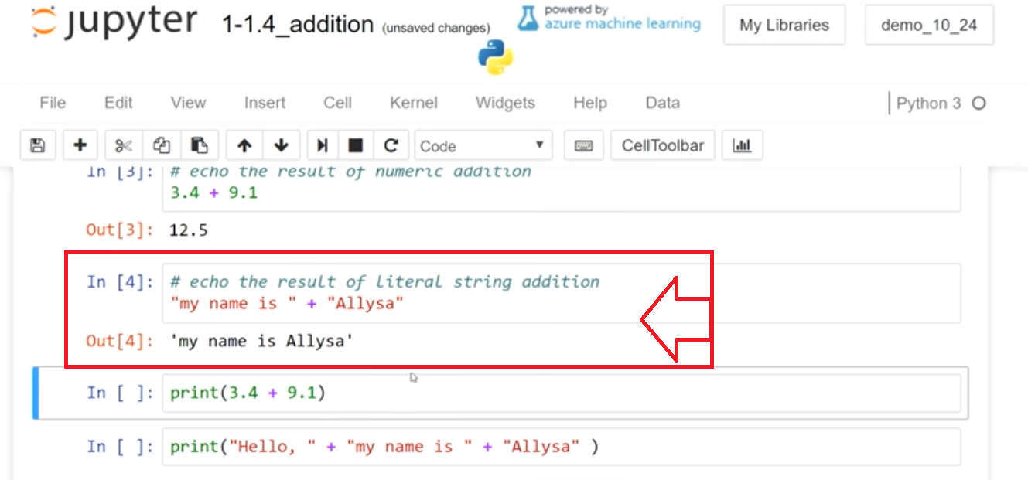

We can also put these within a print function. I can do the math operation in the print function and the result can display.

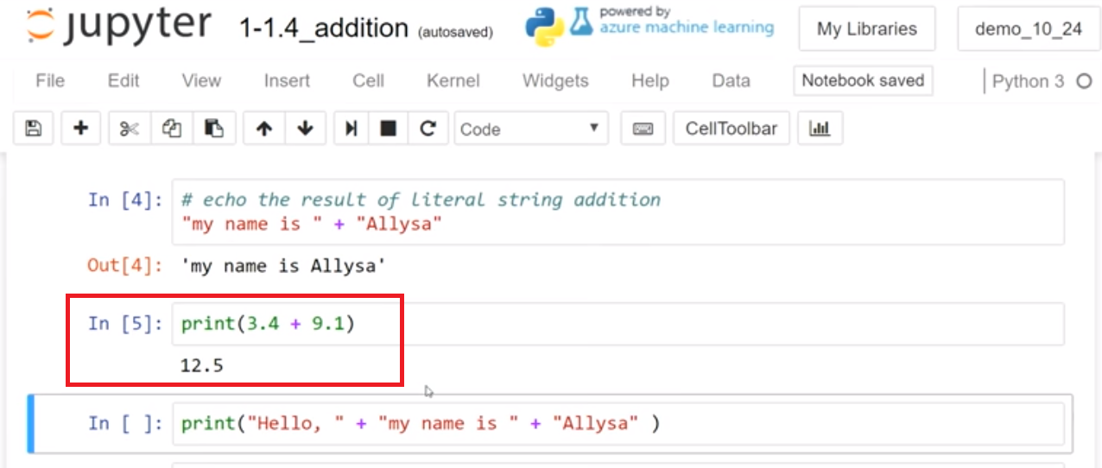

**I can put a number of strings and concatenate them using the + operator, and they display as a single string.**

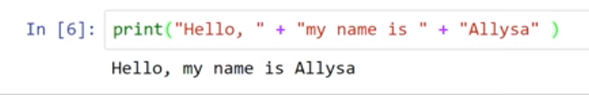

The additional operator allows us to do math additions with numbers or to concatenate strings.

# Concept: Addition with numbers and strings

## Addition: Numbers and Strings

### Numeric addition

**Numeric addition** Single line math equations, run in a code cell, will output a sum

# adding a pair of single digit Integers

3 + 5

## String addition

**string addition** single line equations, run in a code cell, will output a single concatenated string

**Tip:** all strings must be in quotes

# adding a pair of strings

"I wear " + "a hat"

We can also **add variables** as long as we add strings to strings and numbers to numbers

# Example

## String and Number Addition

# [ ] Review and run code for adding a pair of 2 digit Integers

23 + 18

# [ ] Review and run code for adding 2 strings

"my name is " + "Alyssa"

# [ ] Review and run code for adding a variable string and a literal string

shoe_color = "brown"

"my shoe color is " + shoe_color

# Task 1: multi-part

## String and Number Addition

# [ ] add 3 integer numbers

# [ ] add a float number and an integer number

# [ ] Add the string "This notebook belongs to " and a string with your first name

# [ ] Create variables sm_number and big_number and assign numbers then add the numbers

# [ ] assign a string value to the variable first_name and add to the string ", remember to save the notebook frequently"

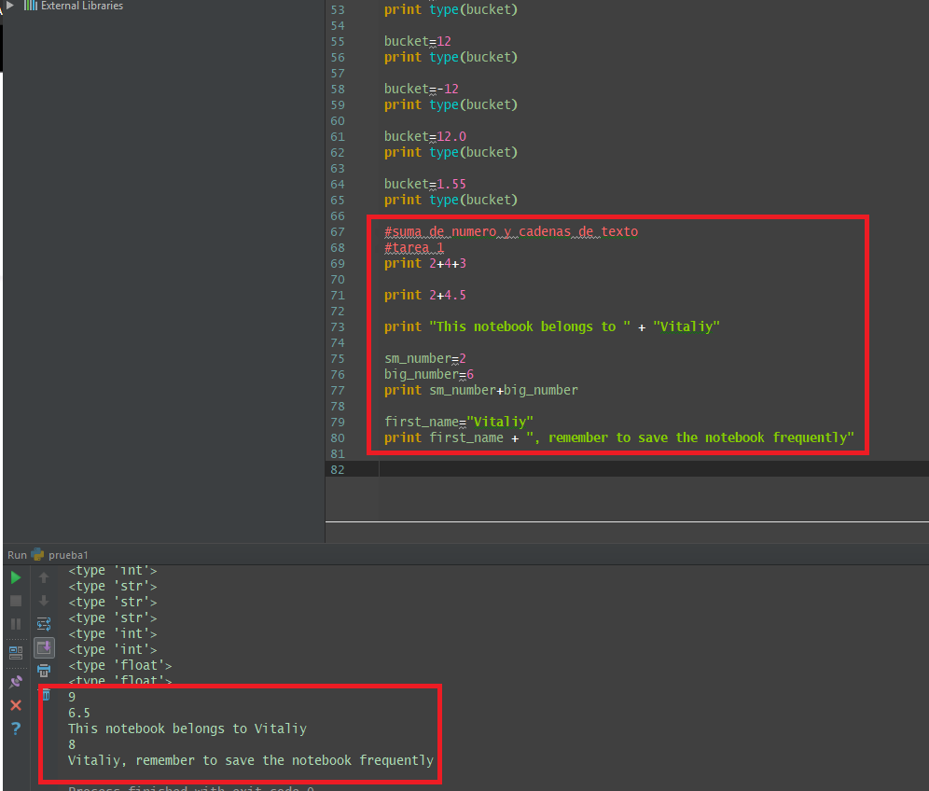

**4.3 Concept: Addition in variables**

**Video:** **ConceptAdditionInVariablesV12.mp4**

Concept: Addition in variables

use addition in variable assignments

It is common to store the results of addition in a variable

**The addition operator, when used with variables, is powerful because we can update and initialize new variables.** Let's take a look. So, I'm going to assign add_two the sum of the two integers, and we can run that and print the result. And we can see 34+16 is 50,

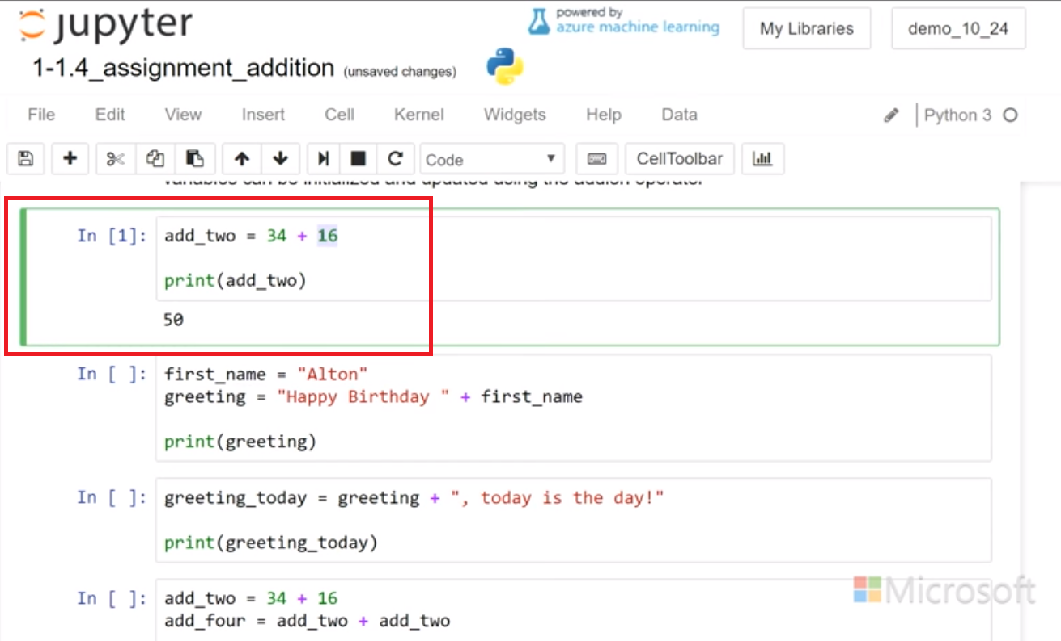

and we can change numbers or add additional integers, and that still runs. And so now I have a variable, add_two, which contains the sum, 70.

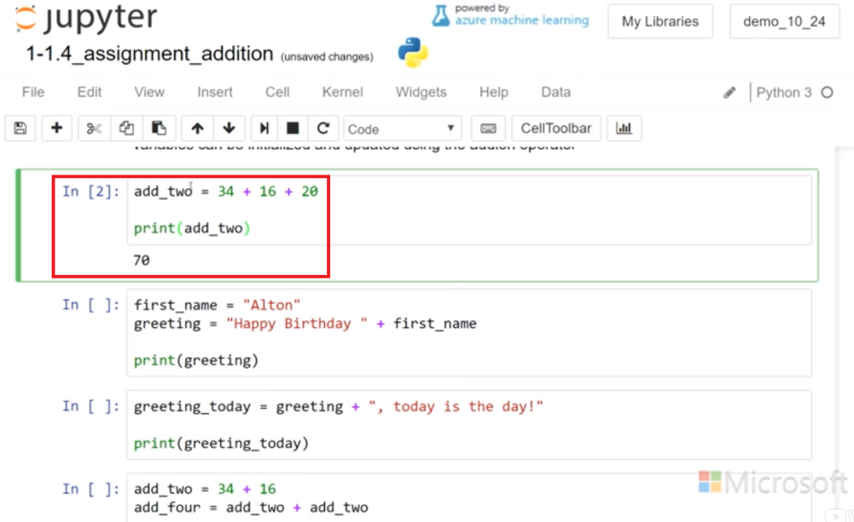

I can also use the string concatenation. And I can have a first name in a variable as Alton. And then I could have a new variable, greeting, which uses this variable, Alton, and with a literal string, Happy Birthday. So let's see what the print(greeting) looks like. And that worked well. So it's just the same as if in this spot I just put in Alton. And then I can further build on that variable. So, greeting, which was created by combining first_name and this literal string.

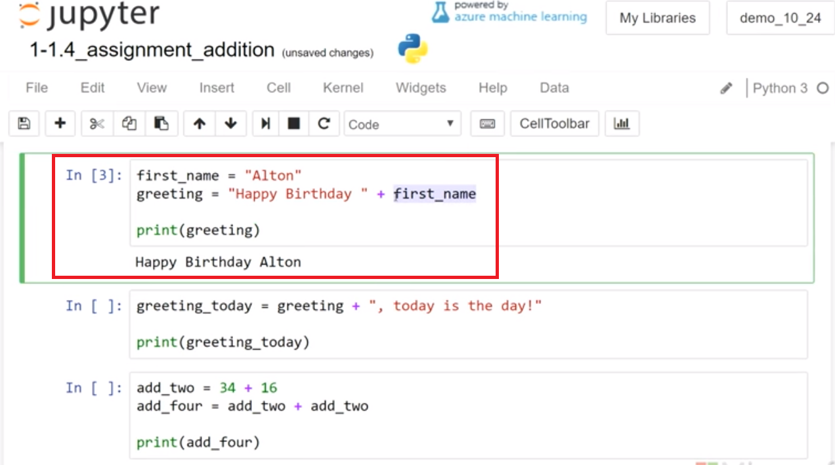

And then I can add another literal string to that. And I can say, here'ss the greeting_today, and I say, today is the day, on to the end of that, and we can run that and print that string. Happy Birthday Alton, today is the day! If I go back And I change to the first_name. Now it's a Happy Birthday Colette. And today is the day.

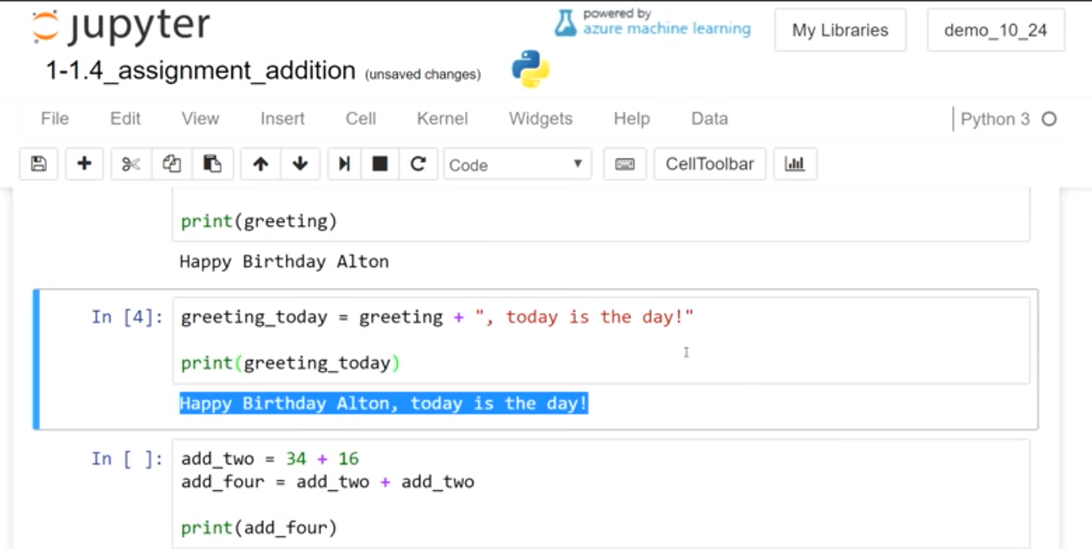

So, variables help us reuse the code. And we can use the string concatenation to build sentences that will be used in our programs and inject the different variables in there. So we had all these different opportunities to update the variables. Here's another example going back to the first, where we had add_two and we saw 34 and 16 was 50. And then I'm gonna reuse the add_two and combine it to itself and assign that to add_four, so lets look at that. Swell, so, again, this is an example, same as the above with the strings but now with the integers.

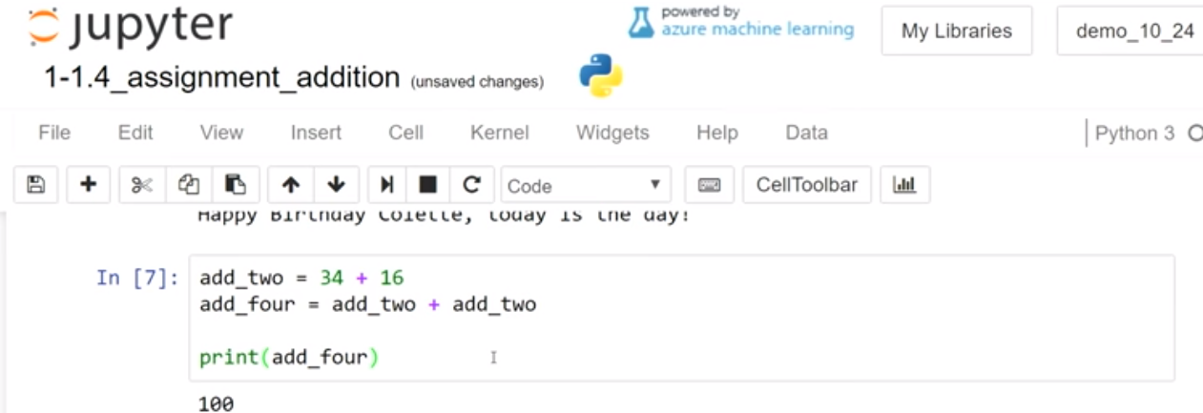

Use the addition operator to initialize and update your variables.

use addition in print ()

Use **print()** to show the results of multiple lines of output

Example

addition in variable assignments and in print()

# [ ] review & run code for assigning variables & using addition

add_two = 34 + 16

first_name = "Alton"

greeting = "Happy Birthday " + first_name

print(add_two)

print(greeting)

# [ ] review & run code for Integer addition in variables and in a print function

int_sum = 6 + 7

print(int_sum)

print(11 + 15)

print()

# string addition in variables and in print()function

hat_msg = "I do not wear " + "a hat"

print(hat_msg)

print("at " + "dinner")

Task 3: multi-part

create Integer addition and string addition output

# [ ] perform string addition in the variable named new_msg (add a string to "my favorite food is ")

new_msg = "My favorite food is"

print(new_msg)

# [ ] perform Integer addition in the variable named new_msg (add 2 or more Integers)

new_sum = 0

print(new_sum)

# [ ] create and print a new string variable, new_msg_2, that concatenates new_msg + a literal string

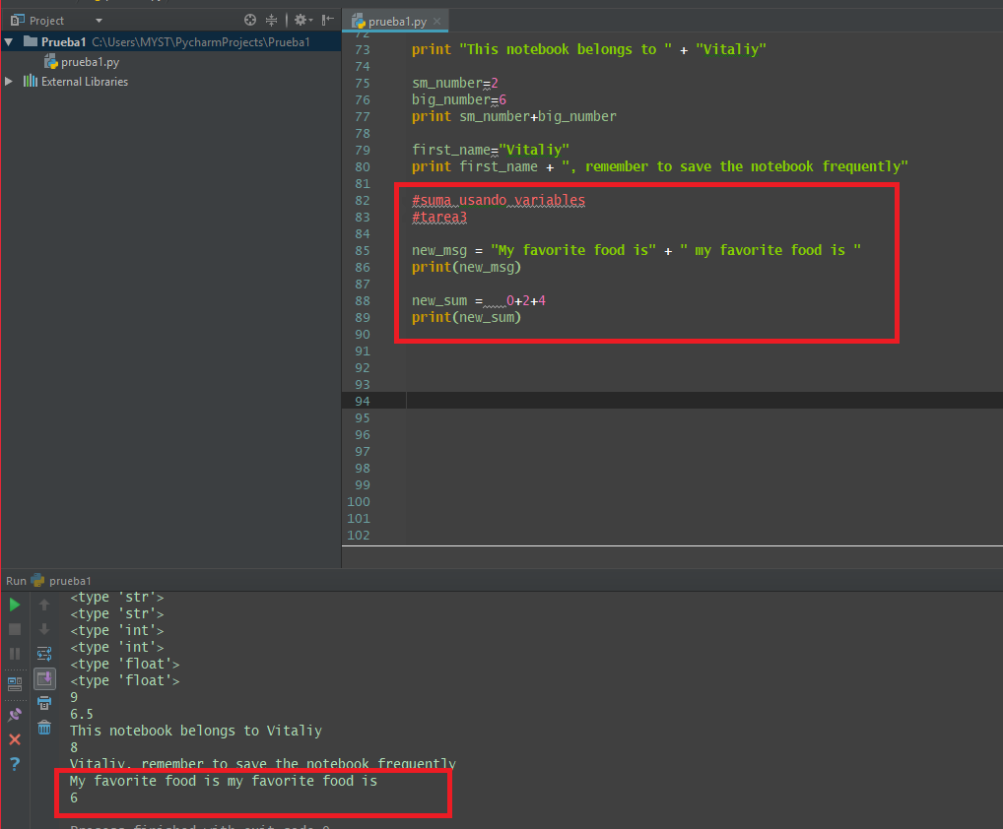

**4.4 Concept: Errors**

**Video:** **ConceptErrorsV13.mp4**

Errors!

Encountering **Errors** and troubleshooting errors are fundamental parts of computer programming

If you've run into some error so far in your programming, congratulations you are a official developer. Errors are normal part of programming process so we have to learn how to trouble shoot them. **Type errors are when types of different type are not allowed to be combined. So with addition, you can only combined strings together, and you can only combine numbers together, but you can't combine numbers and strings.** We're gonna take a look at some of those samples.

**In this example we're trying to combine the string, my number is, the string literal with this integer 123. When you run it you might have seen this error previously, it says we can't convert int object to a string implicitly. This error means that the Python compiler is expecting to add another string to the first string. When it encounters an integer, and doesn't know how to convert it to a string, it gives us this error.**

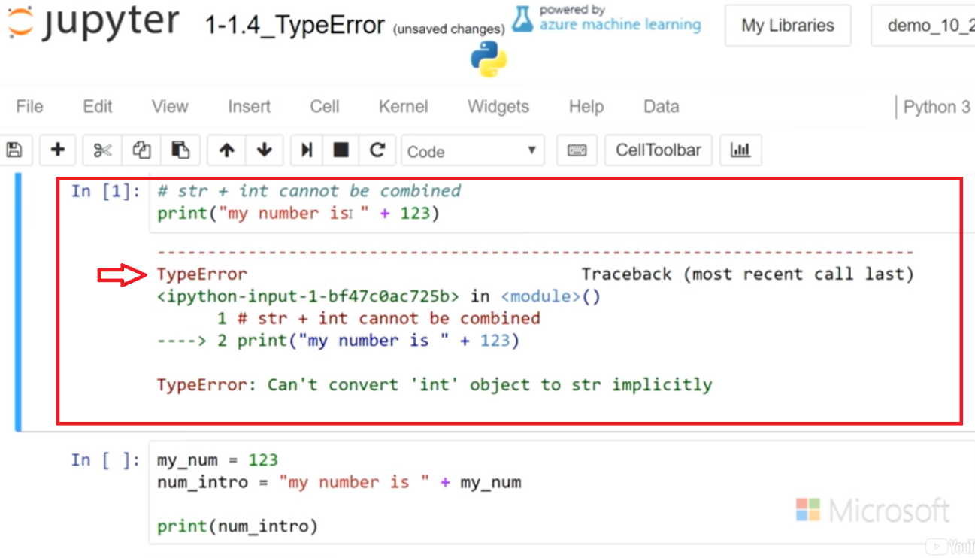

So what we can do here is we can change this number into a string. And then that will run properly.

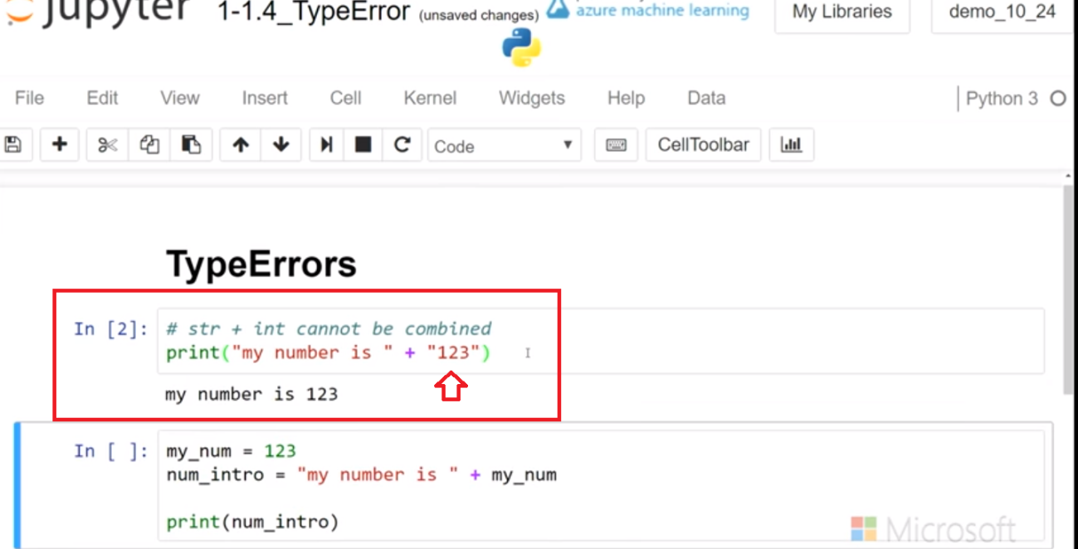

So if you se the type error it's usually means number and string. It's the most common way it would work. Another way you could run into this is with a variable assignment. And so in this case my number is an integer. And so now this num_intro where it's going to introduce the number my number is 123, we hope that's going to print out but we know that we can't add a integer with a strings so we get this error.

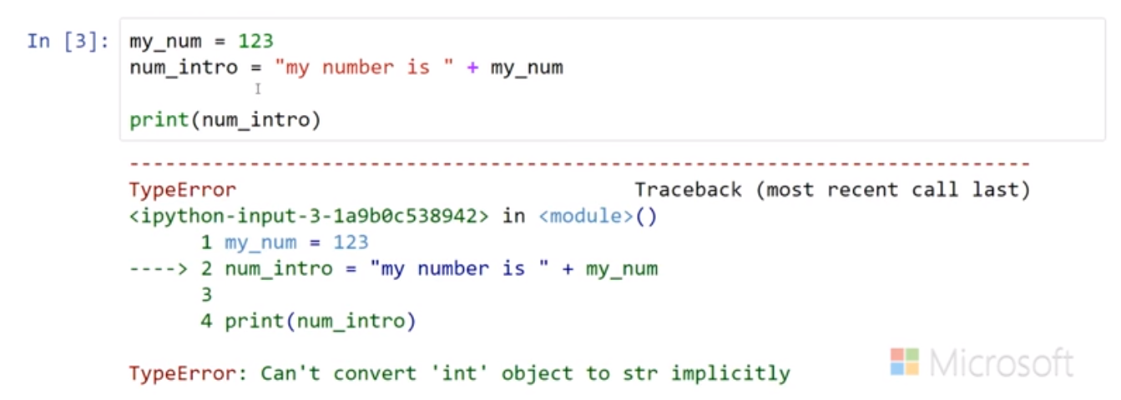

So again, we have to change from integer to string.

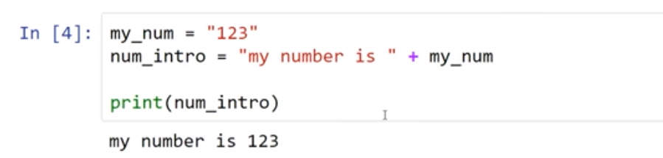

**Type errors are cause when there is an illegal operation involving a type. In examples we saw, we can't combine integer with a string. Always combine strings with strings to avoid the type error.**

# Example

# [ ] review & run code

print("my number is " + "123") #string, represents a text character

print("my number is " + 123) #number, with numeric value

#### TypeError

The line  **print("my number is " + 123)** causes the **TypeError** message to appear

TypeError: Can't convert 'int' object to str implicitly

When adding to the string  "my number is "  the compiler is experiencing another string, but finds a number \***123**

Python cannot convert the Integer   123  to a string without explicit instruction (in code)

**in other words, python only allows combining like types**

* **str + str**
* **int + int**

# Task 3

## Fix TypeError

* Review the code in the cells below and then run the code
* Fix any errors and run until the code no longer shows errors

# [ ] review and run the code - then fix any Errors

total_cost = 3 + "45"

print(total_cost)

# [ ] review and run the code - then fix any Errors

school_num = 123

print("the street number of Central School is " + school_num)

# [ ] Read and run the code - write a hypothesis for what you observe adding float + int

# [ ] HYPOTHESIS:

print(type(3.3))

print(type(3))

print(3.3 + 3)

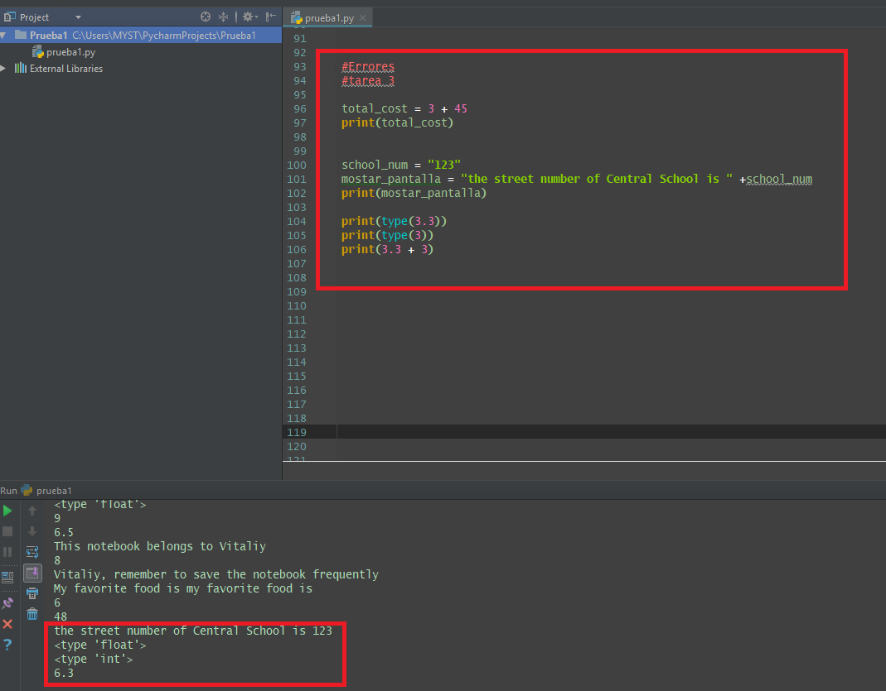

**4.5 Concept Errors: SyntaxError**

**Video:** **SyntaxErrorV14.mp4**

## More Errors!

### SyntaxError & NameError

* **SyntaxError** - breaks code formatting rules of python
* **NameError** - object is not defined (can't be found)

Python has a specific grammar that it follows that is referred to as **syntax**.  
The print function syntax rules for output of a single string include

* parentheses **( )** containing a **string** follow **print** (SyntaxError)
* strings have **matching quotation marks** (SyntaxError)
* print is lowercase and correctly spelled (NameError)

Failure to follow any of these rules results in a SyntaxError or NameError when the code is run

# Example

## SyntaxError

Two common types of errors are the syntax error and the name error. The syntax error is kind of the grammar of Python. If you don't follow the proper rules, you are gonna get an error. The name error is all about not being able to find that name in a program. The first error we're gonna look at is the syntax error that we saw before. And that is the one with strings not having matching quotes. So if I go ahead and put in a unmatching string quote. So here I have a double quote and then single quote If I run that, I get this no end of line while looking for the string message and what that means is Python is searching and searching for this double quote and it can't find it. And so that causes an error so we have to put that back to double quotes and that works properly. Another type of syntax error is with variable names. And variable names can't start with numbers. They can start with an underscore or a letter. And so you can actually see here that the number is showing up in a different color, so Python's giving us a hint that something was wrong there. But if you try to run that it says, it's an invalid syntax. You just can't use that for a variable name. So you could delete that and that would be able to run. Or we can put in the student name or- And then that's a valid Python variable assignment. Here you can see again as I highlight in the cell that the Second parenthesis is facing the wrong way. And so again I'm gonna get a syntax error and it's not knowing it's saying that this is ended the file but it doesn't know why it's unexpected and so if we flip that around then we can see that that type is a float and that runs properly. Another set of errors is the name errors. What that means is Python is going to look for something and it can't find it anywhere because it doesn't exist. In this case print is with a capitalized P. And so I get this NameError. And so it tells you right here that if it's capitalized it's not defined. So all we have to do is spell it right, With the proper capitalization and then that works in It is common to make these typos where you are going to capitalize a start of a sentence, or that you will reverse letters. You can look for that if you see a NameError. Another way the NameError can happen is if we have not defined something. So 'day_of_week' I am trying to print it, but nowhere did I define "day_of_week", and so it says it cannot be found. So the way to correct that is to define the variable. So then we can run that. Syntax errors are caused when we're not following the rules of Python. So if we're missing parentheses or quotes are not matching or you are just using things in the wrong order will get a syntax error. Name error is when python can not find something, and so it could be. Because by the fact you haven't initialized the code yet maybe it 's further down in the code or you type the name of the code improperly and so Python can find it. Good luck TroubleShooting your errors.

* Improperly formatted string (quotes don't match) that results in a SyntaxError

# [ ] review and run the code for properly and improperly formatted print statement

print("Hi!")

## improper format - non matching quotes

print('I like the morning")

* Note that the "prin" misspelling below results in a NameError

# [ ] review and run the code

prin('hi')

* EOF = "end of file" found in code below
* Python went to the end of the file looking for, but not finding, a closing parenthesis

# [ ] review and run the code missing the closing parenthesis

print("where are my socks?"

* In code below: a parenthesis inside quotations will be seen a part of a string and not as a parenthesis

# { ] review and run the code

print("my socks are in the wrong bin)"

Task 4

Fix Errors

**Tip**: explaining errors to a partner often reveals a solution (works even if explaining error to a pencil)

# [ ] repair the syntax error

print('my socks do not match")

# [ ] repair the NameError

pront("my socks match now")

# [ ] repair the syntax error

print"Save the notebook frequently")

# [ ] repair the NameError

student_name = "Alton"

print(STUDENT_NAME)

# [ ] repair the TypeError

total = 3

print(total + " students are signed up for tutoring")

*A parenthesis inside quotations will be seen a part of a string and not as a parenthesis*

**4.6 Self-Check: Module 1 Section 4**

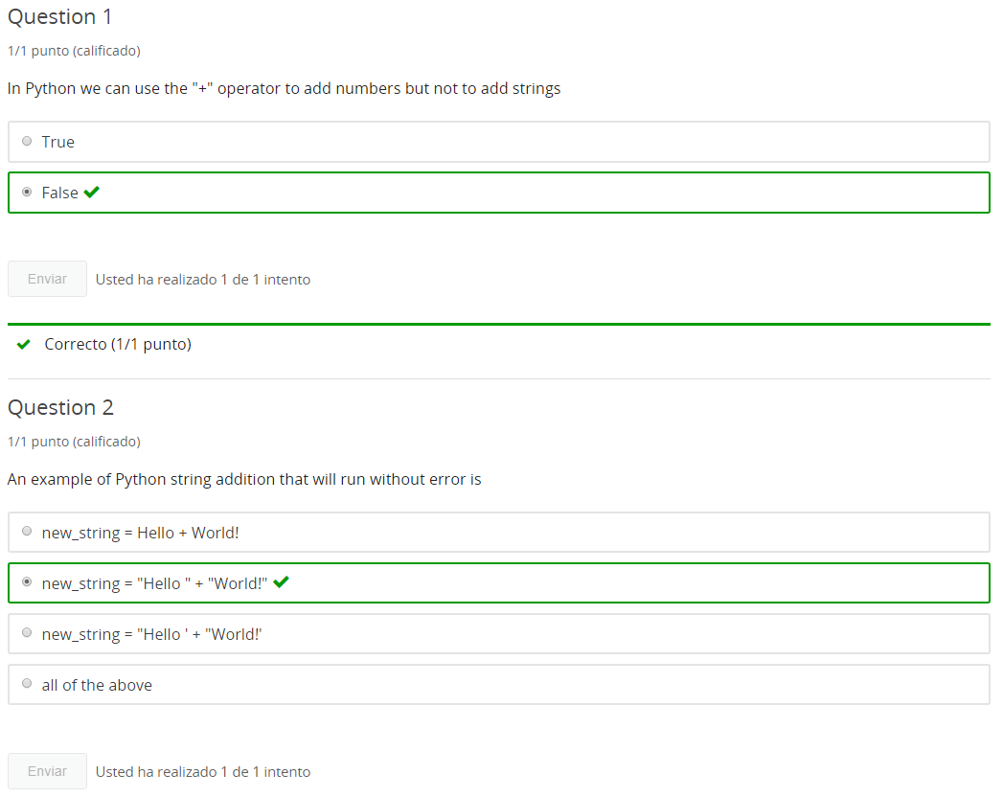

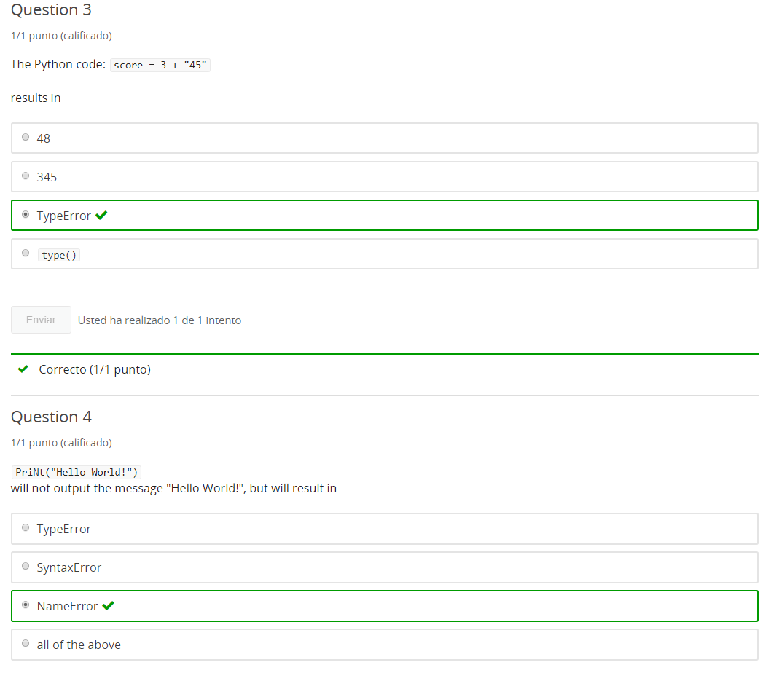

**5. ASCII Art**

**5.1 Into Python**

Jupyter Notebook: MOD01_1-1.5_Intro_Python.ipynb

Getting started with Python in Jupyter Notebooks

* Python 3 in Jupyter notebooks
* print()
* comments
* data types basics
* variables
* addition with Strings and Integers
* Errors
* **character art**

Student will be able to

* **create character art**

**5.2 ASCII Art**

**Video:** **ASCIIartV15.mp4**

# Concept: Character Art

## Creating ASCII Character Art

### Extra Activity

## print() character art

ASCII Art, also known as character art, allows software developers to add creativity to console based applications. These simple examples of ASCII Art can give you an idea of ways to use ASCII Art to decorate your programs. We can create simple letters and you can get much more stylized letters. So you can do a web search for those and get some great ideas. We can put logos on there. We can give rewards for correct answers, make the ASCII Art part of the program.

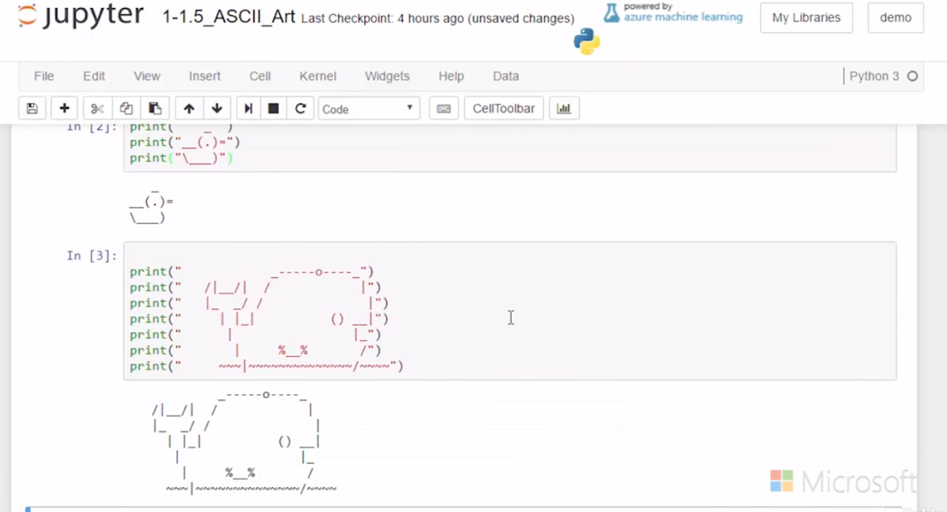

print() output to the console can create character art in the forms of pictures and stylized text. Below we show how to create a stylized letter "A"

# the letter 'A'

print(" *")

print(" * *")

print(" *****")

print(" * *")

print("* *")

print()

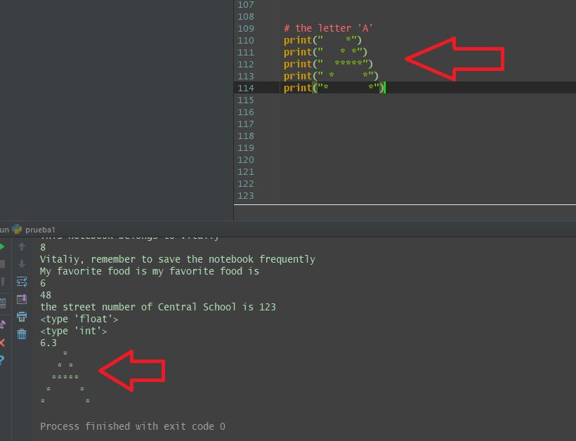

Extra Task

* create the flying bird in character art in the Code cell below

_ _

\ /

\ . . /

V

# create # [ ] flying bird character art

Extra Task cont...

* create the capital letter "E" in character art in the Code cell below

# [ ] capital letter "E" character art

**6. Input**

**6.1 Intro Python**

Jupyter Notebook: MOD01_1-2.1_Intro_Python.ipynb

Strings: input, testing, formatting

* **input() - gathering user input**
* print() formatting
* Quotes inside strings
* Boolean string tests methods
* String formatting methods
* Formatting string input()
* Boolean in keyword

**Student will be able to**

* **gather, store and use string input()**

**6.2 User Input**

**Video:** **UserInputV16.mp4**

# Concept: user input

## input()

### get information from users with input()

the **input()** function prompts the user to supply data returning that data as a string

Working with strings and string variables we've accomplished a lot. Still we're a little bit limited, so let's look at adding input and so we're going to use the input statement.

**So, right here, I have the input statement, as the second line and I'm going to assign small int a new variable to the input.** And before that we have a message, which is telling the user, enter a small int or integer. So, let's see how that works. So now, it asks me to enter small int. And so now, I can put a small integer in there, and I think 3 is pretty small. So I enter that in and now I've populated this variable small int with 3,

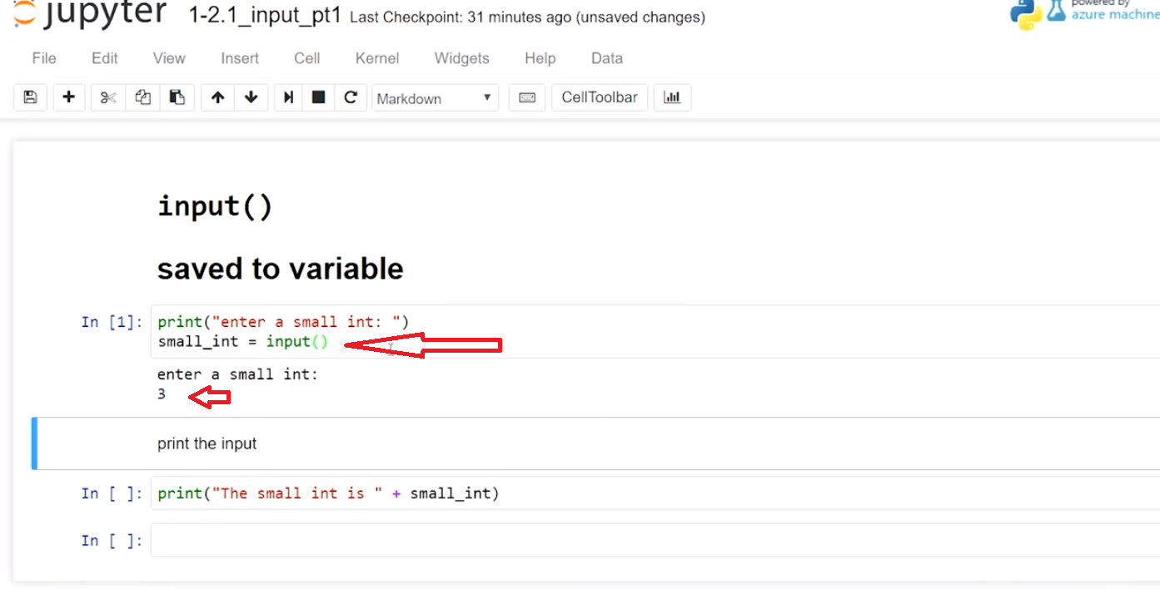

and so, I'm going to go ahead and print the output and if I go to the cell below, **I also have access to the small int variable because in a Jupyter notebook, any variable, any object, that is created in a cell, once it's created, it's available to all the cells.** **So now I can go ahead and run this cell and it says the small int is 3. So that works.**

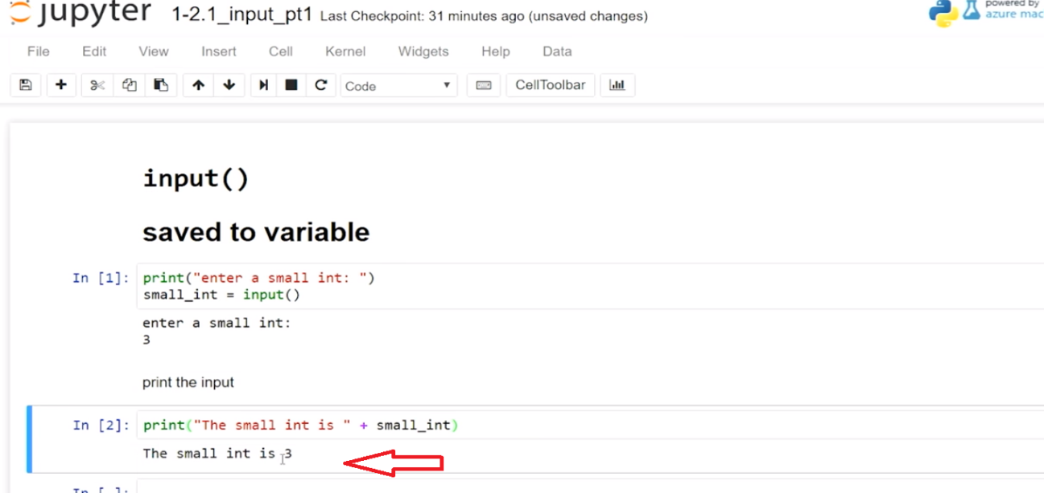

So, let's go ahead and try it again. I'll put in a different number 5, and so now I've re-populated the small integer variable and I see 5 below there. So, working with input, we can populate variables with strings and use them in our programs.

**Example**

# review and run code - enter a small integer in the text box

print("enter a small int: ")

small_int = input()

print("small int: ")

print(small_int)

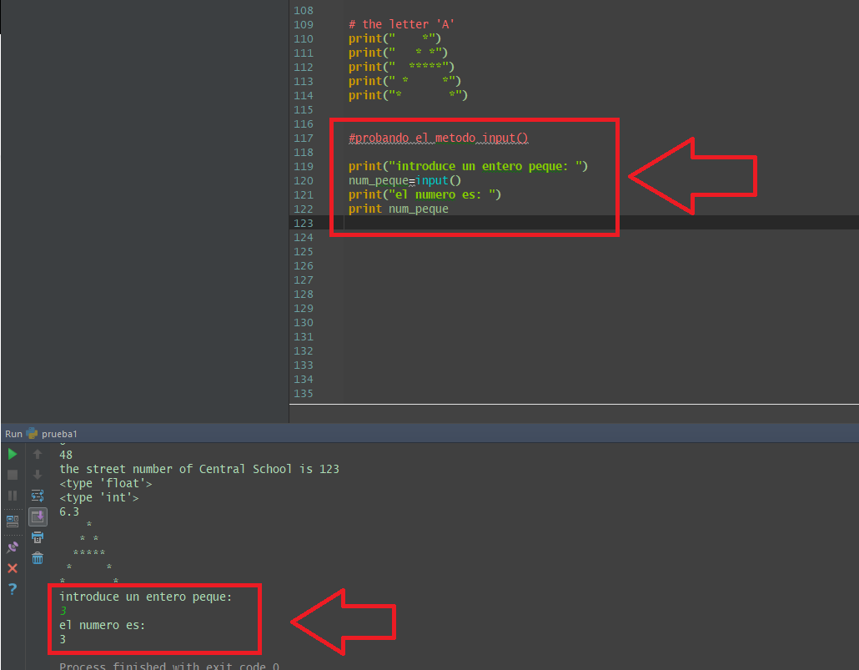

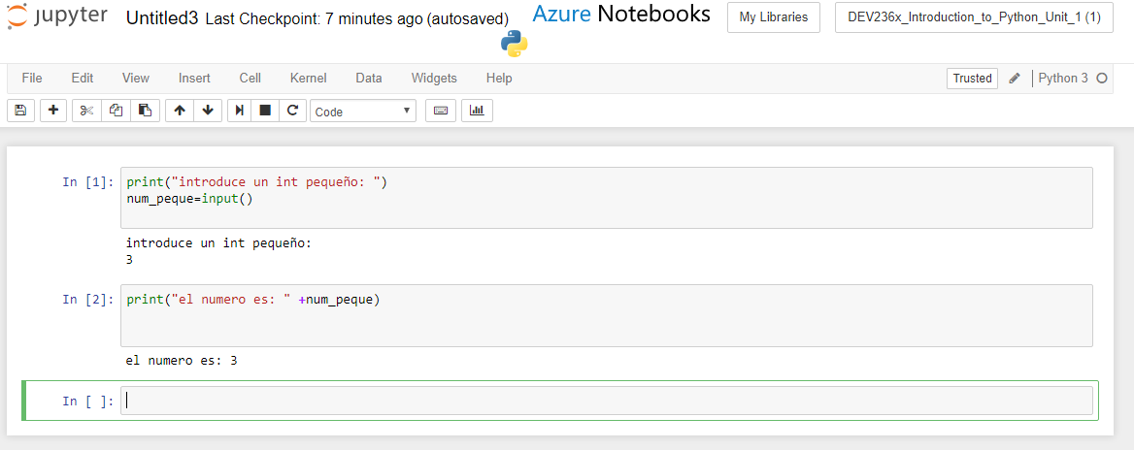

**Task 1**

storing input in a variable

* **[ ]** create code to store input in student_name variable  
  an input box should when run
* **[ ]** type a name in the input box and press **Enter**
* **[ ]** determine the **type()** of **student_name**

# [ ] get input for the variable student_name

# [ ] determine the type of student_name

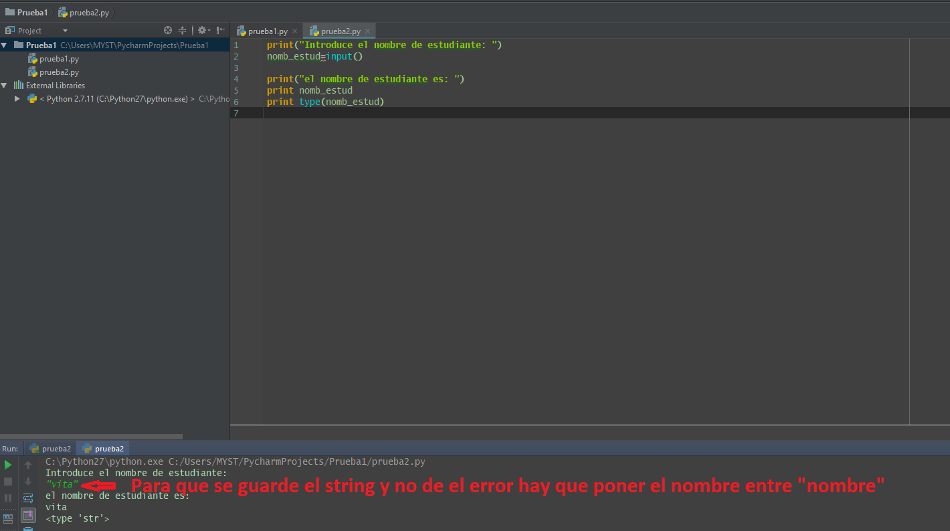

**Task 1 continued...**

**note**: **input()** returns a string (type = str) regardless of entry

* if a string is entered **input()** returns a string
* if a number is entered **input()** returns a string
* **[ ]** determine the **type()** of input below by entering
  + a name
  + an integer (whole number no decimal)
  + a float a number with a decimal point

# [ ] run cell several times entering a name a int number and a float number after adding code below

print("enter a name or number")

test_input = input()

# [ ] insert code below to check the type of test_input

**6.3 Input promps**

**Video:** **InputPrompsV17.mp4**

**Concept: input() prompts**

user prompts using input()

the **input()** function has an optional string argument which displays the string intended to inform a user what to enter  
**input()** works similar to **print()** in the way it displays arguments as output

Let's look at improving our input messages by using the input prompt mechanism and simplify things a little bit. Previously we used a message to the user in a print statement and then we put in our input. Well, that's fine but we have this message up here and then below, **I have to put in my answer and when I improve this with by using the input prompt, I can just do it all on a single line.**

**So, inside of the parenthesis, I'm allowed to put in a message, in a string. And so that will be displayed to the user and we're going to see right here that if I run that now, the prompt message that is inside the parenthesis of the input function is displayed and then I can enter a name in there.** And now, that is assigned to student name and I get my name out here.

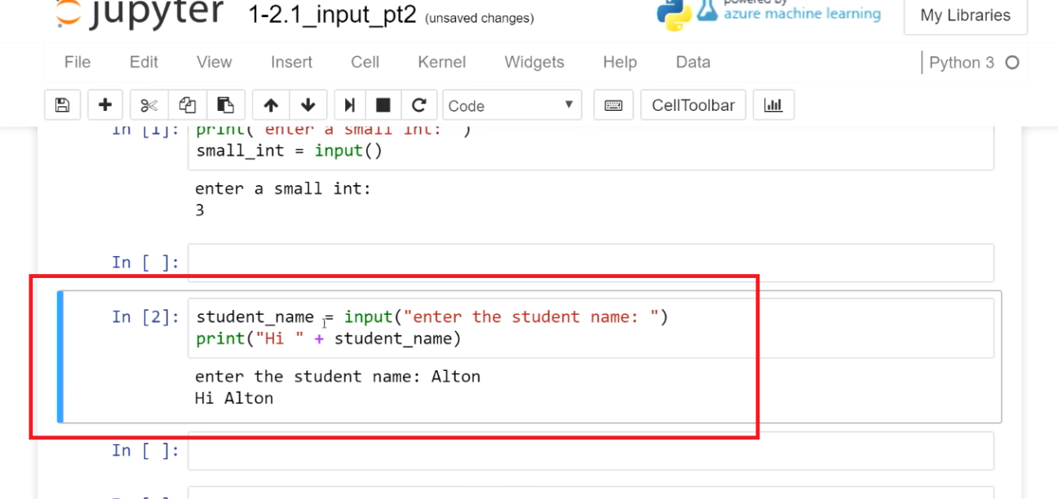

So, let's going forward just use the input prompt and that will simplify things and you keep the prompt with your input statement.

Another thing that we really need to look at here is that when we enter in the student name input, we want to know what kind of type that is. And we see that, that is a type string. So, that is a string because it's a name and we would expect that to be a string.

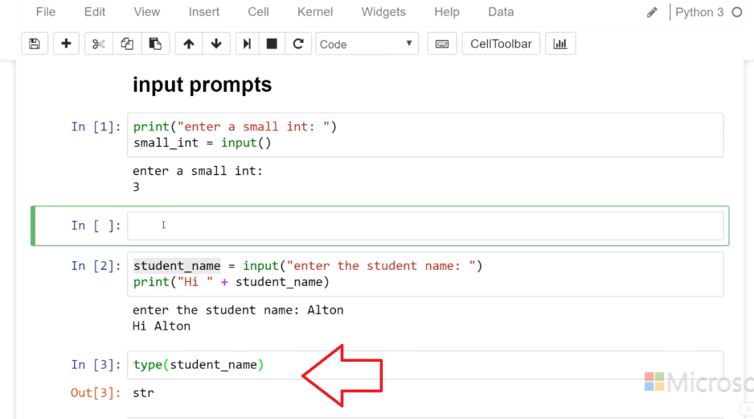

But let's look back at our initial example here with small int. What is that? Well it's also a string. So, no matter what your intent is whether you want this to be a numeric value or a string value, it's always going to be a string. And so this is a digit 3 which is the same as 3 in quotes. This is rather than the numeric 3.**(cosa rara de azure)**

**So we would not be able to add together three plus three. So, what we've learned is that, we can use the input prompt that's built into the input statement by typing inside the parenthesis and that no matter what no matter what we type in to the input statement is always going to be a string.**

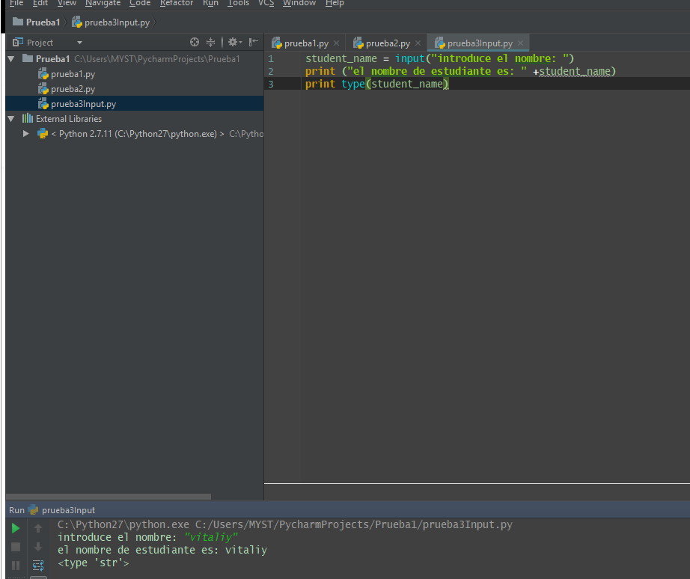

**Example**

student_name = input("enter the student name: ")

print("Hi " + student_name)

**Task 2**

prompting the user for input

* **[ ]** create a variable named **city** to store input, add a prompt for the name of a city
* **[ ]** print "the city name is " followed by the value stored in **city**

# [ ] get user input for a city name in the variable named city

# [ ] print the city name

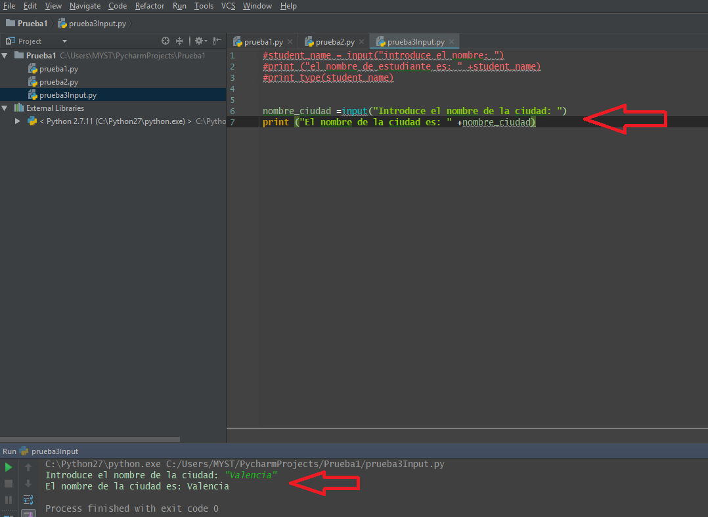

**Task 2 cont...**

multiple prompts for user input

often programs need information on multiple items

* **[ ]** create variables to store input: **name**, **age**, **get_mail**
* **[ ]** create prompts for name, age and yes/no to being on an email list
* **[ ]** print description + input values

example print output:  
name = Alton  
age = 17  
wants email = yes

**tip**: with multiple input statements, after each prompt, **click 'in' the input box** to continue entering input

# [ ]create variables to store input: name, age, get_mail with prompts

# for name, age and yes/no to being on an email list

# [ ] print a description + variable value for each variable

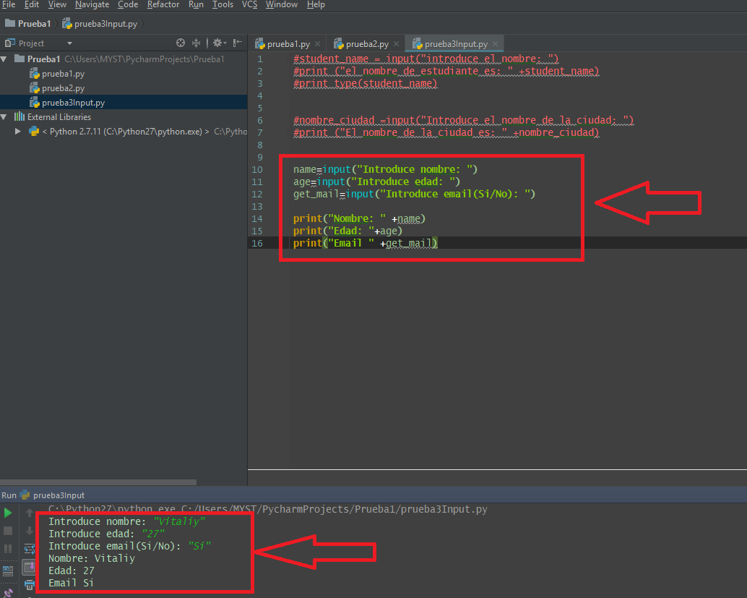

**6.4 Self-Check: Module 1 Section 6 (Graded)**

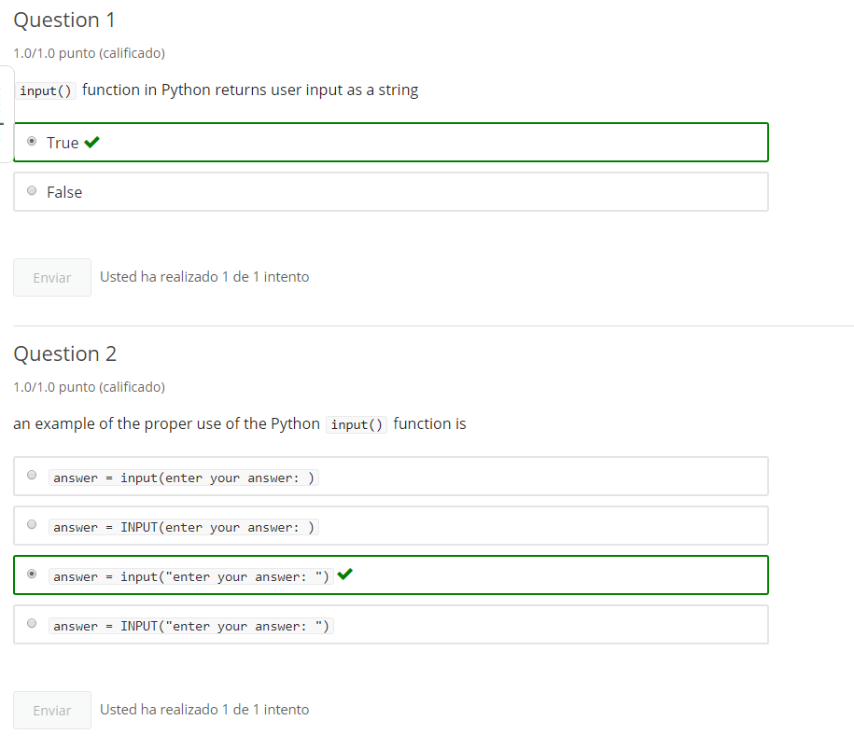

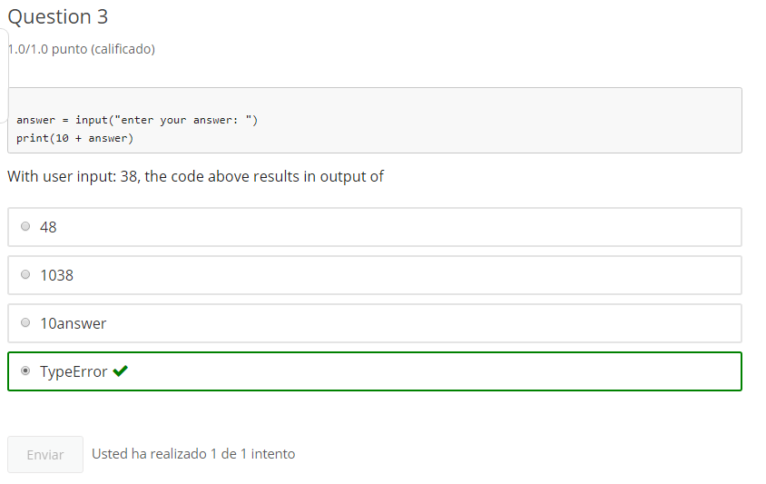

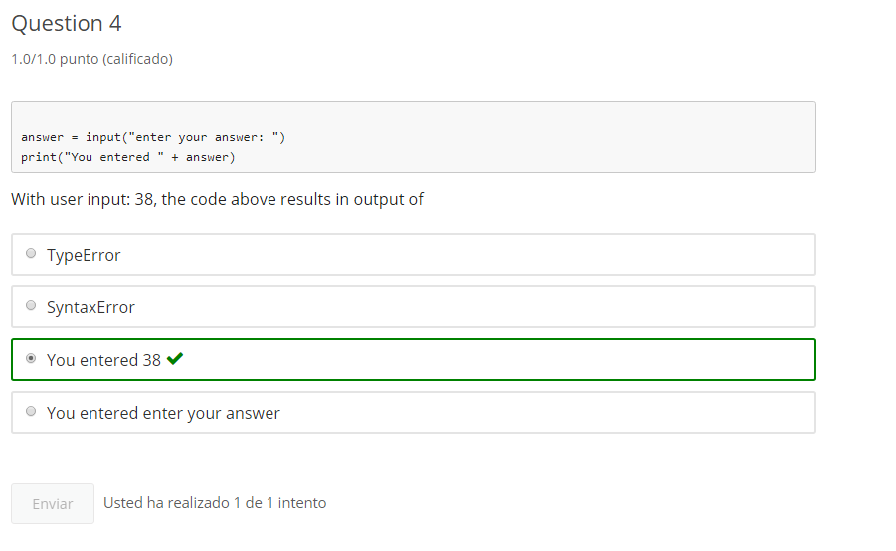

**7. Print Formatting**

**7.1 Intro Python**

Jupyter Notebook: MOD01_1-2.2_Intro_Python.ipynb

Strings: input, testing, formatting

* input() - gathering user input
* **print() formatting**
* Quotes inside strings
* Boolean string tests methods
* String formatting methods
* Formatting string input()
* Boolean in keyword

Student will be able to

* **format print() output**

**7.2 Comma separated string printing**

**Video:** **CommaSeparatedStringPrintingV18.mp4**

**Concept: print formatting**

using comma print formatting with strings

Python provides several methods of formatting strings in the **print()** function beyond **string addition**

The **print()** function supports using **commas** to combine strings for output  
by comma separating strings **print()** will output each string separated with a space by default

**We've learned how to combine strings inside a print statements, using string addition with plus sign.** So, let's look at another way to do some formatting with print and we can combine using commas. So I'm going to just create a string variable here, and enter the Name: Collette, I need to run that cell so that that variable name gets populated with the string and then I can go over here and this is the familiar print statement we used before, **we used a string and then we just add in a variable, that is a string and then we add a another string. And I can run that cell. Now, I got my "Hello Collette!"** but, this-- printing with,

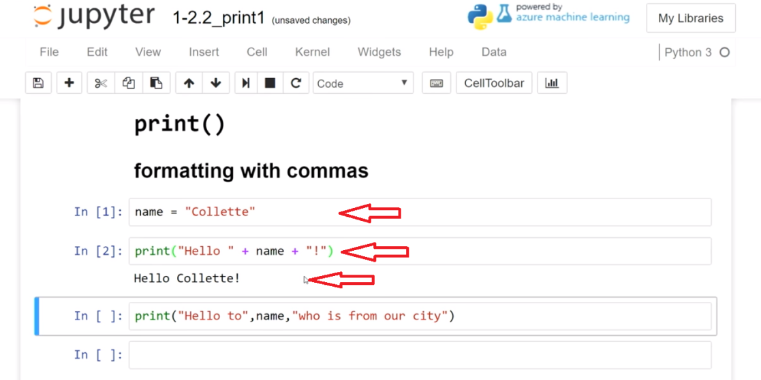

**formatting with commas is a different way to do this and so, what I can do is, put a comma between the different strings.** And so, I've done here. "Hello to" be Collette again, "who is from our city". And I can run that string, and you can see here that concatenates all of the strings inside this print statement in between the commas, it just puts a space in between there and that's a default behavior. So, it says "Hello to", add in a space "Collette" added in a space whose from our city.

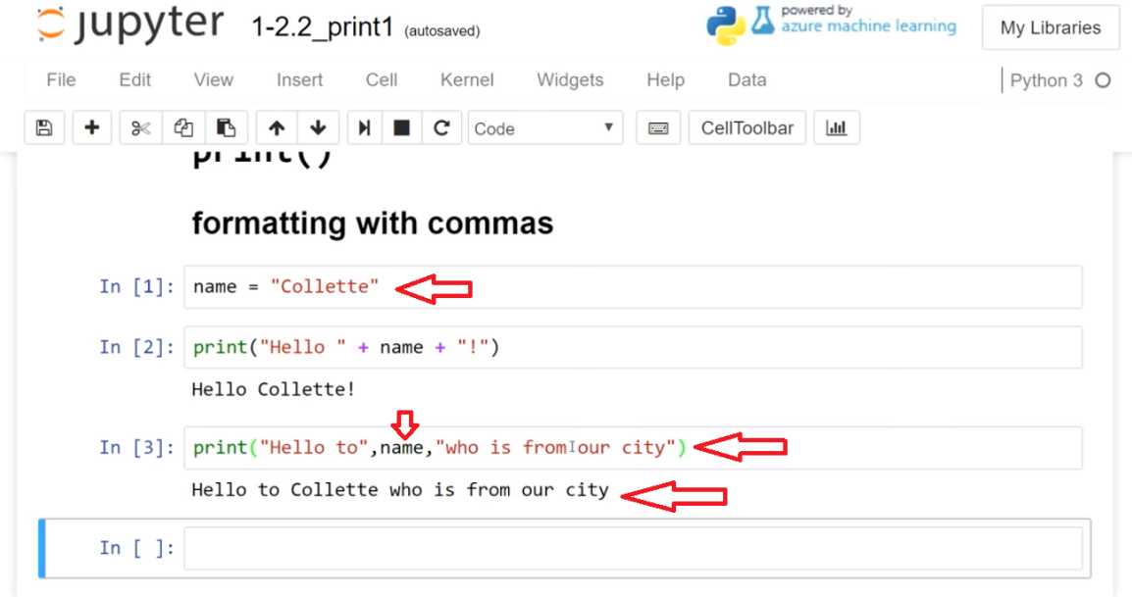

**So we can print format with commas, and concatenate strings very quickly just by putting them next to each other, using the comma for different string variables or literal strings.**

### comma formatted print()

* **[ ]** print 3 strings on the same line using commas inside the print() function

# Example

# review and run code

name = "Colette"

# string addition

print("Hello " + name + "!")

# comma separation formatting

print("Hello to",name,"who is from the city")

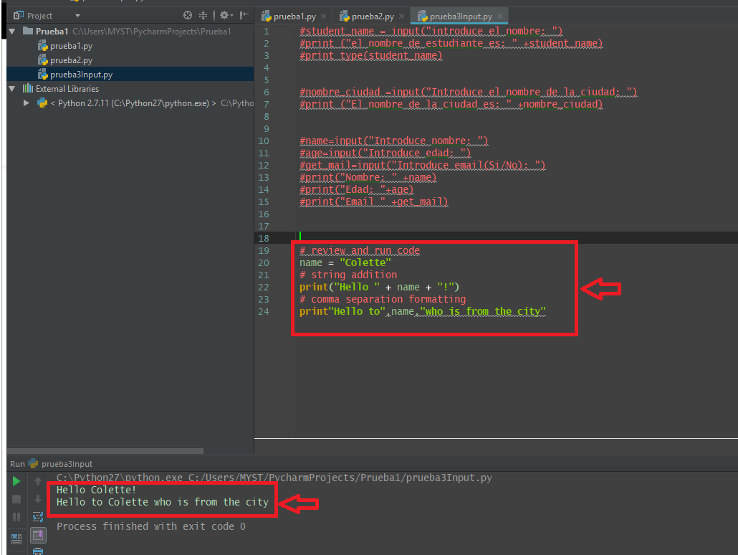

# Task 1

**print 3 strings on the same line using commas inside the print() function**

# [ ] print 3 strings on the same line using commas inside the print() function

**7.3 Printing numbers with strings using comma**

**Video:** **PrintingNumbersWithStingsUsingCommaV19.mp4**

**Previously we ran into some type errors when we try to concatenate strings and numbers inside a print statements. And we're going to see how we can fix that using the comma format and it allows us to combine them easily.**

So this is the old way that we would try to combine these elements using the addition and **we know that we can't add the strings and the numbers together and so, we get that type error.**

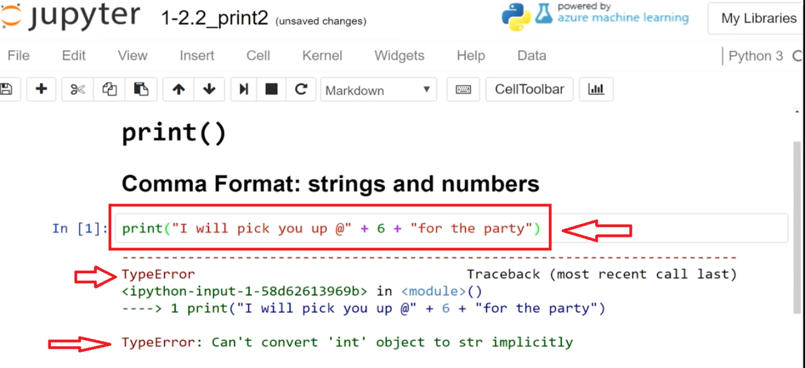

**So the way that we can fix that is you could create a string out of the number**

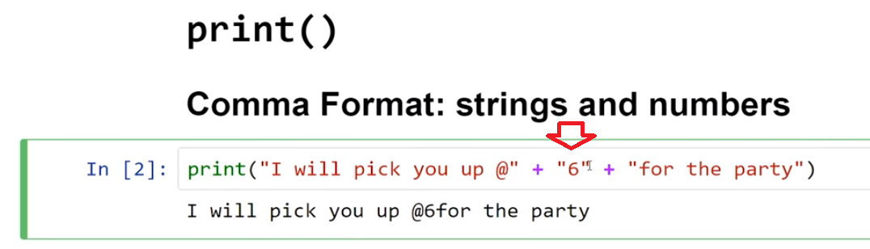

**or we could use a comma. So this is a great improvement is now, I'm allowed to legally combine a number and a string in the same print statement.**

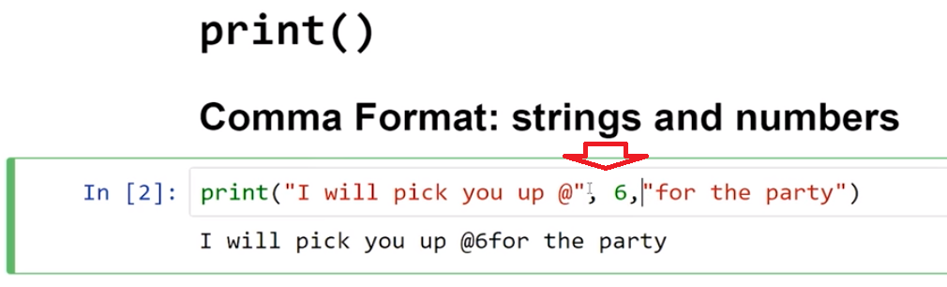

So let's look below with a number variable. So I have num error equals zero and then I have this longish print statement separated with commas using the comma formatting and I have a string int equals and then I have a literal number, and then I have a literal string, and then I have this number here as well that is the variable number error which would be zero and then followed with a string. **So I can alternate strings and numbers or I can do variable numbers and hard-coded numbers and let's see how that runs.** And so that works, my 14 shows up fine and my number of zero errors came up and indeed we got zero errors in that.

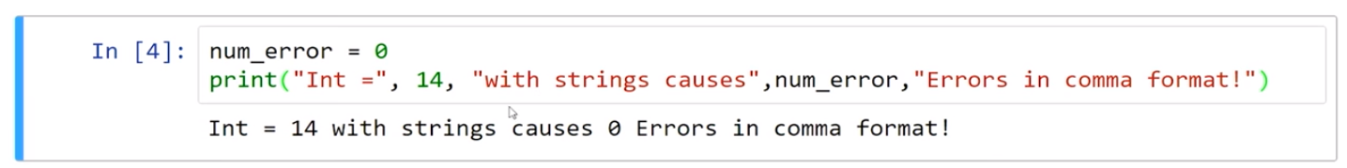

So in this lesson, we learned that we can combine numbers with strings using the comma print formatting and then that can really speed up our display of information.

# Concept: printing strings with numbers

## using commas in print() with strings and numbers together

* print() function formatting with comma separation works different than with string addition.
* print() using comma separation can mix numbers (int & float) and strings without a TypeError

#### print() with numbers and strings together using commas

* **[ ]** use a **print()** function with comma separation to combine 2 numbers and 2 strings

# Example

# review and run code

print("I will pick you up @",6,"for the party")

# review and run code

number_errors = 0

print("An Integer of", 14, "combined with strings causes",number_errors,"TypeErrors in comma formatted print!")

# Task 2

**use a print() function with comma separation to combine 2 numbers and 2 strings**

# [ ] use a print() function with comma separation to combine 2 numbers and 2 strings

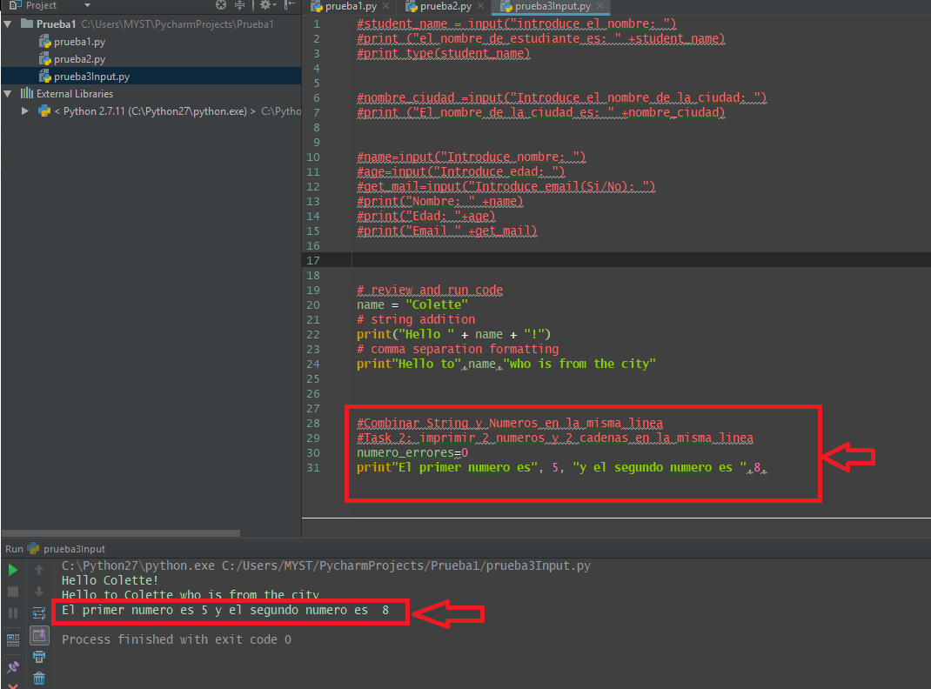

# Task 3

**print() comma separated mixing of strings and variables**  
by comma separating strings and/or string variables **print()** will output each separated by a space by default

**display text describing an address, made from stings and variables of different types**

* initialize variables with input()
  + street
  + st_number
* Display a message about the street and street number using comma separation formatting

# [ ] get user input for a street name in the variable, street

# [ ] get user input for a street number in the variable, st_number

# [ ] display a message about the street and st_number

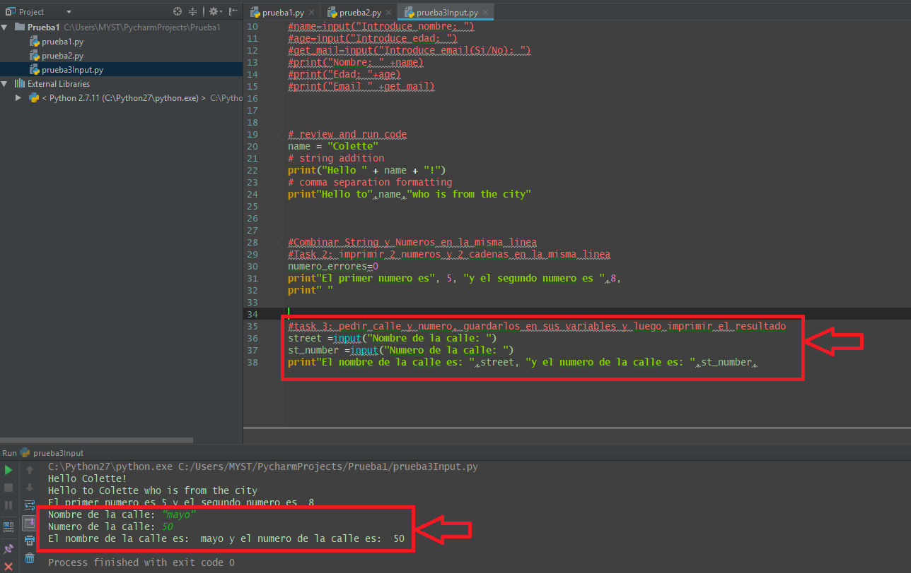

# Task 4

**print() number, strings, variables from input**

* **[ ]** display text made from combining a variable, a literal string and a number

# [ ] define a variable with a string or numeric value

# [ ] display a message combining the variable, 1 or more literal strings and a number

# Task 5

## Program: How many for the training?

Create a program that prints out a reservation for a training class. Gather the name of the party, the number attending and the time.

**example** of what input/output might look like:

enter name for contact person for training group: Hiroto Yamaguchi

enter the total number attending the course: 7

enter the training time selected: 3:25 PM

------------------------------

Reminder: training is schedule at 3:25 PM for the Hiroto Yamaguchi group of 7 attendees

Please arrive 10 minutes early for the first class

Design and Create your own reminder style

* **[ ]** get user input for variables:
  + **owner**: name of person the reservation is for
  + **num_people**: how many are attending
  + **training_time**: class time
* **[ ]** create an integer variable **min_early**: number of minutes early the party should arrive
* **[ ]** using comma separation, print reminder text
  + use all of the variables in the text
  + use additional strings as needed
  + use multiple print statements to format message on multiple lines (optional)

# [ ] get input for variables: owner, num_people, training_time - use descriptive prompt text

owner =

num_people =

training_time =

# [ ] create a integer variable min_early and "hard code" the integer value (e.g. - 5, 10 or 15)

min_early =

# [ ] print reminder text using all variables & add additional strings - use comma separated print formatting

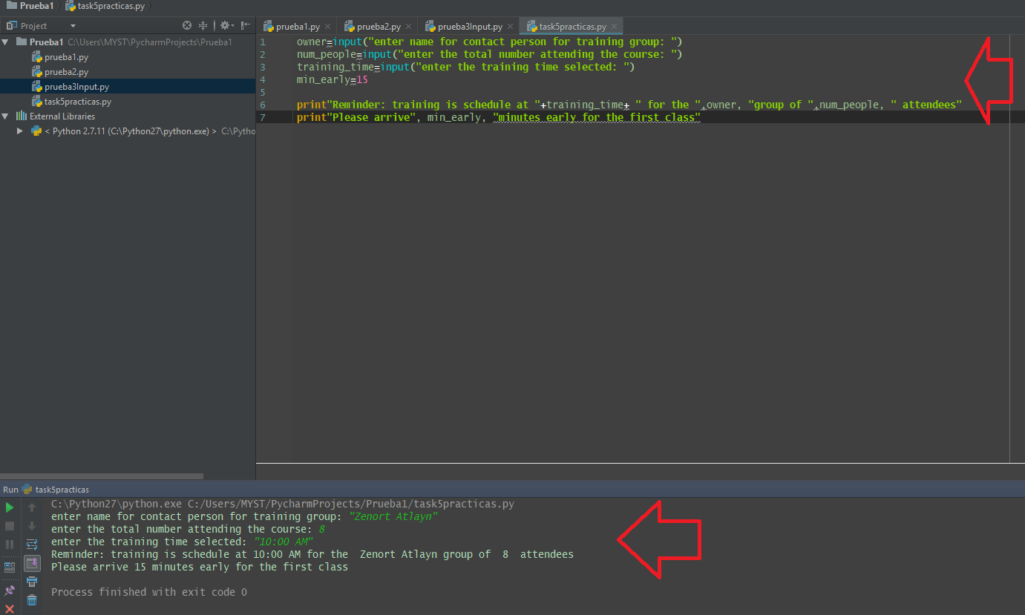

**Code Task 5:**

|  |
| --- |
| owner**=**input**("enter name for contact person for training group: ")** num_people**=**input**("enter the total number attending the course: ")** training_time**=**input**("enter the training time selected: ")** min_early**=**15  **print"Reminder: training is schedule at "+**training_time**+ " for the "**,owner, **"group of "**,num_people, **" attendees" print"Please arrive"**, min_early, **"minutes early for the first class"** |

**7.4 Self-Check: Module 1 Section 7**

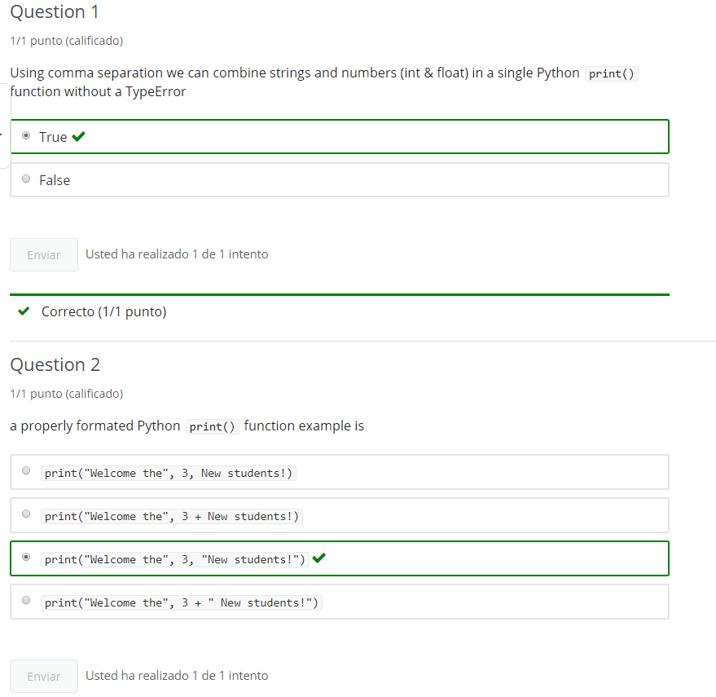

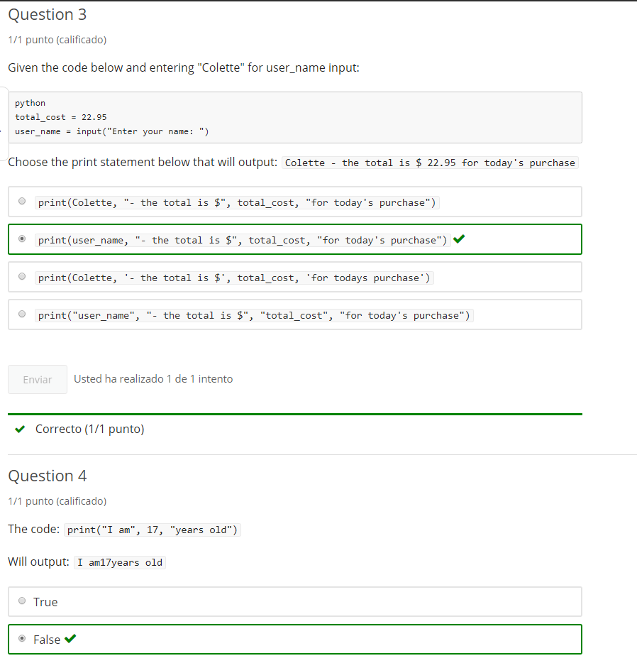

**8. Quote display & Boolean**

**8.1 Intro Python**

Jupyter Notebook: MOD01_1-2.3_Intro_Python.ipynb

Strings: input, testing, formatting

* input() - gathering user input
* print() formatting
* **Quotes inside strings**
* **Boolean string tests methods**
* String formatting methods
* Formatting string input()
* Boolean in keyword

**Student will be able to**

* **test string characteristics**

**8.2 Integers: Representing quotes inside of quoted strings**

**Video:** **IntegersRepresentingQuotesInsideOFQuotedStringsV20.mp4**

**We know Strings come in quotes. But what do you do, when you need to display a quote in a string? It could be a problem because you end the string.** So let's take a look at using Strings with quotes in quotes. So, what does it mean to have quotes in quotes? Well, you know when we use a string quote, we can use either a double quote or a single quote. In this case**, I'm using double quotes to enclose my string here, but because I'm using double quotes, I'm allowed to use single quotes inside. So anytime that I need to display a single quote, I have to use double quotes for my outer string and then this becomes a character.** So, go ahead and run that, and we see that works fine and then there is my single quote.

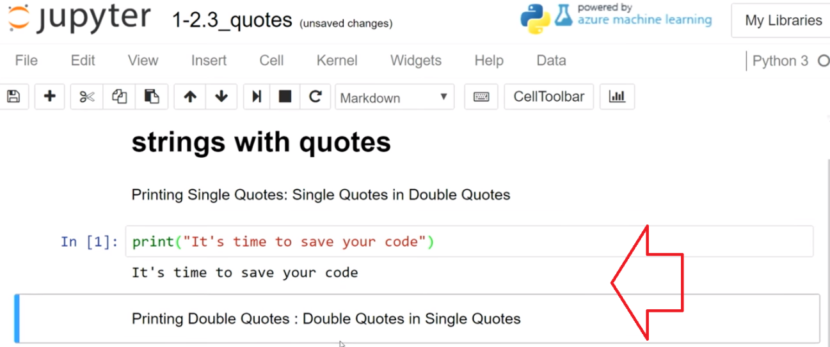

**Now, we just do the reverse, if we want to show a double quote. So, here I have the teacher making a announcement and so we need to put that into double quotes and display those. So, I have single quotes, around the end and these double quotes inside. They just become characters.** So, now I see the-- double quotes show.

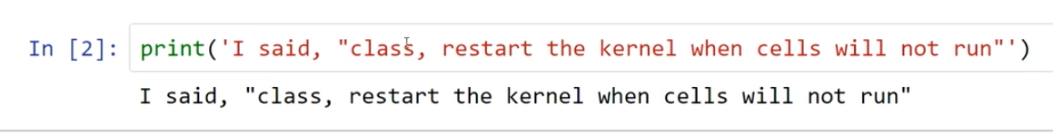

So it has been a problem previously to show quotes, and now you have the ability to do it. You can't show double and single quotes in the same sentence yet, but we're still making progress there.

# Concept: Quotes in Strings

## Representing quotes inside of quoted strings

### single quotes in double quotes

to display single quotes **'** in a string - double quotes can be used as the outer quotes: **"it's time"**

### double quotes in single quotes

to display double quotes **"** in a string- single quotes can be used as the outer quotes: **Alton said "Hello"**

# Example

# review and run the code

# Single quote surrounded by Double

print("It's time to save your code")

# Double quote surrounded by Single

print('I said to the class "sometimes you need to shut down and restart a notebook when cells refuse to run"')

# Task 1

* **[ ] print()** strings that display double and single quotation marks

# [ ] using a print statement, display the text: Where's the homework?

# [ ] output with double quotes: "Education is what remains after one has forgotten what one has learned in school" - Albert Einstein

**note:**: Quotes in quotes handles only simple cases of displaying quotation marks. More complex case are covered later under escape sequences.

**8.3 Boolean String tests (Boolean tests return Bolean True or False)**

**Video:** **BolleanStringTestsV21.mp4**

**When we work with Strings sometimes they're not in the format that we want them to be in. And so we can use some test some boolean string method tests to figure out, what format the strings are in?** **So let's take a look, so we have several boolean string methods that will return a true or false. For instance we have this "Python" isalpha and you just add that method to the end of a string or string variable. The name is lowercase isalpha with parenthesis and then when we run that we see it's true.**

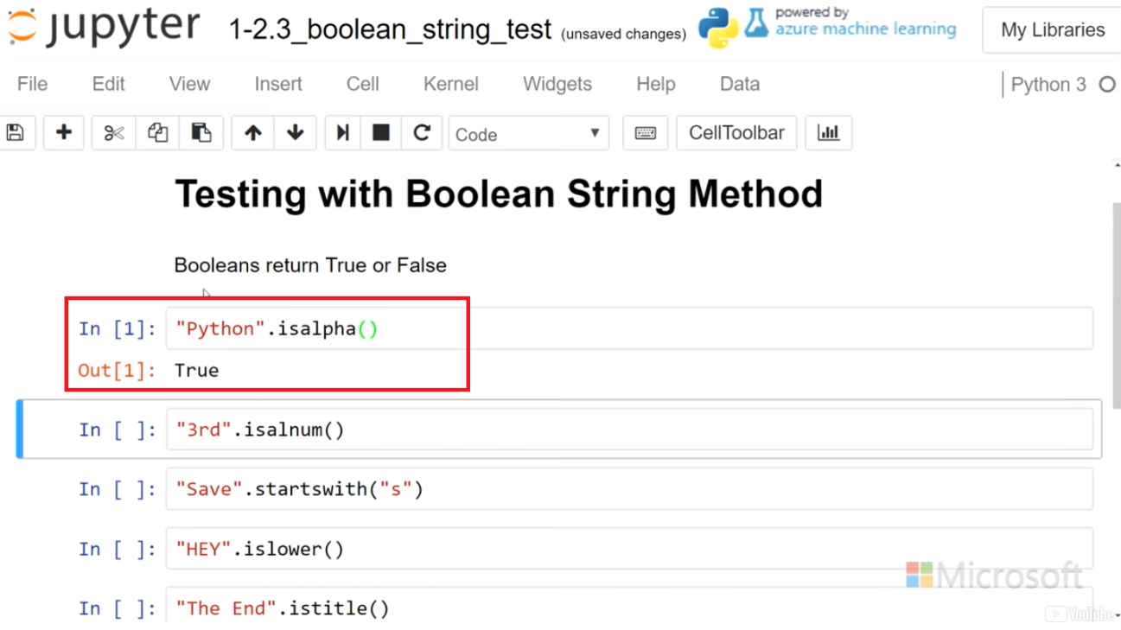

**If I put a space in there, it's still true? No, because the space is not a alphabetical character,**

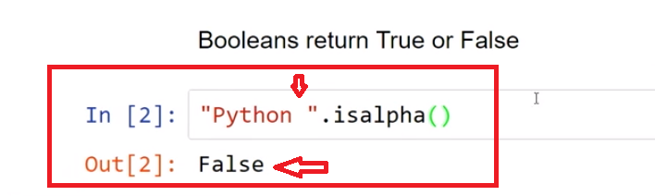

how about if I put a exclamation still **false**. **So, in order to have a isalpha pass you need only letters of the alphabet.**

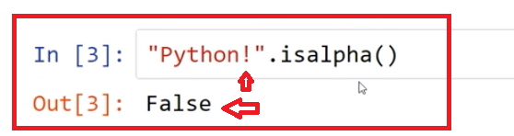

**Here I have isalpha numeric or isalnum. And so same thing If I run that it's true because it has digits and it has alphabetic characters.**

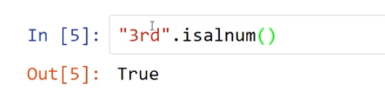

**So again if I put a space in there that resolves to False.**

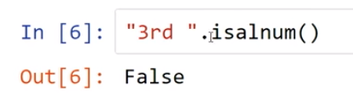

A very useful **method is startswith** and in startswith you can put in a string or a character. And so in this case, I'll see if save startswith("s") and we expect that is False. False because this is case sensitive

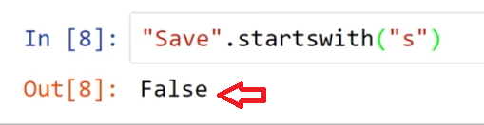

**and so the only way to get truth there is to have a exact match and now it is True.**

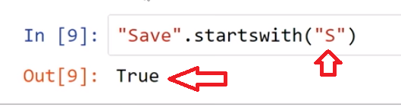

So startswith can be very useful, here I have **is "HEY" islower looks like it's yelling. So that's False.**

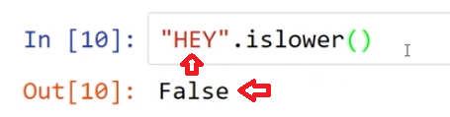

**So maybe I need to find out if its upper, yes, it is upper indeed.**

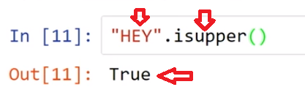

**Title is something that checks, if every word separated by a space in your string is uppercase. So that is** **True**

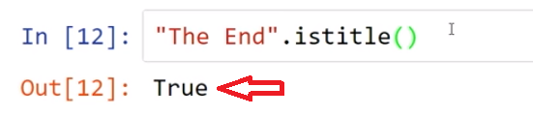

but the **end** **is not True(false)**

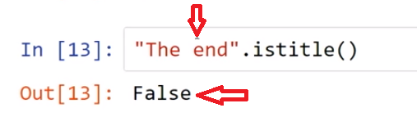

and we also said earlier we can use a string variable. **So here I'm going to get the string of digits 176 to be centimeter height and then I'm going to see are all of those digits and says yes that's True**

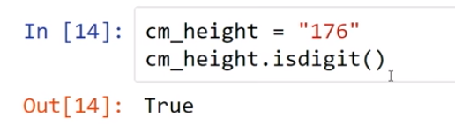

**and if I took the quotes off. What would happen? I'll get an error because this is not a string and this only runs on strings.**

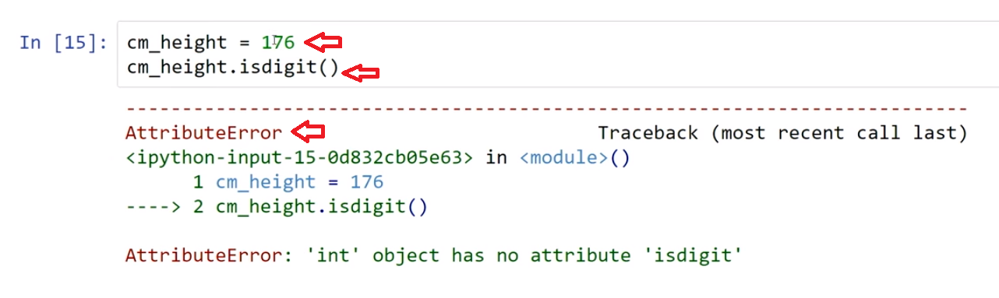

**So, I can also use my string methods inside of a comma formatted print statement.** And so over here I have this centimeter height is it a digit and so, then I just asked I said is centimeter height and then I show the height is it all digits, we can run that and **it says 176 is all digits True**. So this is where the True-False evaluates and you put that right into a print statement.

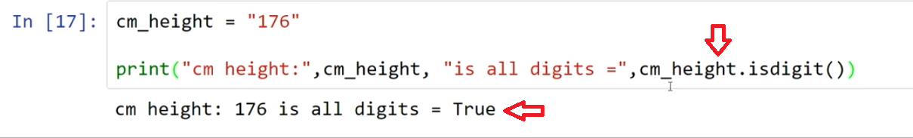

So when we're working with various boolean string methods we're able to identify, what is inner strings and different elements of our string such as what letters it starts with upper, lower and title.

# Concept: Boolean String Tests

## Boolean string tests return Bolean True or False

### methods

* .isalpha()
* .isalnum()
* .istitle()
* .isdigit()
* .islower()
* .isupper()
* .startswith()

type **str** has methods that return a Boolean (True or False) for different tests on the properties of stings.

"Hello".isalpha()

out:[ ]     True

.isalpha() returns True if all characters in the string ("Hello") are alphabetical, otherwise returns False

# Example

## Boolean String Tests

* **[ ] review and run code in each cell**

"Python".isalpha()

"3rd".isalnum()

"A Cold Stormy Night".istitle()

"1003".isdigit()

cm_height = "176"

print("cm height:",cm_height, "is all digits =",cm_height.isdigit())

print("SAVE".islower())

print("SAVE".isupper())

"Boolean".startswith("B")

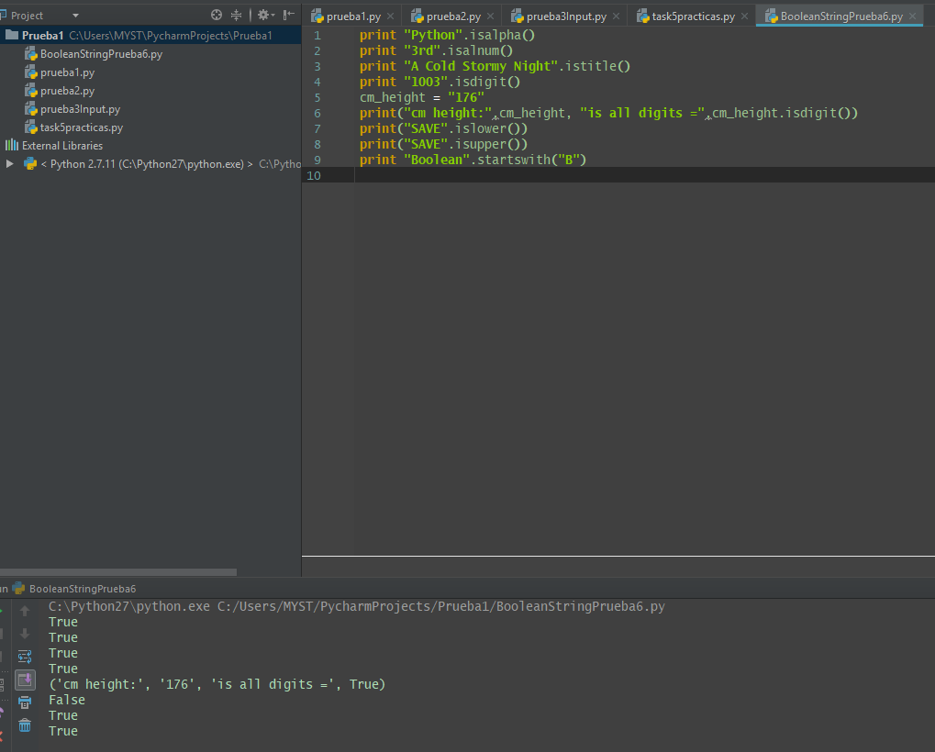

# Task 2: multi-part

### test stings with .isalpha()

# [ ] Use .isalpha() on the string "alphabetical"

# [ ] Use .isalpha() on the string: "Are spaces and punctuation Alphabetical?"

# [ ] initialize variable alpha_test with input

# [ ] use .isalpha() on string variable alpha_test

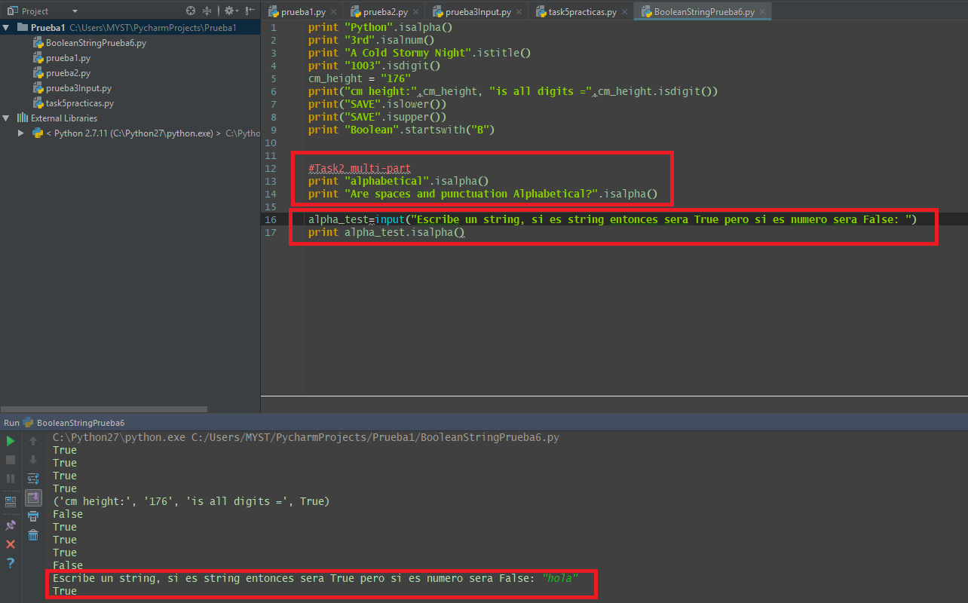

**8.4 Self-Check: Module 1 Section 8**

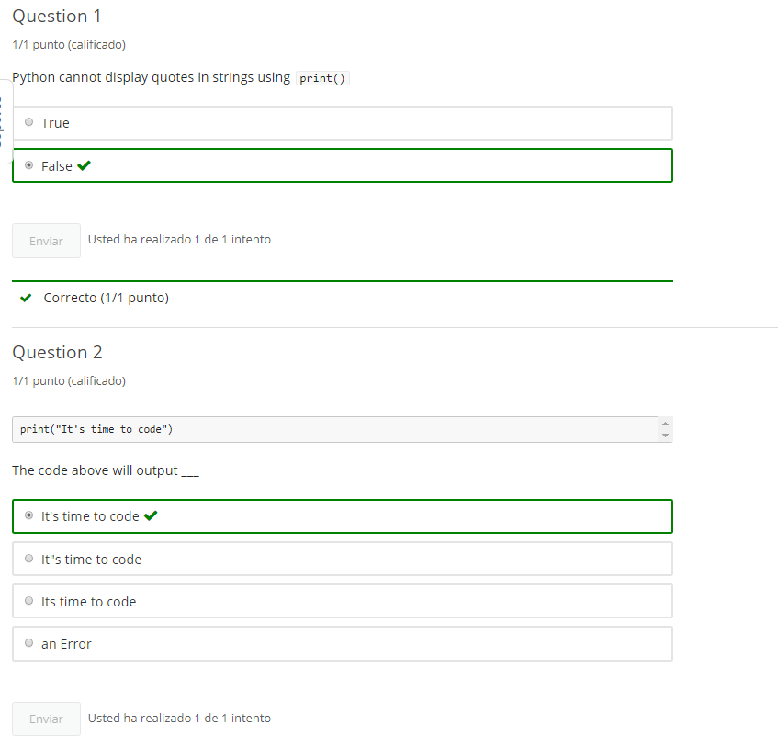

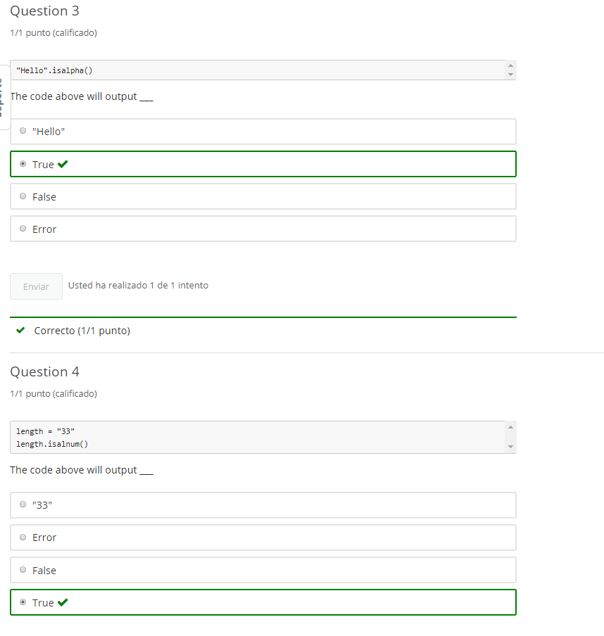

**9. String Formatting & "in" keyword**

**9.1 Intro Python**

Jupyter Notebook: MOD01_1-2.4_Intro_Python.ipynb

Strings: input, testing, formatting

* input() - gathering user input
* print() formatting
* Quotes inside strings
* Boolean string tests methods
* **String formatting methods**
* **Formatting string input()**
* **Boolean in keyword**

**Student will be able to**

* **format string output**
* **search for a string in a string**

**9.2 String format methods**

**Video:** **StringsFormatMethodsV22.mp4**

Boolean string methods were interesting because they could test and tell us if something was upper, lower or maybe even capitalized. **So, we're now we have the String format Methods and they're going to actually help us change a String into uppercase or lowercase or title case et cetera.**

So let's take a look at the String format Method. **So, the format Methods allow us to actually alter the string.** So we have a hard coded string right here, literal string and **we're going to use the lower command and that should change the uppercase letters to lower.**

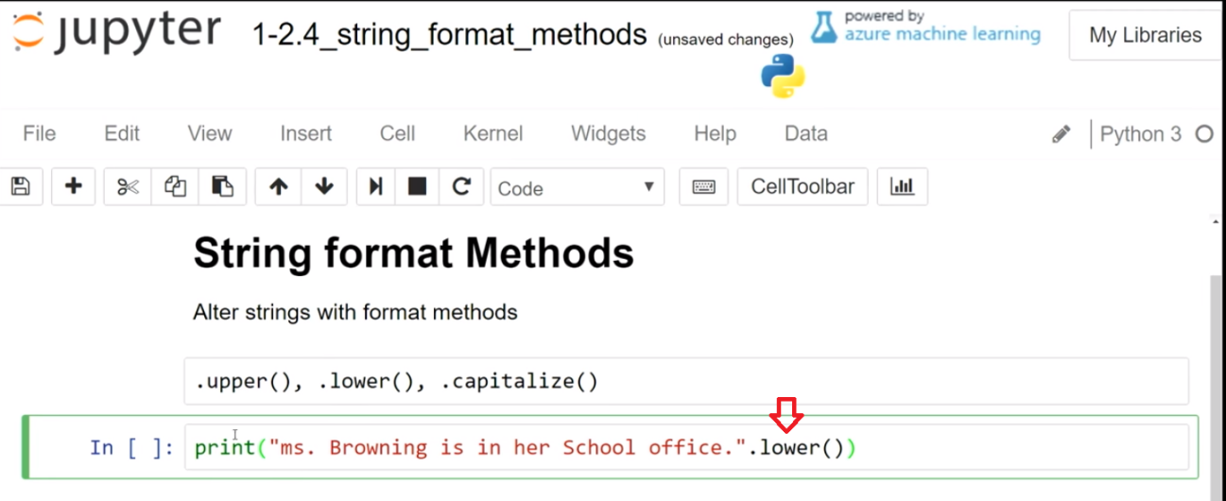

So let's run that, so we see up. **Everything is lowercase now**,

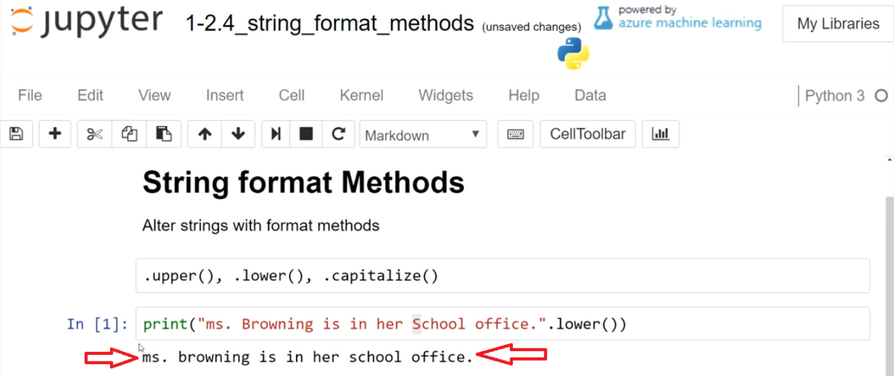

let's try to edit. **In the upper method, puts it to all caps**.

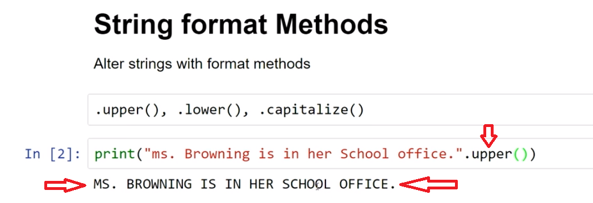

**And we can also use the capitalize. And capitalize-- capitalize will capitalize a word or a sentence with the first word or the first letter of a sentence.** And so you can see here that the title Miss is now capitalized but there may be ***a unintended consequences when you're using this in a sentence that every word is not capitalized, just the first word and it doesn't-- it doesn't keep the old cases, it puts everything else following it to lowercase.*** And so that can be useful especially for single words.

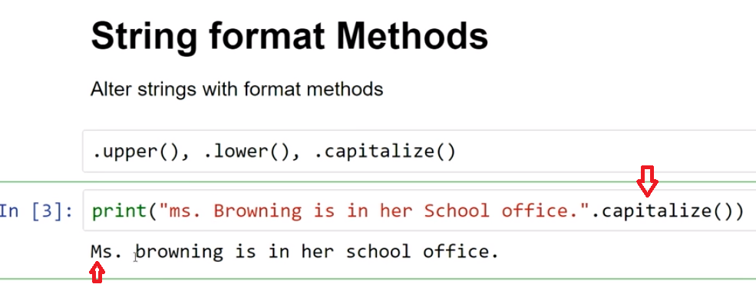

But **title** is maybe more interesting and we have the title below for this print time to save your code and **title looks like a book title and every word gets capitalized**.

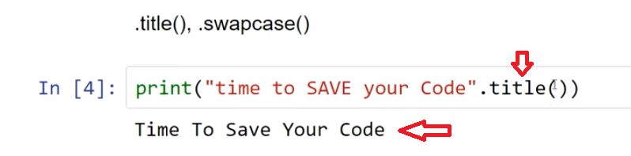

**So, time to save your code and then there is swap case which can be useful at times, but it's more fun**, I think find then a use case and so, ***you can see I get the opposite, all lower case becomes all uppercase and capitalized words become uppercase with the first word lowercase.***

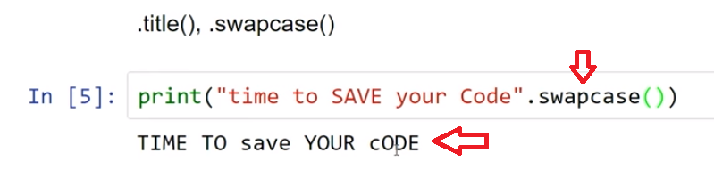

So, using String format Methods we can alter strings to be all uppercase, all lowercase, title case et cetera. And they be very useful in our programs.

# Concept: String Format Methods

## Using string formatting methods

### the following methods can be applied to string objects

* **.capitalize()** - capitalizes the first character of a string
* **.lower()** - all characters of a string are made lowercase
* **.upper()** - all characters of a string are made uppercase
* **.swapcase()** - all characters of a string are made to switch case upper becomes lower and vice versa
* **.title()** - each 'word' separated by a space is capitalized

# Example

## String Formatting Methods

print("ms. Browning is in her office.".capitalize())

fav_color = "green"

print(fav_color.capitalize(), fav_color, fav_color,"and", fav_color.upper()+"!")

# 

# Task 1: multi-part

### [ ] format with .capitalize(), .lower(), .upper(), .swapcase()

**Note:** use **print()**

# [ ] get input for a variable, fav_food, that describes a favorite food

# [ ] display fav_food as ALL CAPS, used in a sentence

# [ ] display fav_food as all lower case, used in a sentence

# [] display fav_food with swapped case, used in a sentence

# [] display fav_food with capitalization, used in a sentence

fav_color = "Forest Green"

# [] display the fav_color variable as upper, lower, swapcase, and capitalize formatting in a single print() statement

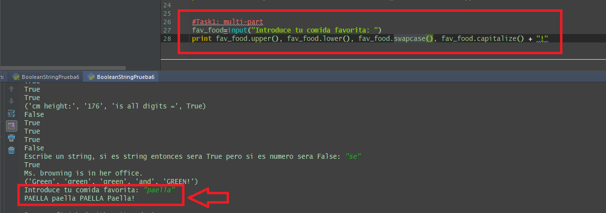

**9.3 Input formating**

**Video:** **InputFormatingV23.mp4**

The string format methods are really useful for display alterations, so putting something all upper or all lower title case. **Another very useful way to use the string methods is on user input.**

Here we have two things going on, first of all we're going to use a variable favorite color, fav_color and input as we've seen before and then so we're going to apply this lower command to actually alter what's going to go into the variable. And so this is a choice this is formatting on input. So right at the input statement you just use the dot lower to invoke the method because input will return a string and so you can use the dot lower on a string, so this really is a string right here. After input returns whatever we put in there, so let's try running that. So I can put in my favorite color and I can use green and then it prints the favorite color green and **notice my capitalization is removed because I use the lower and I could use that with upper as well.**

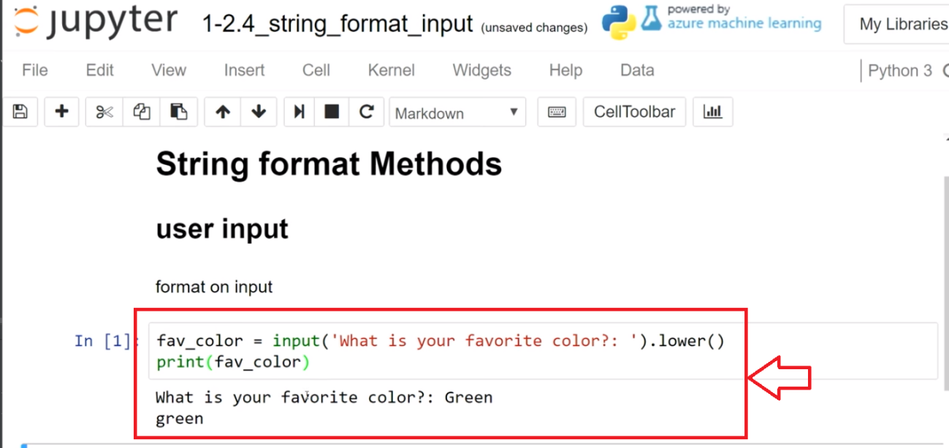

**And I could use blue and we see that I have all caps in that answer.**

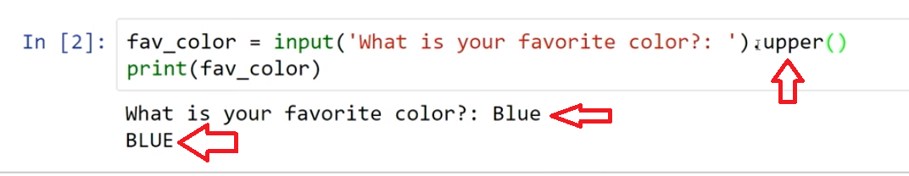

So when do I want to use the String_Formatting and input I can use it when I'm doing the input or I can just get my input stored in a variable and then I can just alter the variable string in print statements and in other places and where that could be an advantage is perhaps later I wanted to see what the format that was originally used in the string. So let's go ahead and run that. so I can go yellow and I can see there that it prints it all caps, although if I just print it without any string modification and then I see that yellow is displayed right there.

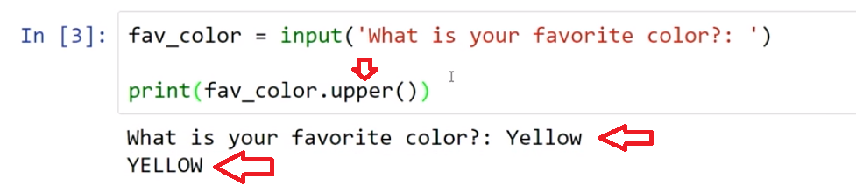

So working with the strings input and then deciding whether I want to modify it right when I come in and the string is entered and that's a case where I never want to change it later or I can modify it in place in a print statement or in other uses.

# Concept: Format Input

## Formatting string input()

When storing input, sometimes a specific format is needed and formatting is applied to the **input()**function

**Note:** this technique overwrites the original user input in the variable with the formatted value

# Example

# review and run code - test a capitalized color input

fav_color = input('What is your favorite color?: ').lower()

print(fav_color)

# Task 2

### [ ] format   input() with .upper()

# [] input variable fav_color as upper

# [] print fav_color

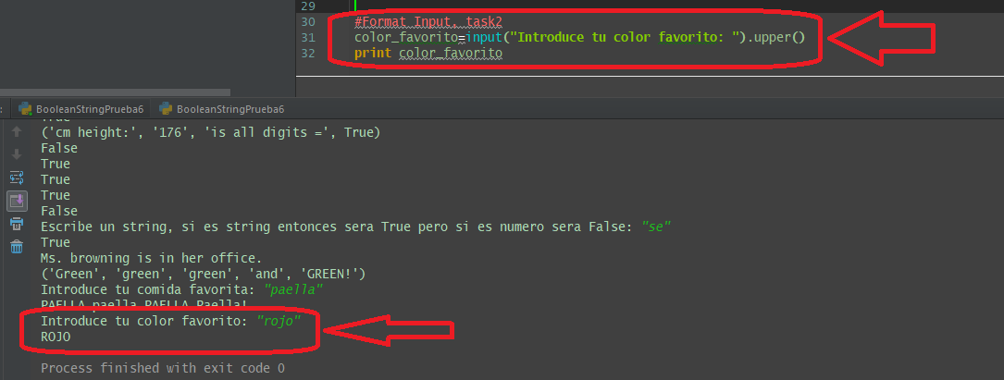

**9.4 Boolean "in" keyword (Using the in keyword to return a Boolean)**

**Video:** **BooleanInKeywordV24.mp4**

We saw how starts with can help us, find a search of the first character and a string. But **sometimes we want to search in the middle of the string and so the Boolean_in_keyword is very useful in this regard.**

So below, I have a string called menu and I just entered a number of things that might be in a menu in that string and then I just can print and to the result here of to see, If pizza is in menu and so, what this will do with the in keyword is, **Pizza it's gonna be the search string and they're gonna run it through this entire list to see if it gets a match and So the way that our work is at each letter, it will just check if there is a P and then when it's there it will see the second letter and soon and that doesn't work then we'll move on to it gets to the start again with another piece.** So we can run this and **it says False**,

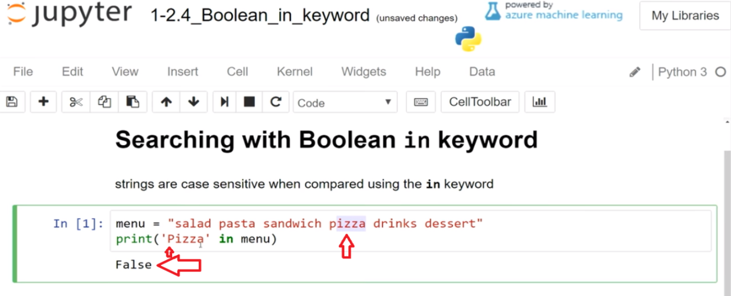

**but I see that right here there's pizza in the menu but it wasn't found so the problem in this case is that, I need to have pizza be lowercase and so, I can run it with a lowercase p and then I see that it's true** and so this is really a great part of Python here is this the way that it works to just use this word and it seems very natural to look for something like this because, I named my variable menu and my search term was quite straightforward, I could just run this really easily and I couldn't use a variable in this case as well.

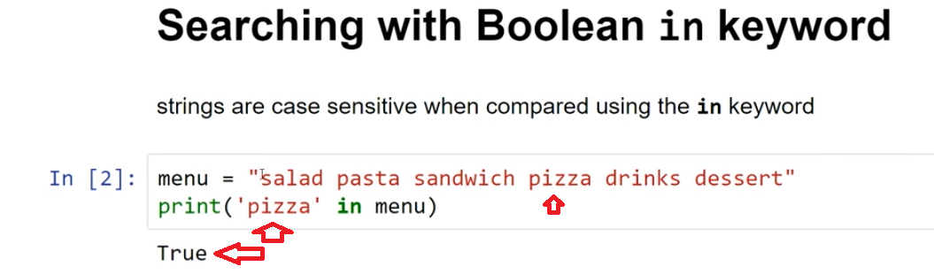

So let's look over here at another version of pizza**. In this case, I put lower and lower and this is really a best practice that you should look for in any of you search, if you don't care about case sensitivity, then it's a good practice to make lower used in both sides and we can see how that makes search run a lot faster .**

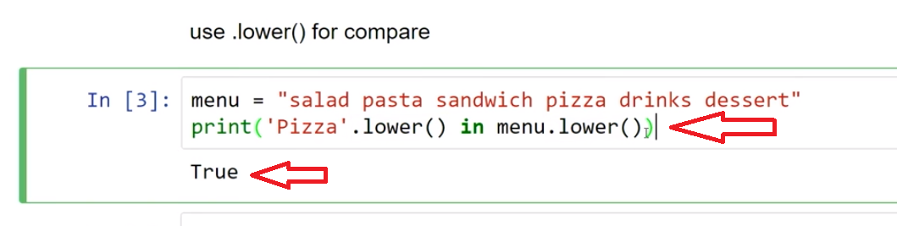

The "in" keyword is very effective in searching within strings and so the best practice we use with that is when case sensitivity is not important , we can use a dot lower and use that string method to make both the search string and search target a lowercase . And that will lead to really effective searching.

# Concept: Boolean in keyword

## Using the in keyword to return a Boolean

the **in** keyword can be used as a simple search returning **True** or **False** indication if a string is included in a target sequence.

### comparing strings is case sensitive

'Hello' is not the same as 'hello'

# Example

# review and run code to test if a string is to be found in another string

menu = "salad, pasta, sandwich, pizza, drinks, dessert"

print('pizza' in menu)

# review and run code to test case sensitive examples

greeting = "Hello World!"

print("'hello' in greeting = ",'hello' in greeting)

print("'Hello' in greeting = ", 'Hello' in greeting)

example below: **remove case sensitivity from a string comparison**

# review and run code to test removing case sensitivity from a string comparison

greeting = "Hello World!"

print("'hello' in greeting = ",'hello' in greeting)

print("'Hello' in greeting = ", 'Hello' in greeting)

print("'hello' in greeting if lower used = ", 'hello'.lower() in greeting.lower())

# 

# Task 3: multi-part

**[ ] add code below** testing the **menu** string variable for 'pizza', 'soup', and 'dessert' using keyword   **in**

* print each test on a separate line
* print a description for each test   (e.g. - "Pizza in menu = True")

# [] print 3 tests, with description text, testing the menu variable for 'pizza', 'soup' and 'dessert'

menu = "salad, pasta, sandwich, pizza, drinks, dessert"

## Program: What is on the menu

### [ ] Create a program where a user can check if an item is on the menu

* store the user response in a variable menu_ask
* use the menu from above and add some additional items
* the program should be able to ignore case mismatch so that "hello" is found in "Hello World!"

# Create a program where the user supplies input to search the menu

### [ ] Challenge: Add to the menu

* print the current menu
* get user input for add_item variable
* new_menu use string addition to add add_item to menu
* print the new_menu

testing

* check if an item is on the menu, check for previous items and the item you added

# add to menu

# Testing Add to Menu - create user input to search for an item on the new menu

# Task 4

## Fix The Error

# [ ] fix the error

paint_colors = "red, blue, green, black, orange, pink"

print('Red in paint colors = ',red in paint_colors)

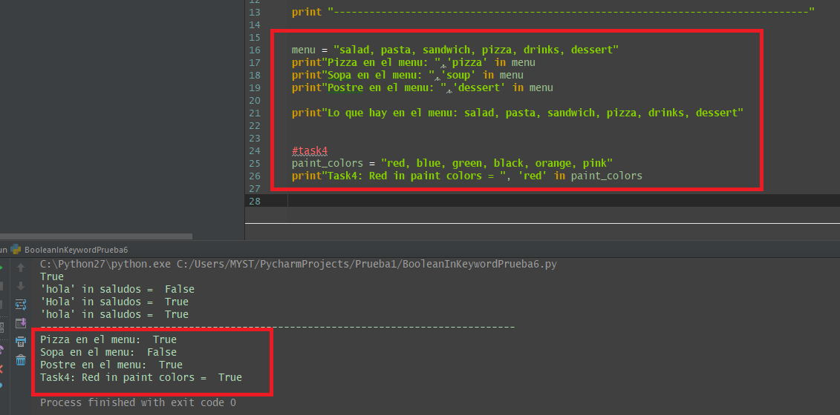

**9.5 Self-Check: Module 1 Section 9**

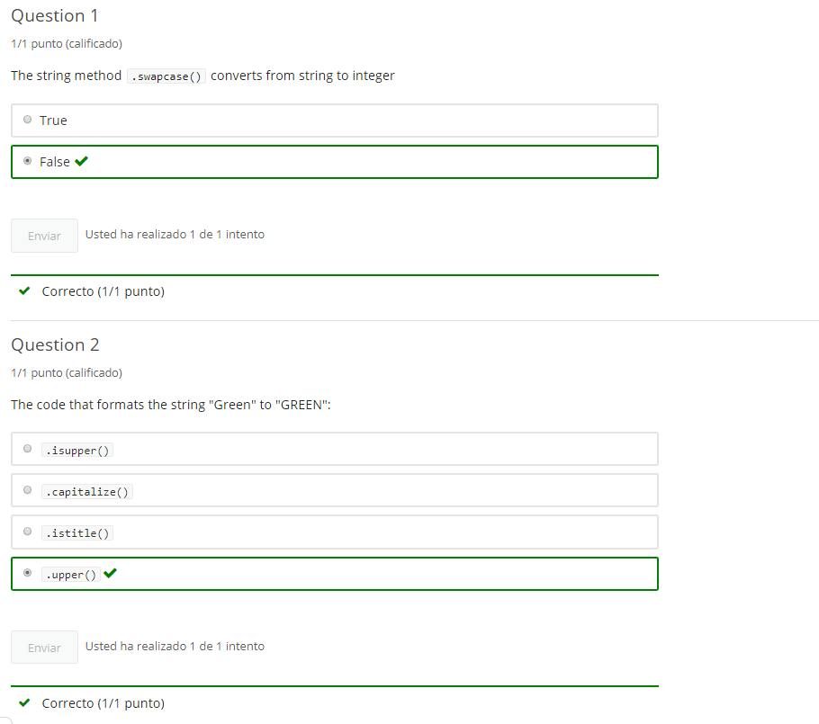

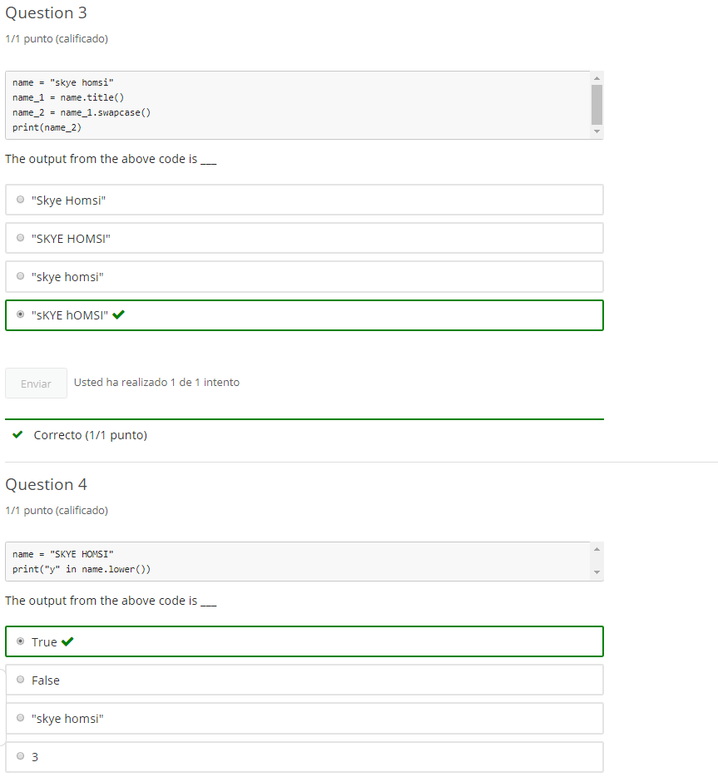

**10. Basics Practice**

**10.1 Module 1 Practice - notebook 1**

# 1-1 Intro Python Practice

optional practice

Jupyter Notebook: MOD01Practice_1-1_IntroPy.ipynb

## Getting started with Python in Jupyter Notebooks

### notebooks, comments, print(), type(), addition, errors and art

# Student will be able to

* use Python 3 in Jupyter notebooks
* write working code using print() and # comments
* write working code using type() and variables
* combine strings using string addition (+)
* add numbers in code (+)
* troubleshoot errors
* create character art

**note:** the **[ ]** indicates student has a task to complete

**reminder:** to run code and save changes: student should upload or clone a copy of notebooks

#### notebook use

*  insert a **code cell** below
*  enter the following Python code, including the comment:

# [ ] print 'Hello!' and remember to save notebook!

print('Hello!')

Then run the code - the output should be:  
Hello!

#### run the cell below

*  use **Ctrl + Enter**
*  use **Shift + Enter**

print('watch for the cat')

#### Student's Notebook editing

*  Edit **this** notebook Markdown cell replacing the word "Student's" above with your name
*  Run the cell to display the formatted text
*  Run any 'markdown' cells that are in edit mode, so they are easier to read

#### [ ] convert *this* cell from markdown to a code cell, then run it

print('Run as a code cell')

## # comments

create a code comment that identifies this notebook, containing your name and the date

#### use print() to

*  print [**your_name**]
*  print **is using python!**

# [ ] print your name

# [ ] print "is using Python"

Output above should be:  
Your Name is using Python!

#### use variables in print()

*  create a variable **your_name** and assign it a string containing your name
*  print **your_name**

# [ ] create a variable your_name and assign it a string containing your name

#[ ] print your_name

#### create more string variables

*  create variables as directed below
*  print the variables

# [ ] create variables and assign values for: favorite_song, shoe_size, lucky_number

# [ ] print the value of each variable favorite_song, shoe_size, and lucky_number

#### use string addition

*  print the above string variables (favorite_song, shoe_size, lucky_number) combined with a description by using **string addition**

for example favorite_song displayed as:  
favorite song is happy birthday

# [ ] print favorite_song with description

# [ ] print shoe_size with description

# [ ] print lucky_number with description

##### more string addition

*  make a single string (sentence) in a variable called favorite_lucky_shoe using **string addition** with favorite_song, shoe_size, lucky_number variables and other strings as needed
*  print the value of the favorite_lucky_shoe variable string

sample output:  
For singing happy birthday 8.5 times, you will be fined $25

# assign favorite_lucky_shoe using

### print() art

#### use print() and the asterisk ****\***** to create the following shapes

*  diagonal line
*  rectangle
*  smiley face

# [ ] print a diagonal using "*"

# [ ] rectangle using "*"

# [ ] smiley using "*"

#### Using type()

-**[ ]** calculate the type using type()

# [ ] display the type of 'your name' (use single quotes)

# [ ] display the type of "save your notebook!" (use double quotes)

# [ ] display the type of "25" (use quotes)

# [ ] display the type of "save your notebook " + 'your name'

# [ ] display the type of 25 (no quotes)

# [ ] display the type of 25 + 10

# [ ] display the type of 1.55

# [ ] display the type of 1.55 + 25

#### Find the type of variables

*  run the cell below to make the variables available to be used in other code
*  display the data type as directed in the cells that follow

# assignments ***RUN THIS CELL*** before starting the section

student_name = "Gus"

student_age = 16

student_grade = 3.5

student_id = "ABC-000-000"

# [ ] display the current type of the variable student_name

# [ ] display the type of student_age

# [ ] display the type of student_grade

# [ ] display the type of student_age + student_grade

# [ ] display the current type of student_id

# assign new value to student_id

# [ ] display the current of student_id

#### number integer addition

*  create variables (x, y, z) with integer values

# [ ] create integer variables (x, y, z) and assign them 1-3 digit integers (no decimals - no quotes)

*  insert a **code cell** below
*  create an integer variable named **xyz_sum** equal to the sum of x, y, and z
*  print the value of **xyz_sum**

### Errors

*  troubleshoot and fix the errors below

# [ ] fix the error

print("Hello World!"")

# [ ] fix the error

print(strings have quotes and variables have names)

# [ ] fix the error

print( "I have $" + 5)

# [ ] fix the error

print('always save the notebook")

## ASCII art

*  Display first name or initials as ASCII Art
*  Challenge: insert an additional code cell to make an ASCII picture

# [ ] ASCII ART

# [ ] ASCII ART

**10.2 Module 1 Practice - notebook 2**

# 1-2 Intro Python Practice

optional practice

Jupyter Notebook: MOD01Practice_1-2_IntroPy.ipynb

## Strings: input, testing, formatting

# Student will be able to

* gather, store and use string input()
* format print() output
* test string characteristics
* format string output
* search for a string in a string

## input()

getting input from users

# [ ] get user input for a variable named remind_me

# [ ] print the value of the variable remind_me

# use string addition to print "remember: " before the remind_me input string

### Program: Meeting Details

#### [ ] get user ****input**** for meeting subject and time

what is the meeting subject?: plan for graduation  
what is the meeting time?: 3:00 PM on Monday

#### [ ] print ****output**** with descriptive labels

Meeting Subject: plan for graduation  
Meeting Time: 3:00 PM on Monday

# [ ] get user input for 2 variables: meeting_subject and meeting_time

# [ ] use string addition to print meeting subject and time with labels

## print() formatting

### combining multiple strings separated by commas in the print() function

# [ ] print the combined strings "Wednesday is" and "in the middle of the week"

# [ ] print combined string "Remember to" and the string variable remind_me from input above

# [ ] Combine 3 variables from above with multiple strings

### print() quotation marks

# [ ] print a string sentence that will display an Apostrophe (')

# [ ] print a string sentence that will display a quote(") or quotes

## Boolean string tests

### Vehicle tests

#### get user input for a variable named vehicle

print the following tests results

* check True or False if vehicle is All alphabetical characters using .isalpha()
* check True or False if vehicle is only All alphabetical & numeric characters
* check True or False if vehicle is Capitalized (first letter only)
* check True or False if vehicle is All lowercase
* **bonus** print description for each test (e.g.- "All Alpha: True")

# [ ] complete vehicle tests

# [ ] print True or False if color starts with "b"

## Sting formatting

# [ ] print the string variable capital_this Capitalizing only the first letter

capitalize_this = "the TIME is Noon."

# print the string variable swap_this in swapped case

swap_this = "wHO writes LIKE tHIS?"

# print the string variable whisper_this in all lowercase

whisper_this = "Can you hear me?"

# print the string variable yell_this in all UPPERCASE

yell_this = "Can you hear me Now!?"

#format input using .upper(), .lower(), .swapcase, .capitalize()

format_input = input('enter a string to reformat: ')

### input() formatting

# [ ] get user input for a variable named color

# [ ] modify color to be all lowercase and print

# [ ] get user input using variable remind_me and format to all **lowercase** and print

# [ ] test using input with mixed upper and lower cases

# [] get user input for the variable yell_this and format as a "YELL" to ALL CAPS

## "in" keyword

### boolean: short_str in long_str

# [ ] get user input for the name of some animals in the variable animals_input

# [ ] print true or false if 'cat' is in the string variable animals_input

# [ ] get user input for color

# [ ] print True or False for starts with "b"

# [ ] print color variable value exactly as input

# test with input: "Blue", "BLUE", "bLUE"

## Program: guess what I'm reading

### short_str in long_str

1. **[ ]** get user **input** for a single word describing something that can be read save in a variable called **can_read**  
   e.g. - "website", "newspaper", "blog", "textbook"
2. **[ ]** get user **input** for 3 things can be read  
   save in a variable called **can_read_things**
3. **[ ]** print **true** if the **can_read** string is found  
   **in** the **can_read_things** string variable

example of program input and output  
[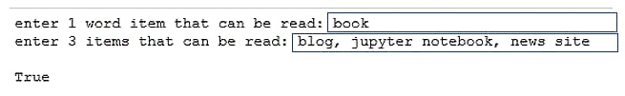](https://1drv.ms/i/s!Am_KPRosgtaij7A_G6RtDlWZeYA3ZA)

# project: "guess what I'm reading"

# 1[ ] get 1 word input for can_read variable

# 2[ ] get 3 things input for can_read_things variable

# 3[ ] print True if can_read is in can_read_things

# [] challenge: format the output to read "item found = True" (or false)

# hint: look print formatting exercises

## Program: Allergy Check

1. **[ ]** get user **input** for categories of food eaten in the last 24 hours  
   save in a variable called **input_test**  
   example input [[](https://1drv.ms/i/s!Am_KPRosgtaij65qzFD5CGvv95-ijg)](https://1drv.ms/i/s!Am_KPRosgtaij65qzFD5CGvv95-ijg)
2. **[ ]** print **True** if "dairy" is in the **input_test** string  
   **[ ]** Test the code so far
3. **[ ]** modify the print statement to output similar to below  
   example output [[](https://1drv.ms/i/s!Am_KPRosgtaij65rET-wmlpCdMX7CQ)](https://1drv.ms/i/s!Am_KPRosgtaij65rET-wmlpCdMX7CQ)  
   Test the code so far trying input including the string "dairy" and without
4. **[ ]** repeat the process checking the input for "nuts", **challenge** add "Seafood" and "chocolate"  
   **[ ]** Test your code
5. **[ ] challenge:** make your code work for input regardless of case, e.g. - print **True** for "Nuts", "NuTs", "NUTS" or "nuts"

# Allergy check

# 1[ ] get input for test

# 2/3[ ] print True if "dairy" is in the input or False if not

# 4[ ] Check if "nuts" are in the input

# 4+[ ] Challenge: Check if "seafood" is in the input

# 4+[ ] Challenge: Check if "chocolate" is in the input

**11. end of Mod coding assignment**

**11.1 Module 1 Required Code Description**

**Video:** **Module1RequiredCodeDescriptionV25.mp4**

Let's look at module one's required coding activity. And the first thing that you want to know about it if you're reading through the page, you'll see the code requirements. And so those are that **you use a variable assignment, so such as setting a greeting to a string, like a variable.**

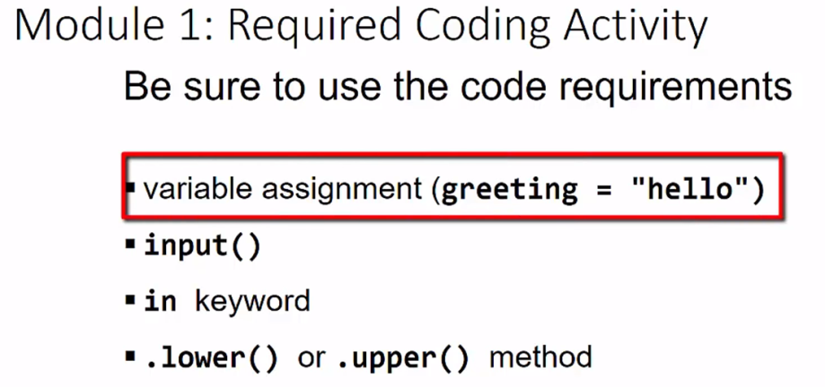

So I say the **variable greeting = "hello", that you use an input statement so that you're going to get that feedback, and maybe assign that to greeting as well.**

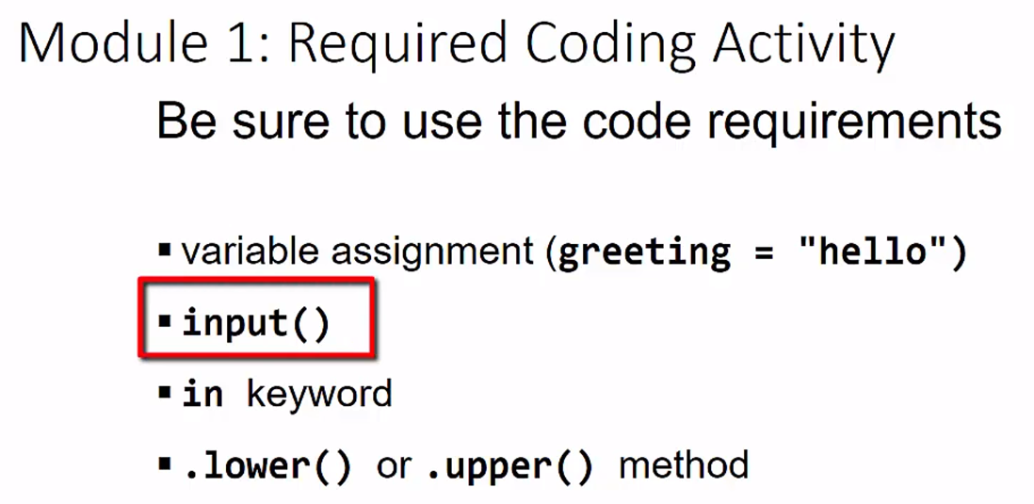

And then you would **use the in keyword**. **That's the key to this entire activity is that we're going to search a larger string and to see if specific substrings are contained in there.**

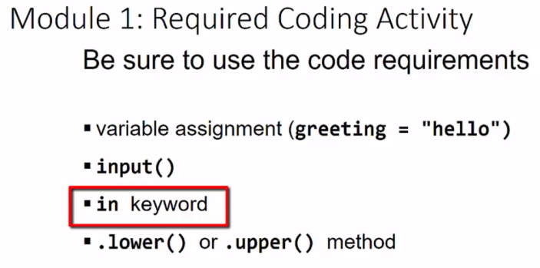

And **to make our match easier to do, we're going to convert things to all upper or all lower so that it's not case-sensitive.**

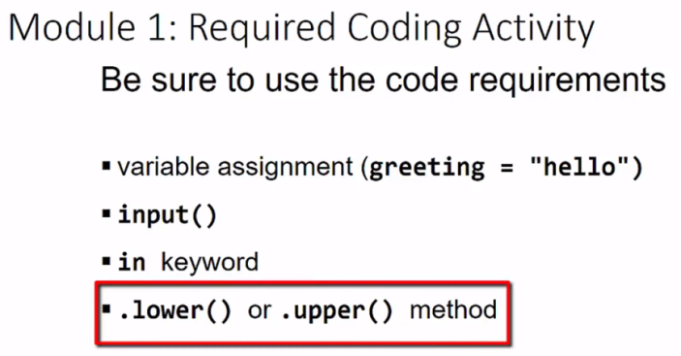

Let's run that solution code. **So the first thing your program should do is prompt people for different categories of food they've eaten in the last 24 hours, so that would be something like you would say, I might have meat, and I might have dairy, and fruit, and pasta.** And so, you could just go ahead and just put some different categories in food like that.

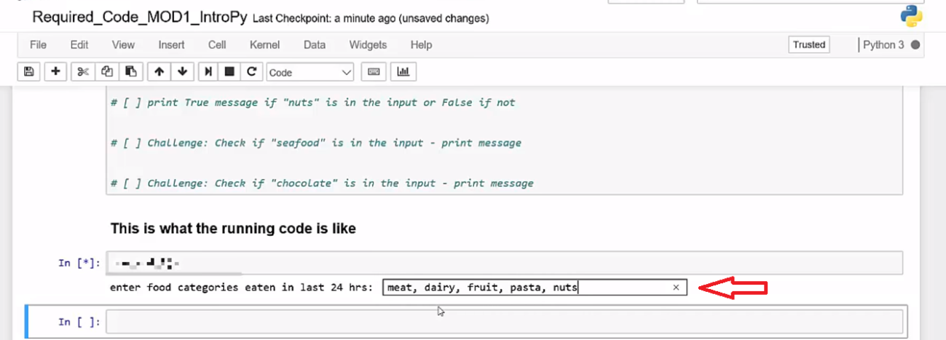

**And then when you have enough things in there, you'd put enter, and then that gets recorded in as a string, and then you do your string tests, so then it will print out these various messages.** So this one says, "It is true that dairy is contained in that string", and "It is true that nuts is contained in the string", and "It is false that seafood and chocolate are contained in the string". So, this is what your code should look like.

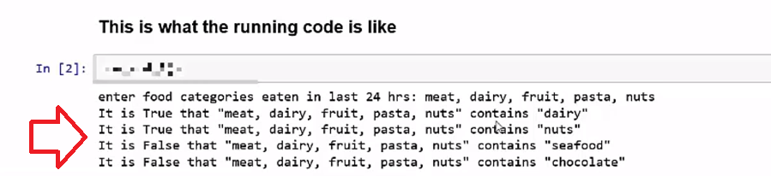

Again, let's make sure that we use all of the required code elements and we'll submit those into the edX form. The edX form is not necessarily the most elegant. And what I mean by that is that you will not see your code formatted when you paste it in, so I placed some solution code in there and then we see that it all kind of looks like one line and that's to be expected. But then you hit the Submit button and, I got everything right, so there I go.

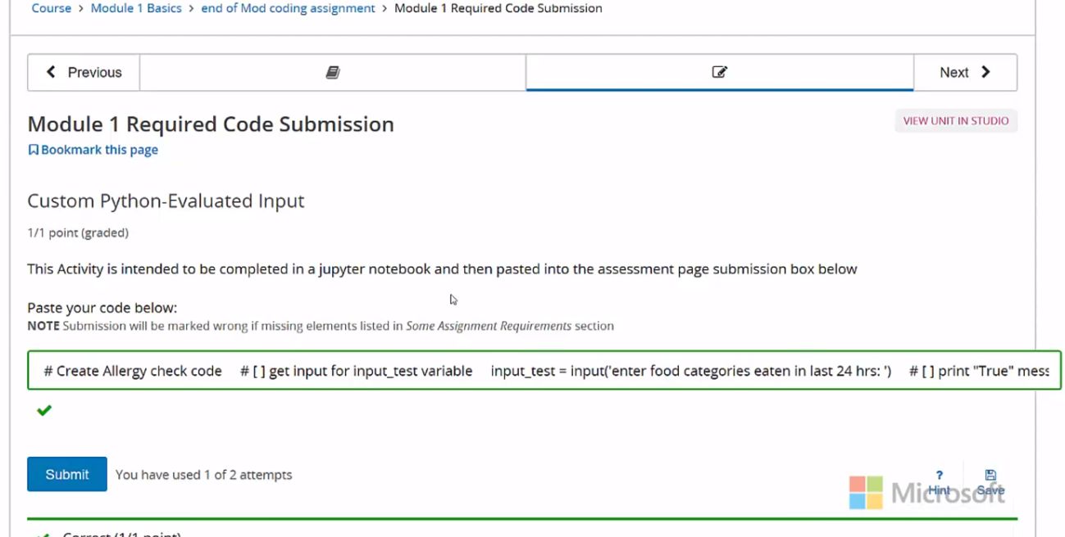

If I was missing one of the keywords, then it would say I'm wrong and I would have one more attempt to get that right. So, please check again that you have all of the keywords. Good luck.

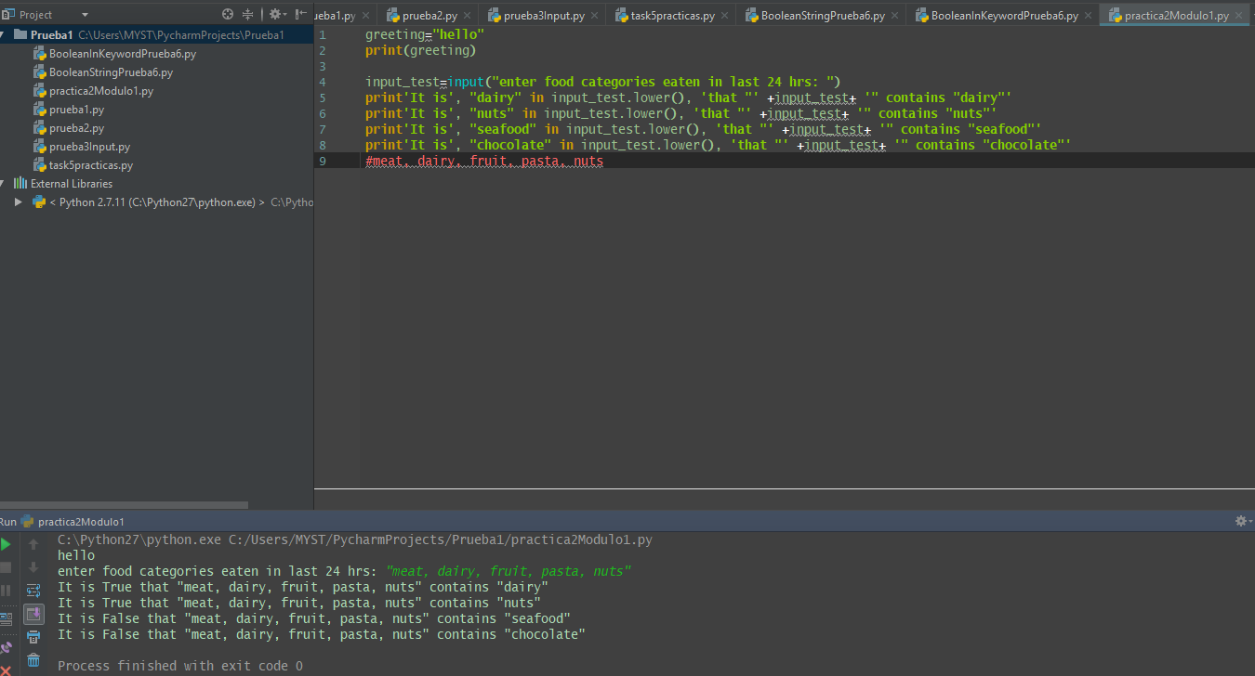

# Module 1 Required Coding Activity

Introduction to Python Unit 1

**This Activity is intended to be completed in the jupyter notebook, Required_Code_MOD1_IntroPy.ipynb, and then pasted into the assessment page that follows.**

All course .ipynb Jupyter Notebooks are available from the project files download topic in Module 1, Section 1.

This is an activity from the Jupyter Notebook **Practice_MOD01_1-2_IntroPy.ipynb** which you may have already completed.

| **Assignment Requirements** |
| --- |
| **NOTE:** This program requires print output and using code syntax used in module 1 such as variable assignment, input, in keyword, .lower() or .upper() method |

## Program: Allergy Check

1. **[ ]** get user **input** for categories of food eaten in the last 24 hours  
   save in a variable called **input_test**  
   example input [[](https://1drv.ms/i/s!Am_KPRosgtaij65qzFD5CGvv95-ijg)](https://1drv.ms/i/s!Am_KPRosgtaij65qzFD5CGvv95-ijg)
2. **[ ]** print **True** if "dairy" is in the **input_test** string  
   **[ ]** Test the code so far
3. **[ ]** modify the print statement to output similar to below  
   example output [[](https://1drv.ms/i/s!Am_KPRosgtaij65rET-wmlpCdMX7CQ)](https://1drv.ms/i/s!Am_KPRosgtaij65rET-wmlpCdMX7CQ)  
   Test the code so far trying input including the string "dairy" and without
4. **[ ]** repeat the process checking the input for "nuts", **challenge** add "Seafood" and "chocolate"  
   **[ ]** Test your code
5. **[ ] challenge:** make your code work for input regardless of case, e.g. - print **True** for "Nuts", "NuTs", "NUTS" or "nuts"

# Create Allergy check code

# then PASTE THIS CODE into edX

# [ ] get input for input_test variable

# [ ] print "True" message if "dairy" is in the input or False message if not

# [ ] print True message if "nuts" is in the input or False if not

# [ ] Challenge: Check if "seafood" is in the input - print message

# [ ] Challenge: Check if "chocolate" is in the input - print message

# Important: [How to submit code by pasting](https://courses.edx.org/wiki/Microsoft.DEV236x.1T2017/paste-code-end-module-coding-assignments/)

**11.2 Module 1 Required Code Submission**

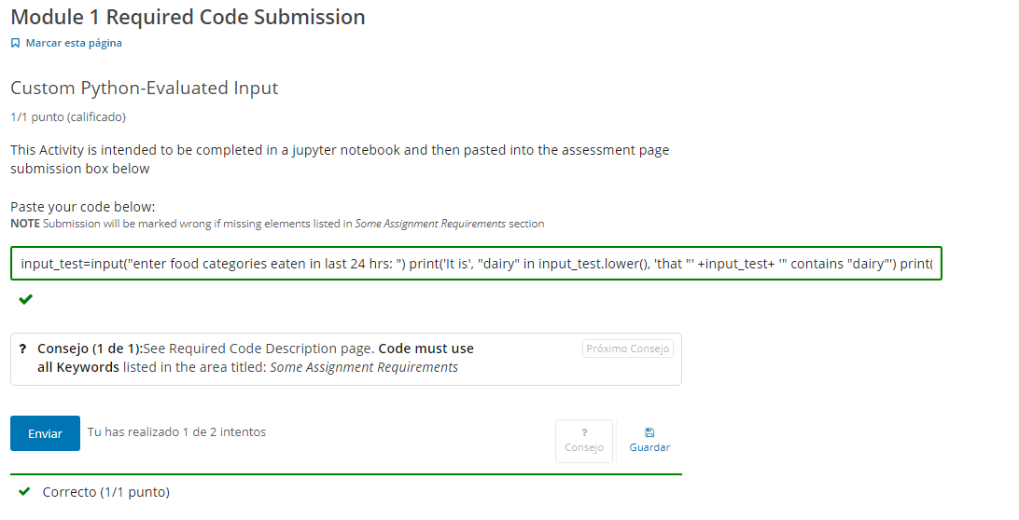

# Mi código:

